**NPS PMT Base Irradiation Test**

**V. Berdnikov, D. Mack**

**June 20, 2023**

**Abstract**

The production version of the NPS bases contains an amplifier and two voltage regulation chips which were not previously tested for rad-robustness. Two bases were powered and exposed on the RadCon test range in the Cs-137 irradiator for a several days until they appeared to be nonfunctional. This irradiator provides a mixed beta and gamma dose of up to 0.2 kRad/hr. The health of each base could only be checked a few times during its irradiation, but the results are consistent with severe damage occurring between 5 and 10 kRad. The weakest link appears to be the voltage regulation chips. It’s not clear what the dose rate will be at the bases during the NPS run but, assuming a nominal 1000 hour long run, we probably want to keep the average significantly less than 5 Rad/hour. Small but significant changes were also noted in the voltages of the transistorized active stages. These changes will be harmless in the NPS run, but will require follow-up if we develop active dividers to provide cheap, stable HV for the SOLID GEMs.

**Introduction**

Due to the need to measure energies over 2-3 orders of magnitude in dynamic range, setting up any high energy calorimeter is difficult. The NPS will take this challenge to the next level, since it will operate a high energy calorimeter with high scintillation light yield in a high luminosity environment. A sweeping magnet will reduce the low energy charged background, but due to high light levels from the remaining background, the gain of the PMT has to be no larger than O(1000) to prevent excessively high anode currents[1]. To match the NPS signal at the PMT anode to an FADC with 1 V full scale, the total gain needs to be O(20,000), hence an amplifier with an effective charge gain of O(20) is required.[2] Low noise amplification is essential to achieve high energy resolution since a single mV at the input to the amplifier corresponds to O(300) MeV. Two voltage regulation chips were therefore added to the base to provide very low noise +-3V power to the amplifier. In all, there are 3 solid state components which are well-justified but not previously tested for rad-robustness. (See Figure 1.)

Further information about the amplifier and the linear voltage regulator can be found in Appendix A and B, respectively.

**Experimental Setup**

The literature on radiation damage to low noise amplifiers is messy. Every manufacturer’s amplifier is a little different, and there are half a dozen parameters that could be measured. Our naïve expectation was that by O(10) kRad, there would be a significant decrease in the product of gain and bandwidth. We therefore needed to be able to monitor the magnitude, rise-time, and fall-time of a short pulse during the irradiation, and designed the experiment accordingly. After the irradiation, the damaged bases were attached to a PMT, pulsed with an LED, and compared to an undamaged base. Finally, the output voltages of the regulator chips were checked, and the voltages on the 3 transistorized stages for one of the bases were compared to voltages before irradiation.

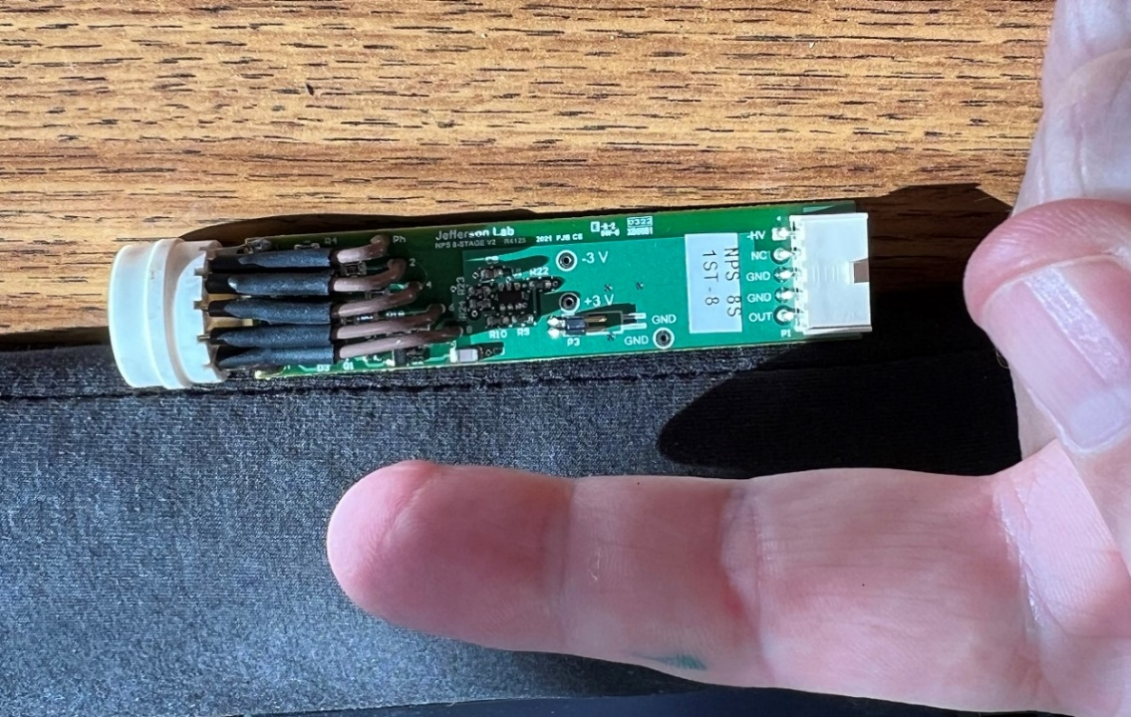

Figure 1 Amplifier side of a base. The two +-3V test points are clearly visible, along with a convenient ground. The two voltage regulation chips are on the other side of the board.

The Cs-137 irradiator on the RadCon test range was used. Figure 2 gives an impression of the workspace. During the current SAD, our access was usually limited because RadCon has so many radiation monitors to recalibrate. Most of our soaks therefore took place overnight or on a weekend.

Figure 3 shows a close-up of the setup inside the cabinet. The cabinet has generously sized cable penetrations. The grey ribbon cable is for LV power for the amplifier. The LV needs to be at least 3V at the amplifier, so I*R drops in the LV power cable need to be taken into consideration. For the short power cable we used, Fernando Barbosa suggested setting the LV to +-3.5V. The current limit on the Topward PS was set barely over the operating current to minimize damage in the event of a fail-to-short-circuit scenario.

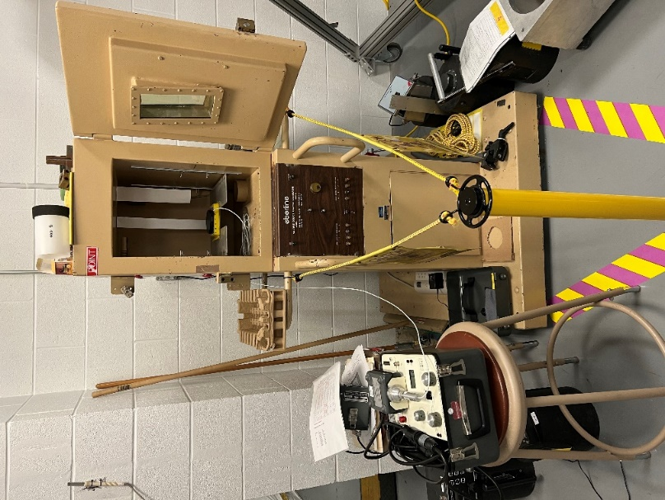

Figure 2 Cs-137 irradiator cabinet (before we moved in). When the door is shut and locked, and the shutter control rods are unlocked and pulled, a somewhat conical beam of beta and gamma rays comes out of a hole in the floor of the cabinet.

One of the test clip hooks in Figure 3 injects a pocket pulser signal into the anode. The other test clip hook picks up the signal from the output of the amplifier for display on a nearby oscilloscope. This *in situ* pulsing only tests the health of the amplifier.

The irradiation test was delayed for weeks while we figured how to stably inject a signal into the amplifier. Connecting a pulser through even the shortest cable caused the amplifier output to oscillate at +-1V and 250 MHz. (Presumably because we were loading the amplifier input with capacitance and antenna noise.) Injecting the signal through a large resistance as in Figure 4 was ultimately successful. However, most of the pulser signal traveling down the 50 Ω cable never makes it to the amplifier input because it reflects off the much larger impedance of the resistor. Values from 100 Ω to 1 MΩ were explored, the trade-off being between stable operation (which prefers a higher resistance) and the magnitude of the amplifier output (which prefers a lower resistance). A value of 1 KΩ gave the best performance. Only a mother could love the amplifier output pulse seen in Figure 5, but it was adequate to monitor the effect of radiation damage on the signal magnitude or rise time or fall time.

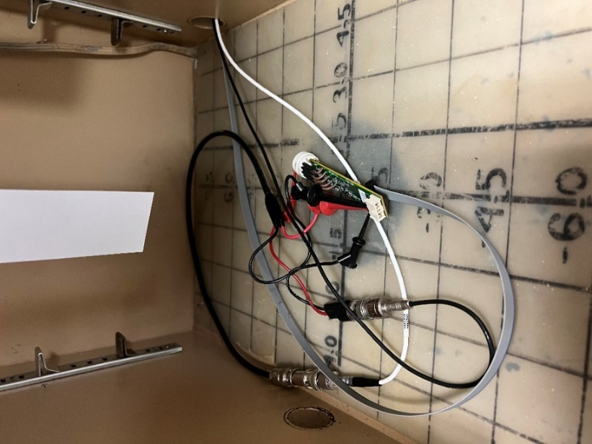

Figure 3 Test setup for the base before closing the door. The base is supported by a plastic sheet which does not significantly attenuate the beam.

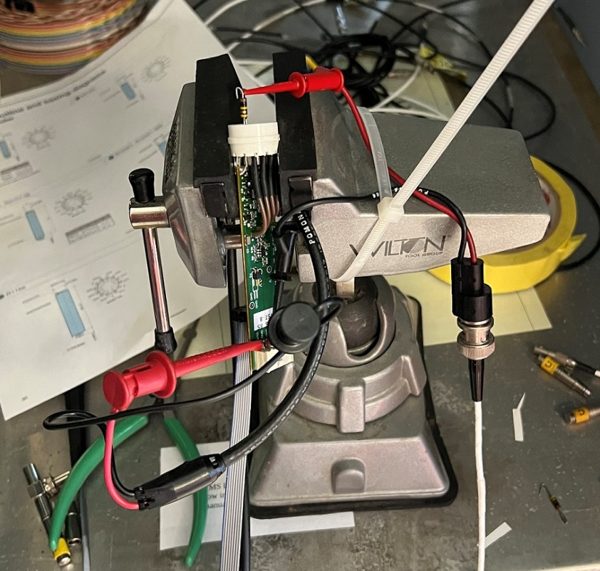

Figure 4 Bench view of how the pulser signal is injected into the PMT anode through a large resistance. (Near the top.) The resistor lead is cut to about half length, folded into a V shape, and plugged more or less securely into the PMT socket.

**1st Base Results**

It was not possible to check the health of the base every hour. The base appeared healthy when checked at 0.0 and 0.7 kRad on Friday. On Monday morning when the dose had reached 14.1 kRad, the output was found to have a large +DC offset, and the +LV was drawing no current. Initial observations from the RadCon test range are summarized in Table 1.

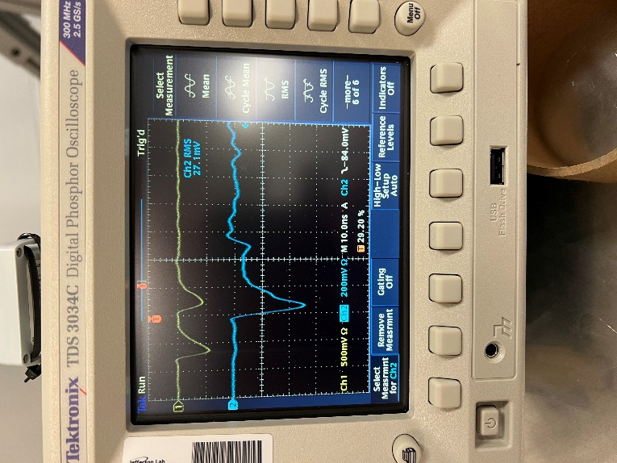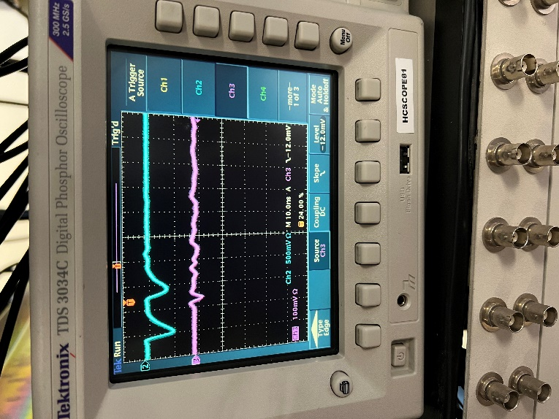

Figure 5 For both plots, the input pulser signal is the top o-scope trace, while the amplifier output is the bottom o-scope trace. Note the reflection on the input trace, which accounts for the low apparent amplifier gain in this photo. (Left) Amplifier power on. (Right) Amplifier power off.

Table 1 Results for the 1st base from the RadCon Test Range.

|  |  |  |  |  |
| --- | --- | --- | --- | --- |
| Base  ID | Dose Rate  kRad/hr | Time | Cumulative  Dose  kRad | Status |
| NPS 8S  1ST 8 | 0 |  | 0 | Output DC offset -8mV. |
|  | 0.2 | 11:35 Fri April 5 | 0 | No increase in rms output noise when the shutter is opened and the irradiation begins. |
|  | “” | 14:56 Fri  April 5 | 0.7 | Output DC offset now -9mV.  (possibly just from the room warming up) |
|  | “” | 09:45 Mon  April 8 | 14.1 | Apparently nonfunctional.  +3.5V LV channel drawing no current.  No obvious pulse seen in amplifier output.  Output DC offset +1,600 mV. |

Further tests on the 1st base were then done with a PMT and LED pulser setup as shown in Figure 6. The damaged base was confirmed to be completely non-functional at +-3V LV with the HV at 605V. But at +-5V LV, there was a spark of life: a signal which was over 2 orders of magnitude smaller than the control, and with a noticeably slower fall-time than the control. (See Figure 7.) Interestingly, the DC offset of the damaged base improved at the higher LV setting, decreasing from over 1V to “only” +170 mV. There are scenarios where the FADC could continue to operate with such a large DC offset, but with such low gain there would be no hope of increasing the HV enough to compensate. As we’ll see with the 2nd base studies below, the peculiar 100 MHz oscillations on the tail of the pulse only seem to appear in bases that are essentially dead.

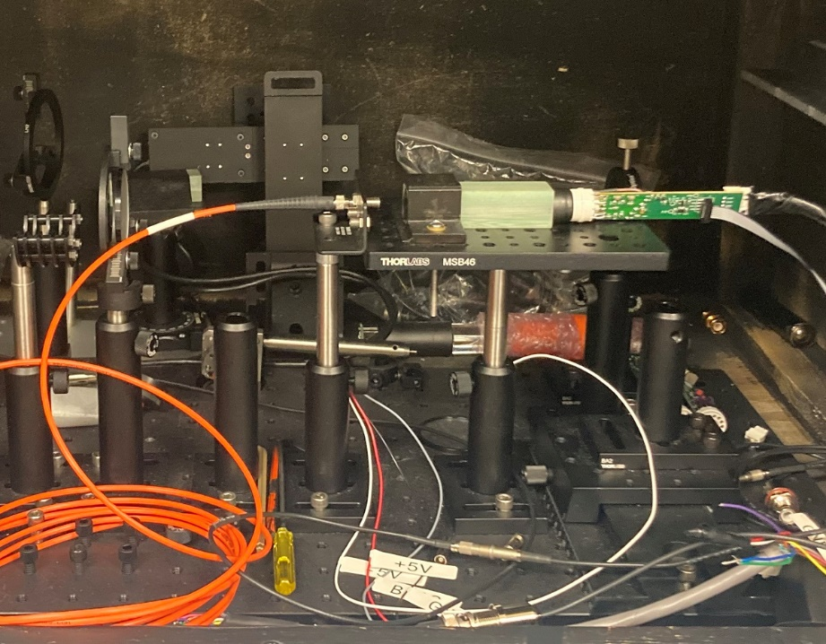

Figure 6 LED test setup in Fernando's lab. A PMT is attached to the base, and the LED pulses are brought in by the orange fiber cable.

The voltages out of the +-3V regulator chips were measured. The -3V was nominal, but the +3V test point gave -0.8V. These results were stable over a range of LV, and after repeated off/on cycles of the LV. It appears one of the voltage regulator chips in the 1st base has failed.

The inter-stage voltages of the 1st base were measured before the irradiation, so it was possible to look for changes afterward. The largest change was on the last stage, where the ΔV went from 33V to 35V. Because the supply voltage was fixed at 200V, this increase on the last stage leads to a small decrease on most previous stages. At the NPS production HV, the change in the gain would be at most -10%. These changes may be too small and too slow to be noticed in the NPS environment. This qualitatively confirms the statement in the NPS proposal to PAC40 in 2013

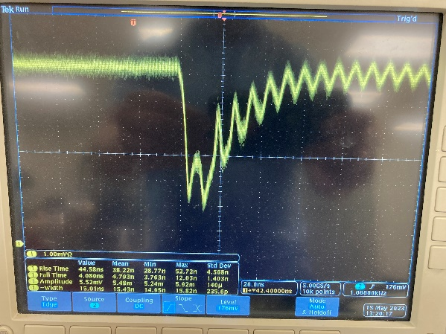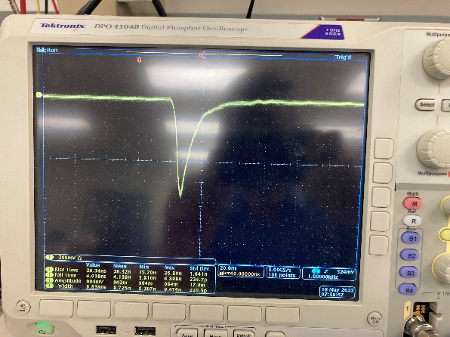

Figure 7 (Top) After increasing the LV to +-5V, the 1st damaged base yields a 5 mV pulse in the LED test setup. (Bottom) With the same PMT, an undamaged base gives a 950 mV pulse with a noticeably shorter fall-time. The operating HV for the PMT was 610V in both cases.

that they “found no degradation of the base for a radiation dose of 100 kRad”.[3] To be clear, that was for an older version of the active divider base which did not contain an amplifier or voltage regulator chips.

What drives these inter-stage voltage changes? It may not matter for NPS, but we’ll discuss it briefly since it will be relevant for future active dividers to provide cheap, stable HV for the SOLID GEMs. The resistors themselves are probably very rad-hard. As for the transistors, Jack Segal has noted that the performance of an active divider should be somewhat insensitive to rad-damage induced changes in the beta function of the transistors. (I.e., although the response to a dramatic load change may get slower, regulation should be achieved.) But the voltages in the transistorized section are set by ΔVi = Ii*Ri , and our measurements of the NPS base suggest the parallel leakage currents of the undamaged transistors are O(10)% of the current through the resistors. Thus our working hypothesis is that dose-dependent changes in the leakage resistance of the transistors is changing the current through these final resistors, and hence their ΔVi .

To conclude this section: it turned out to be surprisingly easy to kill an NPS base. From the literature on rad-damage in low noise amplifiers, we expected significant deterioration by O(10) kRad, but not outright death. This may be because the +-3V regulator chips are failing before the amplifier damage becomes obvious. Anyway, we needed to test another base to determine the threshold for damage more precisely.

**2nd Base Results**

The resolution of the next set of tests was a little more fine-grained. The 2nd base appeared healthy at 0.0, 0.5, 0.9, and 4.5 kRad. The dose rate was then reduced for a soak over the weekend. On Monday morning, it was found in an apparently inoperative state at a total dose of 10.4 kRad. (Note this was at the nominal LV supply voltages of +-3.5V.) Initial observations from the RadCon test range are summarized in Table 2.

The voltages out of the +-3V regulator chips were measured. The -3V was nominal, but the +3V was -0.8. However, these results change with the LV setting as well as with power cycles! Results from a quick test are summarized in Table 4. The voltage regulation chips appear to be very sick. This instability led to great confusion and frustration at the RadCon test range. It was unclear if we were incorrectly writing down the wrong amplifier DC output offset, or if it had truly changed after turning the power off, shifting a few cables, and turning the power back on.

We did not look for inter-stage voltage changes on the 2nd base because no baseline measurements were made before the irradiation.

Follow-up tests on the 2nd base were then done with a PMT and LED pulser. The pulse signal magnitude and the DC offset were studied as a function of low voltage. (See Table 3.) At +-3V and +-4V, the base had no useful gain, and the DC offsets were large. However, at +-5V, the gain of the base recovered to 90% that of an undamaged base. It still had a large DC offset though. (See Figure 8.)

Table 2 Results for the 2nd base from the RadCon test range.

|  |  |  |  |  |
| --- | --- | --- | --- | --- |
| **Base**  **ID** | **Dose Rate**  **kRad/hr** | **Time** | **Cumulative**  **Dose**  **kRad** | **Status** |
| NPS 8S  1ST 6 | 0 | 12:00 Thurs  May 11 | 0 | Pulser is sketchy. But rise- and fall-times OK.  Output DC offset -15mV. |
|  | 0.2 | 14:30 Thurs  May 11 | 0.5 | Pulser is sketchy. But rise- and fall-times OK.  Output DC offset -15 mV. |
|  | “” | 16:30 Thurs  May 11 | 0.9 | Pulser is sketchy. But rise- and fall-times OK.  Output DC offset now -16mV. |
|  |  | 10:25 Fri  May 12 | 4.5 | Pulser is sketchy. But rise- and fall-times OK.  Output DC offset now -14mV. |
| Stopped irradiation for a few hours. This particular base lacks the filter cap, and started oscillating,  so the input cable needed to be shortened. More connectors were needed. | | | | |
|  | 0.085 | 14:45 Fri  May 12 | 4.5 | Pulser is sketchy. But rise- and fall-times OK.  Output DC offset now -16mV. |
|  | “” | 10:00 Mon  May 13 | 10.4 | Complicated: Found oscillating with +100 mV offset.  Both LV were drawing current.  Power cycled to stop oscillation.  One LV current dropped to zero.  Output DC offset magnitude 650 mV.  No obvious pulse on amplifier output.  Apparently nonfunctional. |

Table 3 Results for the 2nd base from the LED test setup. When the LV was raised to +-5V on the 2nd base after 10.4 kRad, the gain largely restored to normal values. However the DC offset remained large.

|  |  |  |
| --- | --- | --- |
| **Base/LV setting** | **LED Pulse Magnitude** | **Output DC offset** |
| Control/ +-3V | 590 mV | -10 mV |
| Irradiated/ +-3V | No pulse visible | +1,000 mV |
| Irradiated/ +-4V | 20 mV | +260 mV |
| Irradiated/ +-5V | 530 mV | +360 mV |

Table 4 Sequential steps using the 2nd base which showed that the test point voltages depend on the supplied LV and can seemingly switch between good and bad after a power off/on cycle.

|  |  |  |
| --- | --- | --- |
| **LV** | **Voltage at -3V test point** | **Voltage at +3V test point** |
| +-5V | -3.0 | -0.8 |
| Power cycle | | |
| +-3.5V | +0.4 | +3.0 |
| +-5V | -0.4 | +3.0 |
| Power cycle | | |
| +-5V | -3.0 | -0.8  (back to initial state!) |

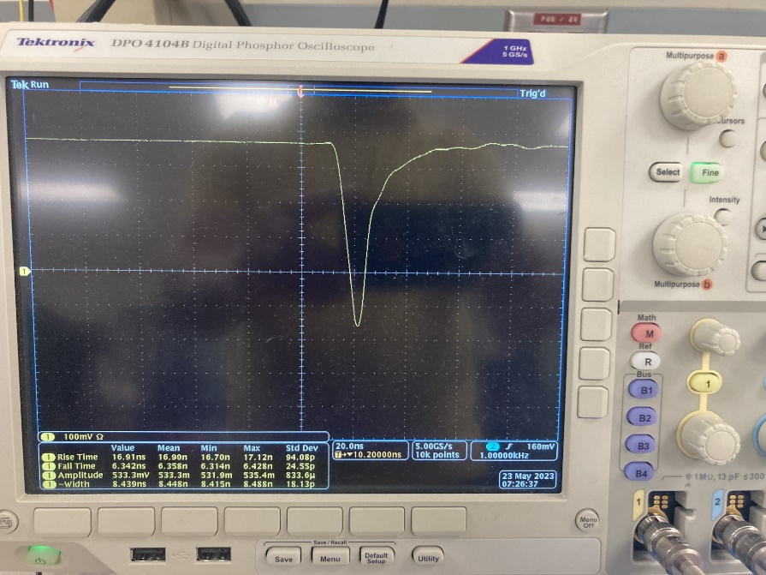

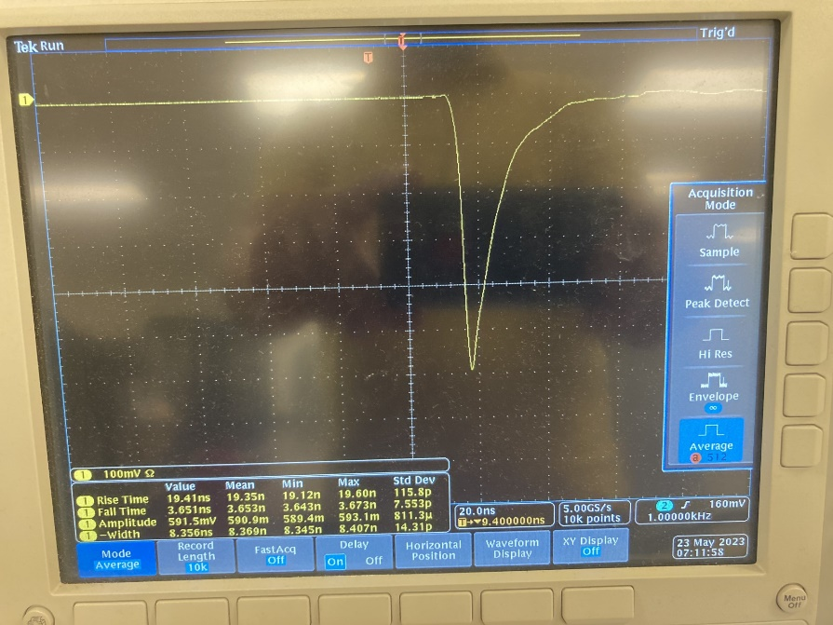

Figure 8 (Top) The 2nd base at +-5V LV after 10.4 kRad dose. Except for the large DC offset, the damage to the gain and the rise-time are tolerable. (Bottom) Signal at +-3V LV when using an undamaged base.

**Conclusion**

Assuming the bases have the LV set at +-5V, then in round numbers it looks like we can expect 4 stages of rad damage:

|  |  |  |
| --- | --- | --- |
| **Stage** | **Dose (kRad)** | **Expected condition of base** |
| 1 | 0-5 | no noticeable damage to gain, DC offset, rise-time, or fall-time |
| 2 | 5-10 | apparent transition region  (poorly sampled in our tests due to  limited access on the weekends) |
| 3 | 10-15 | possibly nonfunctional at 10 kRad due to large DC offset,  definitely nonfunctional at 15 kRad due to very low gain. |
| 4 | 15+ | definitely nonfunctional due to very low gain,  large DC offset issue as well |

A base is definitely dead if the gain gets too low. It’s less clear to us how fatal these large DC offsets are. But if the gain and offset change too rapidly, it will become very hard to set and maintain the FADC threshold, set and maintain the new software trigger, and monitor and recalibrate the gain. To make things worse, when the voltage regulation chips get sick, the amplifier output’s DC offset can change dramatically after a power cycle.

We probably want to conservatively stay well below 5 kRad of total electromagnetic dose, so some sort of monitoring is essential. Mitigation by the PI's could include things such as

* running the larger angle settings first,
* reducing the integrated luminosity at the smallest angle settings,
* shielding, and
* having plenty of spare bases.

**Acknowledgements**

Dave Hamlette for always pointing us in the right direction.

Melvin Washington and David Wallace for patiently hosting and assisting us on the RadCon test range.

Fernando Barbosa for circuit diagrams, careful instructions on how configure a Topward PS to deliver +-3.5V, use of the LED test setup, and discussions.

Chris Stanislav for making up the LV cable.

Jack Segal for discussions and loaning us a pocket pulser which we broke.

Brad Sawatzky for loaning us a pocket pulser which we also broke.

The EEL Room 109 Physics Electronics gang, who made available to us their superbly organized drawers of resistors.

Hamlet Mkrtchyan for finding the reference to his rad-damage tests on a much earlier version of the base.

**Appendix A**

The amplifier is the OPA8472D. A datasheet can be found at <https://www.ti.com/lit/ds/symlink/opa847.pdf?HQS=dis-dk-null-digikeymode-dsf-pf-null-wwe&ts=1687118694801&ref_url=https%253A%252F%252Fwww.ti.com%252Fgeneral%252Fdocs%252Fsuppproductinfo.tsp%253FdistId%253D10%2526gotoUrl%253Dhttps%253A%252F%252Fwww.ti.com%252Flit%252Fgpn%252Fopa847> .

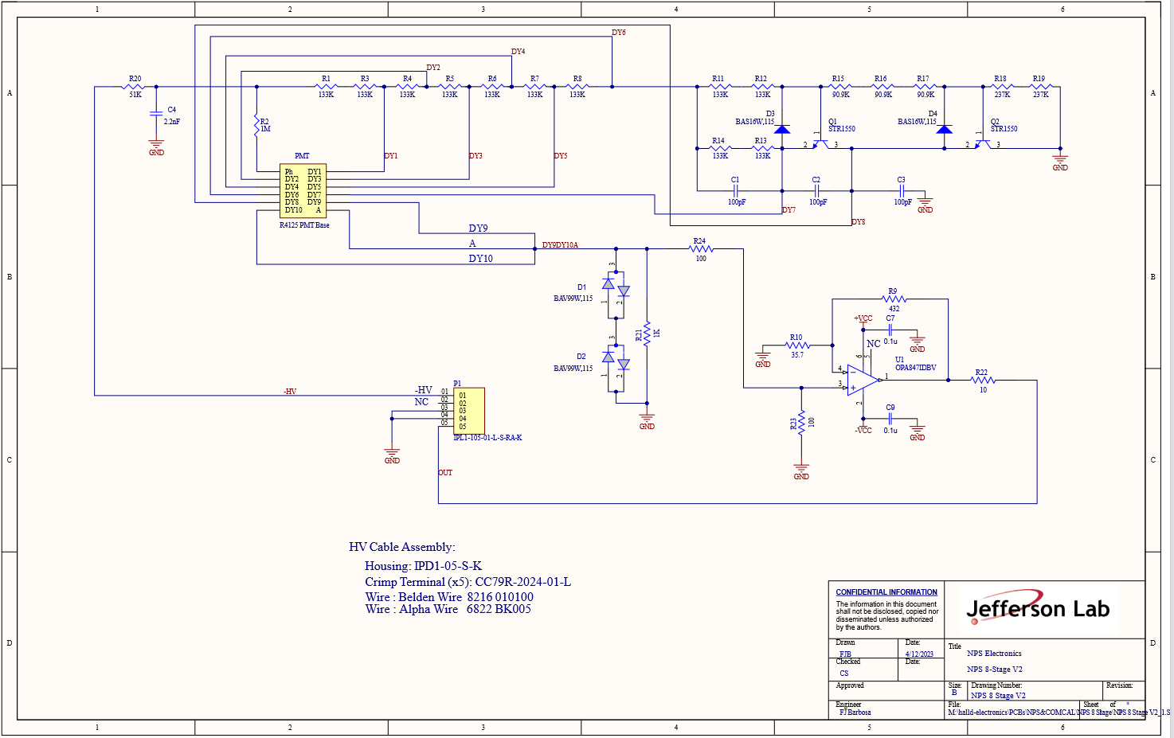

**Appendix B**

The voltage regulator is the MIC5270. A datasheet can be found at <https://ww1.microchip.com/downloads/en/DeviceDoc/mic5270.pdf> .

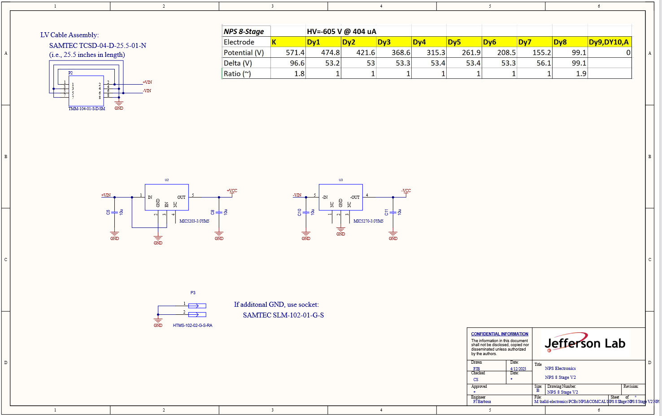

1. This assumes 1 kRad/hr in virgin PbWO4 blocks and 15 pe’s/MeV.
2. Calculations are available on Sheet 2 of the Excel file at <https://hallcweb.jlab.org/doc-private/ShowDocument?docid=1174> .
3. A poster with many more details says the base was rad-hard to 150 kRad. <https://hallcweb.jlab.org/doc-private/ShowDocument?docid=1223>