Preparation for running exp 12-11-107

Following a meeting at TAU with Paul Brindza, Or Hen, and Eli Piasetzky on 30 Jan 2012, enclosed is a summary of the preparation needed to run the experiment.
We plan to be at JLab Feb 2012 for the data mining collaboration meeting and would like if possible to start the design process.

LAD detector
- General Considerations:
  - LAD will be build using parts of the existing CLAS6 TOF system.
  - We have ~132 individual bars available, assembled in 12 panels (6 ‘short’ and 6 ‘long’).
  - We will not disassemble these 12 panels to individual counters, but instead use them as the LAD building blocks.
  - LAD needs to be positioned on the SHMS side of Hall-C, at a distance of ~4 meters from the target, covering large backward scattering angles (90º - ~180º).
  - Both proton and neutron detection capabilities are required.
- Guiding concept
  - Three planes (two long and one short) will be used as “stand alone” proton detectors.
  - These proton detection planes will be at the front of LAD, with the exposed side of the scintillator facing the target.
  - All other planes (four long and 5 short) will be used as neutron detectors.
  - These neutron detection planes should be packed as tight as possible and positioned as close as possible to the proton detection planes – to maximize the solid angle.
See figure 1 for a possibly packing and staging concept

- What needs to be done
  - Conceptual design of the super frame/frames to hold the panels.
  - Time line for design and construction
  - Budget estimate.
  - We would like to get the detectors as soon as possible and check them in the coming two years at JLab.
  - Place to store and work on CLAS detectors for LAD and a shelving system.
  - Hall C Techs have to be ready to receive the CLAS detectors at any time after May12, 2012 on short notice. Hall B will not do anything except remove carefully.

Scattering chamber
- General Considerations
  - Need to allow electron scattering angles of 13.5º and 17º.
OK no problem
  - Need to allow proton scattering at large backwards angles (90º-180º) at the SHMS side with maximal out of plane opening.
See below.
- Possibilities
  - Using one of the old Hall-C chambers (with small modification), rotated so that the SOS window is used for the LAD protons.
The original Hall C scattering chamber has a large height and large included angle SOS window.
If this is rotated to allow the -90-180 coverage we can include both spectrometers and beam lien in the HMS window. HMS window is ~ 10-90 degrees and SOS window is about -10 - -135 degrees. If we rotate 45 degrees toward SHMS we can get all the coverage. We need to check the height of the opening against the proton detector height and acceptance. The SOS window has the height assymetric upwards. Maybe use old chamber “upside down” so extra height is down or offset chamber to split on beam height or machine open chamber more. We don’t use this so we can mop to suite the LAD.
  - Design a new chamber, similar to the Hall-A Big-Bite chamber.
A new cylinder is about 100K$.
Need budget estimates and design for both alternatives.

Target and Beam-Line elements
- General Considerations
  - Need to use a long cryo-target to allow rejecting random ep coincidence with a vertex cut.
  - Need to keep non-target related background to a minimum
  - There are only two relevant spectrometer settings: 13.5º and 17º

- Possibilities
  - Use a 20-30cm, G0 like, deuteron cryo-target.
I will contact the target group about this.
  - Offset the beam from the center of the target in the direction of LAD to minimize proton energy loss.
Better to offset the target to keep background low and scattering angles in the spectrometers the same.
  - consider the possibility of using a Hall-B BONUS like deuterium gas target
  - Use a large diameter Exit vacuum beam-line to reduce background.
  - Use a Helium-balloon down stream of the exit window .
  - Vacuum coupling of HMS/SHMS/exit beam line?
While minimizing non-target related background, both the last two/three
options limit the minimum possible spectrometer angles. This should not affect us.

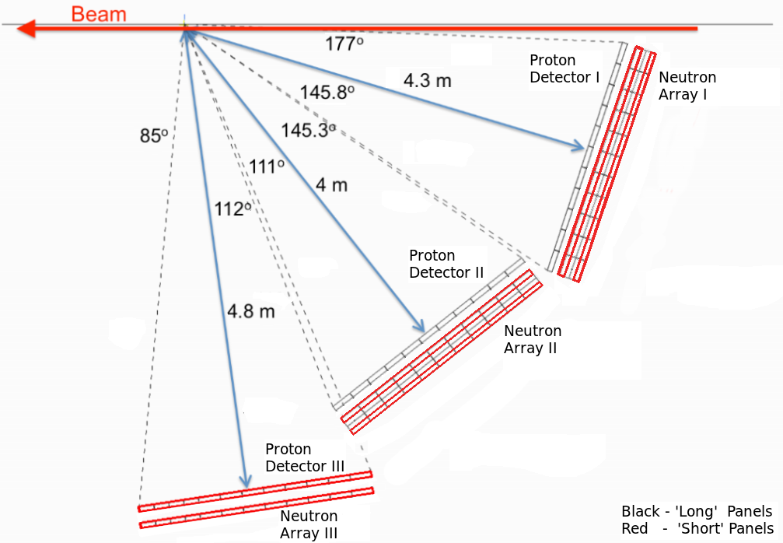

Figure 1: A schematic sketch of the proposed LAD layout.

