Dear Frederick and Amaury,

Thanks a lot for your formal response to my comments of March 17, 2014 about the drawings of helium vessel. Your response is extremely helpful to us. Based on your response, here are my comments.

1. Since you are going to fabricate the helium vessel in accordance with ASME 2010 Section VIII Division 1, your code analysis/calculation must be updated in compliance with ASME VIII Division 1. Please don’t forget to check buckling based on Division 1. A finite element analysis of the vessel following the Design-by-Analysis rules of ASME 2010 Section VIII Division 2 will not meet the design requirements of Division 1 because the design factor of Division 1 is 3.5 while the design factor of Division 2 is 2.4. Still, finite element analysis of the helium vessel is extremely useful because it can check the welds, the brackets, the suspension links, and the appropriate preloads, and whether the suspension links are under tension or compression.
2. I understand that the stress of the fillet welds was checked in your stress analysis report. However, since there are issues with the preload, temperature profile of the suspension link, and coefficient of thermal expansion of Nitronic 50 in the ANSYS model, the stress of the welds must updated once these issues are resolved. Stress criteria - allowable stress for the structural integrity - must be discussed and be consistent with OVC. Multi-zone meshing technique should be used with the fillet welds, and brackets. Since the welds and brackets are areas/volumes of concerns, reasonably finer meshes should be used. If possible, you should avoid using tetrahedral elements, and consider using groove welds reinforced with fillet melds because these welds are critical. Also, in your stress report, the shear stress of the welds should be checked by hand calculation based on the maximum actual reaction force in the suspension links.
3. You stress report must demonstrate that the suspension links are under tension, not compression, in all kinds of load sequences. The force in the suspension links are easy to check by plotting the reaction forces of the ball joint. 317111-jlab-he-Vessel-19-02-2014.wbpz, however, shows that there are compressive forces in the suspension links.

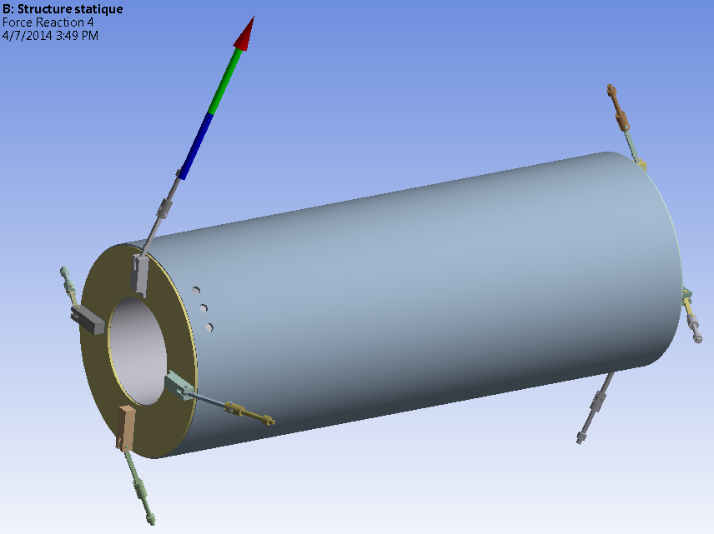

Thanks a lot,

Eric