N°1-24 April 2013 – Final Design Report, milestone D4

DOCUMENTS SUBMITTED FOR APPROVAL:
D4-Final Design Review:
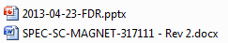
D5-QA/QC
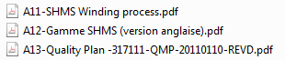
D7-Magnetic Analysis
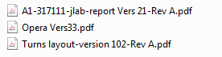
D8-Stress Analysis
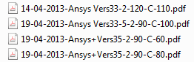
D9-Quench Analysis
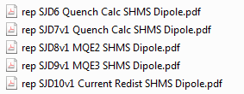
D10-Quench protection
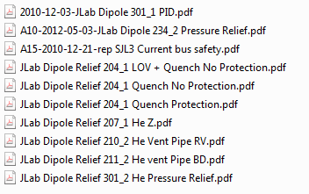

D11-Pressure analysis
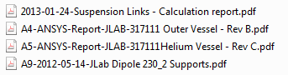
D11-Drawings package
Assembly
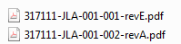
Coil
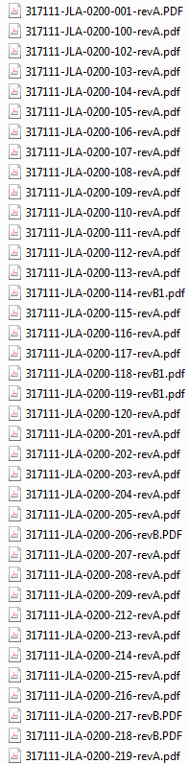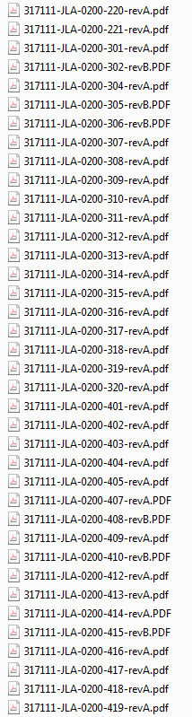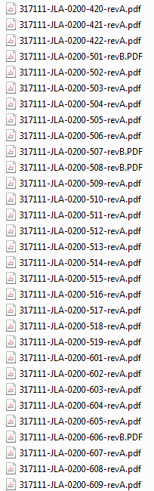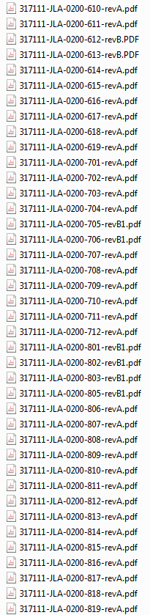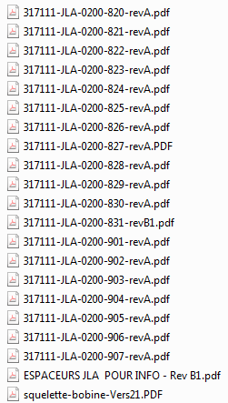

Conductor
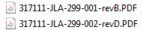

Cold mass
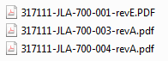
Outer vessel
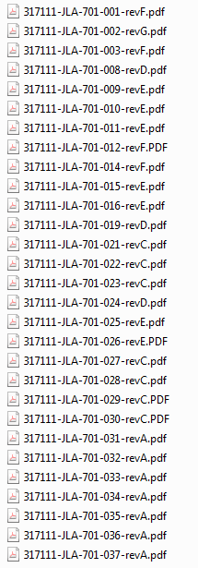
Radiation Screen
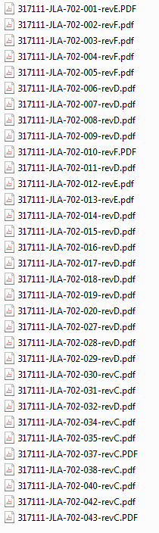
Helium Vessel
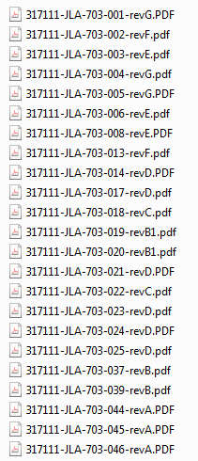
Force rings
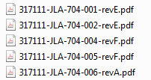
Transport suspension
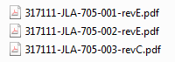
Suspensions Links
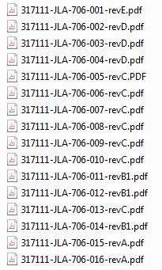
PID

CUSTOMER ANSWERS:
Please send back directly this document by e-mail to fforest@sigmaphi.fr
Caution: reply time longer than 2 weeks may postpone the magnet delivery time
Caution: new request made after approval may add extra-cost in time design and manufacturing

- Items listed above are APPROVED with the following comments:

To do list to complete the documents before manufacturing:

Contract
- Amendment about the risks sharing related to the conductor

D5-QA/QC
- Update the documents with :
- Conductor consolidating process
- Coil vacuum impregnation process
- Vessel parts subcontracting
- Completion date: 19/07/2013
D6-Magnet traveler
To be done
- Completion date:19/07/2013
D7-Magnetic analysis
- Update the Opera model with the turns layout based on the consolidated conductor dimensions to check the field harmonics
- Completion date: 15 May 2013
D8-Stress analysis
- Upgrade the Ansys model with the non linear stress/strain curve measured at 80K
- Do the simulation at several collaring temperatures to simulate the pre loading tolerances
- Completion date: 14 june 2013
D11-Pressure analysis
- Select the vessels parts subcontractor
- Completion date: 15 May 2013
- Complete the weld design review and analysis with the subcontractor
- Update the vessels drawings
- Complete the FEA calculations and do the design approval with Apave
- Completion date: 19 July 2013
- Do the welds qualification and welders qualification at the subcontractor facility
- Completion date: 18 October 2013
D15-Drawings package
- Modify the spacers geometry to be consistent with the Opera model and the consolidated conductor dimensions
- Completion date: 15 May 2013
- Update the welds design with the vessels parts subcontractor
- Validate the tolerances build up between the vessels inner bore
- Completion date: 19 July 2013
- Define some temporary collars to measure the real coil modulus and initial stress/strain lag
- Completion date: 19 July 2013

Customer Name: Date:

