This document describes only the product parameters. See the Quality Plan for the process and control description.

SUMMARY

2. REVISION RECORD 2

3. CUSTOMER REFERENCE DOCUMENTS 2

4. DESIGN RESPONSIBILITY 2

5. CUSTOMER SPECIFICATION COMPLIANCE MATRIX 2

6. SYSTEM COMPOSITION 2

7. CUSTOMER INTERFACES 5

8. DIPOLE MAGNETIC PARAMETERS 6

9. SUPERCONDUCTING CONDUCTOR PARAMETERS 7

10. SUPERCONDUCTING COIL PARAMETERS 8

11. MAGNETIC STEEL PARAMETERS 9

12. QUENCH PROTECTION PARAMETERS 9

13. MECHANICAL PARAMETERS 9

14. CRYOGENICS PARAMETERS 10

15. ASME BOILER AND PRESSURE VESSEL CODE 12

16. VACUUM VESSEL PARAMETERS 12

17. ELECTRICAL AND POWER SUPPLY PARAMETERS 12

18. SENSORS PARAMETERS 13

19. SYSTEM CONTROL PARAMETERS 13

20. REGULATIONS AND LABELLING PARAMETERS 14

21. MAGNETIC MEASUREMENT – ROTATING COIL 14

# REVISION RECORD

|  |  |  |
| --- | --- | --- |
| DESCRIPTION | REVISION | DATE and AUTHOR |
| Creation | 1 | 25/11/2011 – FF |
| Changing of impregnation process (VPI), consolidation of the conductor at 2.95mm | 2 | 17/04/2013 - AP |

# CUSTOMER REFERENCE DOCUMENTS

|  |  |
| --- | --- |
| Date | Customer documents |
| 07/12/2009 | SHMS superconducting dipole technical specification - JLAB - Ref 67115-SPEC-00020 - December 7, 2009 |
|  |  |

# DESIGN RESPONSIBILITY

The magnet dimensions and parameters proposed are based on the JLAB reference design provided with the tender specification. Sigmaphi has performed a full set of magnetic, mechanical, electrical and thermal calculations in order to optimize and validate the final design.

Due to conductor quality issue Sigmaphi’s responsibility shall be agreed in a specific contract amendment.

CUSTOMER SPECIFICATION COMPLIANCE MATRIX

See the document: 

SYSTEM COMPOSITION

Magnet schematic overview:

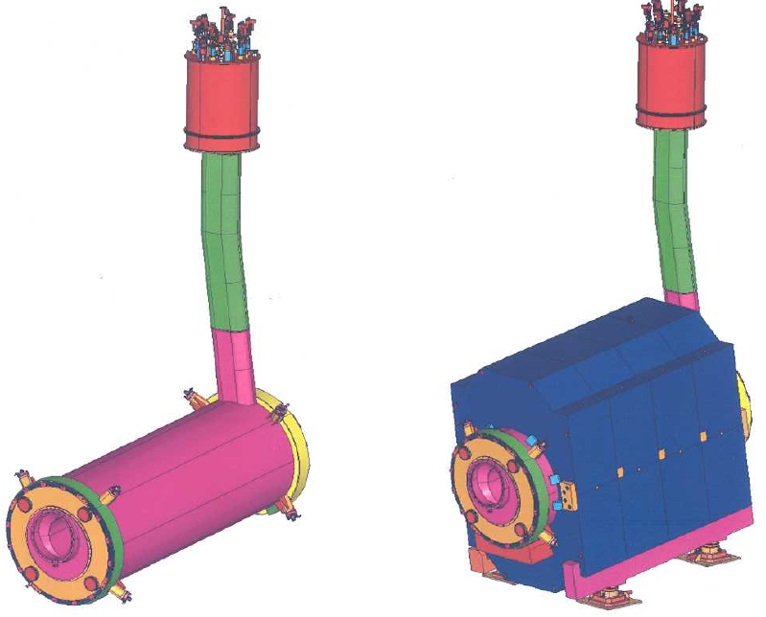

*Dipole SHMS overview (courtesy of JLAB)*

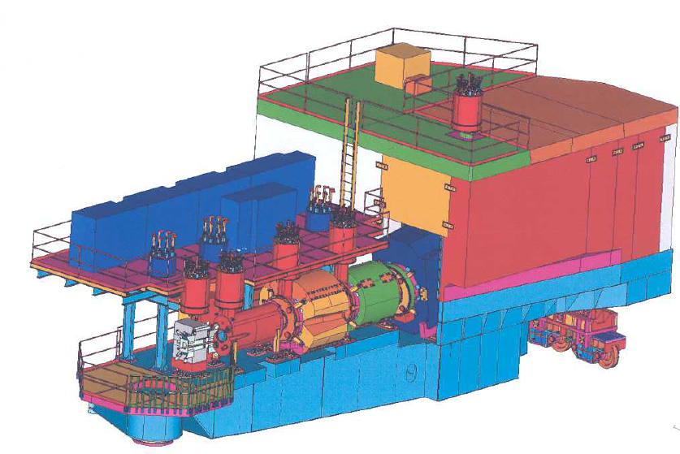

*)*

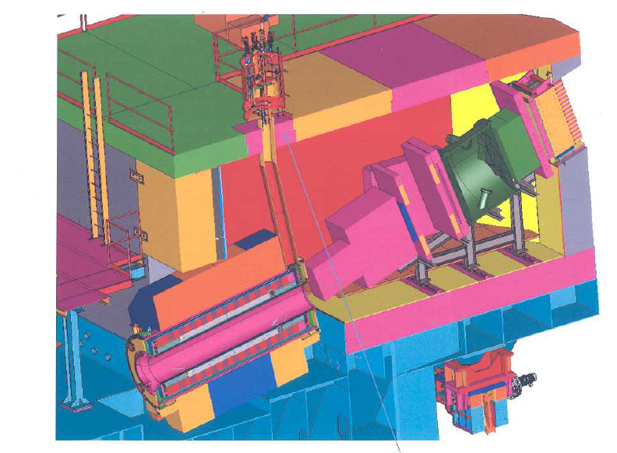

*Installation overview (courtesy of JLAB)*

The magnetic system delivered by Sigmaphi includes the superconducting coil and its cryostat.

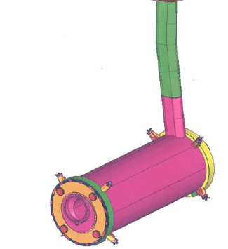

*Superconducting coil and cryostat delivered by Sigmaphi*

|  |
| --- |
| COMPONENTS |
| Superconducting coil  Superconducting composite conductor (supplied by JLAB)  Conductor consolidated by Sigmaphi at 2,95mm  Fiberglass insulation and VPI (Epoxy resin CTD-101-K)  Aluminum collars |
| Coil monitoring  Voltage taps |
| Helium vessel |
| Helium piping |
| Helium monitoring  Temperature sensors and wiring |
| Helium vessel multi layer insulation |
| Nitrogen radiation screen |
| Nitrogen piping |
| Nitrogen monitoring  Temperature sensors and wiring |
| Nitrogen radiation screen multi layer insulation |
| Outer vessel  Beam vacuum chamber interfaces  Yoke mechanical interfaces |
| Coil suspension links |
| Suspension link monitoring  Strain sensors and wiring |
| Shipping support |
| Documentation  Technical specification  Drawings and 3D model  Magnetic simulation report on the coil  Mechanical and Thermal simulation report on the coil  Pressure vessel design reports according to ASME BPV  Mechanical and Electrical Control reports  Pressure vessel manufacturing and testing reports according to ASME BPV  Magnetic measurement report |

# CUSTOMER INTERFACES

|  |  |  |
| --- | --- | --- |
| PARAMETERS | Customer specification | SIGMAPHI specification (contractual) |
| System installation |  | The cryostat and the chimney are delivered separately  The assembly, welding and control work to attach the chimney to the cryostat and the chimney to the cryogenic control reservoir is done by JLAB employees.  Especially this work includes:   * SC cable junction soldering and control * Instrumentation wires routing * Helium piping welding and control * Nitrogen piping welding and control * Multilayer insulation and control * Vacuum piping welding and control |
| Critical overall dimensions and space constraints | Outer dimensions according to JLAB 3D model | Ok  See Sigmaphi drawing and 3D model for details |
| Mechanical fixation and support | 2 x 4 pads located on the outer vessel according to JLAB 3D model | Ok  See the Sigmaphi drawings and 3D model for details |
| Alignment references (3.0) | Magnetic center measured and transferred on the cryostat with an accuracy of +/- 0,25 mm | Magnetic center measured at room temperature, low current and without the iron yoke.  The magnetic axis location is measured related to fiducial holes H7 machined on the outer vessel cryostat with an accuracy of +/- 0,25 mm |
| Other requirements |  | Cooldown, magnetic measurement and acceptance tests at maximum current are done at JLAB by JLAB employees |

# 

# DIPOLE MAGNETIC PARAMETERS

|  |  |  |  |
| --- | --- | --- | --- |
| PARAMETERS | Customer specification | SIGMAPHI specification (contractual) | SIGMAPHI calculation  (information) |
| Opera file version |  |  | Version 33 |
| Operating frequency | DC | DC |  |
| Turns number per pole (1.6) | 608 | 585  The number of turns between the lower pole and upper pole is adjusted to be the same in each symmetrical block | 606 |
| Nominal current – Inom (1.6) | 3150 A | 3350 A | Nominal current is changed because conductor thickness & turns number are modified. |
| Maximum current – Imax (1.6) | 3500 A | 3685 A (103% Inom) | 3557,5 A |
| Sigmaphi responsibility test current (1.6) | 3465 A | 60% Inom |  |
| Maximum Ampere turns per pole @ Imax (1.6) | 2,128.E6 At | 2,156.E6 At | 2,156.E6 At |
| Nominal field – Bo @ Inom (1.6) | 3,86 T | 3,87 T |  |
| Maximum field – Bmax @ Imax (1.6) | 4,25 T  Field orientation horizontal | ≥ 4,10 T  Field orientation horizontal | 4.26 T |
| Nominal integrated field @ Inom |  | 11 T.m |  |
| Maximum integrated field @ Imax (1.6) | 12,3 T.m | ≥ 12 T.m | 12.038 T.m |
| Maximum effective length @ Imax (1.6) | 2,90 m | 2,9 m +/- 0,2 m | 2.86 M |
| Free inner bore diameter (1.6) | 600 mm | 590 mm +5/-5 mm to approved |  |
| Operating stored energy (1.6) | 13,4 MJ |  |  |
| Maximum Stored Energy (1.6) | 16,2 MJ | ≈ 16 MJ | 16.07 MJ @ Imax |
| Magnet Inductance (1.6) | 2,7 H | ≈ 2,4 H according to the real number of turns per pole | 2.86 H |
| Good field region dimensions (1.6) | Reference radius R250mm | Reference radius R250mm | Reference radius R250mm |
| Integrated harmonics coefficient (1.6) | b3: +2%  b5: -1%  b7: +0,5%  b9: -0,5%  Σ ∫ B(n>9)/ B(1) All Others |0.1 %| | Measured at room temperature, low current, without iron yoke performed by Sigmaphi  Measurement at Inom with the iron yoke performed by JLAB | Calculated @ Imax  b3: 0,19  b5: 0.06  b7: 0.03  b9: 0.03 |
| Coil operating peak field (1.6) | 4,92 T | Not contractual |  |
| Coil maximum peak field | 5,41 T | Not contractual | 5.57 T |
| Yoke peak field |  | Not contractual | 1.88 T |

SUPERCONDUCTING CONDUCTOR PARAMETERS

|  |  |  |
| --- | --- | --- |
| PARAMETERS | Customer specification | SIGMAPHI specification (contractual) |
| Strand material (1.6) | NbTi-Cu | *JLAB responsibility* |
| Strand copper / SC ratio (1.6) | NbTi 1,8:1 | *JLAB responsibility* |
| Strand dimensions (1.6) | 0,065 mm | *JLAB responsibility* |
| Rutherford cable – number of strands (1.6) | 36 strands | *JLAB responsibility* |
| Rutherford cable dimensions (1.6) | 11,7 mm x 1,3 mm  *Trapezoidal shape 1,053 mm - 1,259 mm x 11,68 mm* | *JLAB responsibility* |
| Critical current (Temperature, Field) (1.6) | Ic @ 4,2 K and 5T = 12333 A  Ic @ 4,2 K and 6T = 9875 A  Ic @ 4,2 K and 7T = 7416 A | *JLAB responsibility* |
| Temperature margin at Imax,Bmax (1.6) | 1,6 K | *JLAB responsibility* |
| Solder (1.6) | Pb (60%) Sn (40%) | *JLAB responsibility* |
| Stabilizer material (1.6) | OFHC copper | *JLAB responsibility* |
| Stabilizer RRR (1.6) | RRR (300K/4,5K) = 120 before consolidation according to JLAB’s measurements | *JLAB responsibility* |
| Stabilizer dimensions (1.6) | -Initial 18,75 mm x 3,5 mm   * -New design proposed on November 2011: 18,69 mm x 3,25 mm * (0,736” x 0,128”) | 18,73 mm x 3,166 mm - 3,118 mm considered as the reference dimensions (based on November 2011 samples stacked by 10 and measured) |
| SC soldered conductor dimensions after consolidation at 2,95mm | 3,02mm <= Thickness after consolidation <= 3,10mm  18,85mm <= Width after consolidation <= 19,20mm | -Measurements on all reels before and after consolidation  -Average thickness = 3,05mm  -Maximal width = 19,2mm  -A derogation will be required in case of dimensions out of tolerance. |
| SC conductor spool dimension (1.6) | Diameter 2438 mm (96”) | Ok |
| SC conductor insulation material and thickness (1.6) | 1 dry tape half overlapped  - Width = 30mm  - Theoretical thickness = 0,25 mm | - Practical thickness = 0,225 mm  - Practical thickness per side = 0,45mm |
| Superconducting conductor insulated cross section (1.6) | 3,95 mm x 20,2 mm | -The practical thickness of insulated conductor have been verified thanks to an assembly of conductors between midplane and intermediary spacer.. |

# 

# SUPERCONDUCTING COIL PARAMETERS

|  |  |  |
| --- | --- | --- |
| PARAMETERS | Customer specification | SIGMAPHI specification (contractual) |
| Coil winding type (1.6) | Cosinus (Ɵ) 2 sectors  “Sun ray conductor layout”  Sector 1 90°-48,4 °  Sector 2: 39,6° – 24°  Turns layer 1 65 25 = 90  Turns layer 2 68 26 = 94  Turns layer 3 72 27 = 99  Turns layer 4 76 28 = 104  Turns layer 5 79 29 = 108  Turns layer 6 83 30 = 113 | Cosinus (Ɵ) 2 sectors  “parallel stack conductor layout”  See the Sigmaphi coil technical specification 317111-SPEC-COIL-Dipole JLAB.pdf for the details  Turns layer 1 65 + 23 = 88  Turns layer 2 69 + 23 = 92  Turns layer 3 73 + 23 = 96  Turns layer 4 76 + 23 = 99  Turns layer 5 80 + 23 = 103  Turns layer 6 84 + 23 = 107 |
| Insulation between each coil layer (1.6) | Fiber glass G10 - 0.5 mm thick | Ok |
| SC conductor total length and weight per magnet |  | Lengths calculated by Sigmaphi for one dipole coil:  Layer #1+#2 = 1235 meters (Dipole E)  Layer#3+#4= 1377 meters (Dipole F)  Layer#5+#6= 1525 meters (Dipole G)  6 spools (2E+2F+2G) are required for one dipole magnet  *Note: the initial spool length is increased due to the copper thickness reduction* |
| Coil splices location |  | Double pancake winding without inner splices  1 splice between each double pancake (located at the winding outer) |
| Coil ground insulation material and thickness |  | Fiber glass and epoxy resin  Thickness 2-5 mm |
| Collar materials (6.4.10) | Aluminium 6061  Collars segmented for eddy current limitation | Aluminium 5083  Collars segmented and anodized for eddy current limitation  Anodization thickness ≥ 40 microns (insulation voltage breakdown≥ 500 Vdc) |
| Coil collaring temperature interference fit | 100 K | 90°C to be confirmed (interference temperature 90-22=68°C) |
| Turn to turn electrical test (6.2.5)(6.26) | Overall Hipot tests, fast voltage discharge set at 200 V  Inductance test "Coil ringing" according to IEEE Std 4-1978 (2 waves 500 V peak) | Ok  Ok |
| Ground electrical test (6.2.5) | Coil shall be tested at 1000 V DC in dry air or N2 | Ok, in air |

# MAGNETIC STEEL PARAMETERS

JLAB responsibility

# QUENCH PROTECTION PARAMETERS

|  |  |  |  |
| --- | --- | --- | --- |
| PARAMETERS | Customer specification | SIGMAPHI specification (contractual) | SIGMAPHI calculation |
| Coil Minimum Quench Energy (MQE) |  | Not contractual | Between 20 mJ and 1 mj |
| Discharge time constant (1.6) | ≤ 36 s | JLAB’s responsibility |  |
| Coil maximum temperature during a quench |  | < 100 K with protection resistor | < 160K with no protection resistor |
| Coil maximum voltage during a quench |  | < 100 V with protection resistor | < 200V with no protection resistor |
| Current leads life time without cooling at nominal current |  | JLAB’s responsibility |  |
| Current lead maximum temperature during a leads quench |  | JLAB’s responsibility |  |

# MECHANICAL PARAMETERS

|  |  |  |
| --- | --- | --- |
| PARAMETERS | Customer specification | SIGMAPHI specification (contractual) |
| Overall dimensions | According JLAB 3D model | ≈ 4260 x 1630 x 2800 mm  See the Sigmaphi drawing 317111-JLAB-001-001 and 3D model for details |
| Coil weight |  | Coil assembly before collaring: ≈ 8,41 tons  Force rings: 5,92 tons  Coil collared: 14,33 tons |
| Vessels weight |  | Helium vessel: 3,91 tons  Radiation screen: ≈ 0,98 ton  Outer vessel: 4,25 tons |
| Cryostat final assembly weight (1.6) (1.9) | 20 tons  Maximum crane capacity 20 tons | 23,6 tons  Enough crane capacity must be provided by JLAB |
| Coil location adjusting range | +/- 3 mm | Ok |
| Coil centering tolerances (1.6) | +/- 1 mm | JLAB responsibility |
| Suspension links material (6.4.2.2) | Titanium Ti-6Al-4V  Nitronic 50 stainless steel | Ok |
| Suspension links orientation (6.4.2.2) | 45° / 22,5 ° | Ok |
| Maximum force applied on the suspension links | Force exerted by gravity on each suspension link: 7,2.104 N  Maximum force exerted one each suspension link in the worst case scenario (coil off centered by 3 mm and lateral acceleration of 1g : 1,7.105 N | According to analytic calculation note:  -Maximal force when gravity is applied: 91000 N  -Maximum force exerted on suspension links in the worst case scenario (coil off centered by 3 mm, lateral acceleration of 1g and internal pressure = 6 bars): 236 kN |
| Suspension link preload at room temperature |  | 45,5 kN in average |
| Assembly clearances |  | See the Sigmaphi drawing 317111-JLAB-001-001 |
| Thermal deflections (6.3.2) | To be documented |  |

# CRYOGENICS PARAMETERS

|  |  |  |
| --- | --- | --- |
| PARAMETERS | Customer specification | SIGMAPHI specification (contractual) |
| Helium cooling mode | Liquid Helium bath, natural convection | Ok |
| Nitrogen cooling mode | Liquid Nitrogen bath, natural convection | Ok |
| Helium total Heat load (1.6) | 40 W | ok except for the Cryogenic Control Reservoir that is not included |
| Nitrogen total Heat load (1.6) | 100 W | ok except for the Cryogenic Control Reservoir that is not included |
| Current lead heat load (1.6) | 3 W @ 0 A  6W @ 5000 A  Helium consumption: 1,8 L/Hr/kA | JLAB responsibility |
| Cooldown mode general description (1.6) | 250K to 80K Helium flow rate (3 atm) 10 grams/sec  4.5K Helium flow rate (3 atm) 5 grams/sec | JLAB responsibility |
| Cooldown duration | ≤ 10 days from 300 K to 4,5 K  Maximu difference temperature 50 K in the magnet | JLAB responsibility |
| Liquid Helium consumption for cooldown |  | JLAB responsibility |
| Liquid Nitrogen consumption for cooldown |  | JLAB responsibility |
| Magnet operating time without helium cooling |  | JLAB responsibility |
| Helium consumption in normal operating mode |  | JLAB responsibility |
| Nitrogen consumption in normal operating mode |  | JLAB responsibility |
| Hold on time without cooling (6.3.7) | 1 hour | JLAB responsibility |
| Liquid helium volume | 330 Liters | Ok |
| Liquid helium weight | 41,3 Kg | Ok |
| Helium Normal operating temperature and pressure (1.6) | 4,4 K and 1,2 atm absolute | Ok |
| Helium Design pressure  (defined as the most severe condition of coincident temperature and pressure expected in normal operation) | 6 atm absolute (5,88 bar) | Ok |
| Helium Maximum allowable working pressure | 6 atm absolute (5,88 bar) for the temperature range of 4K to 300 K | Ok |
| Helium Relief valve setting ] | 60 psig (4,14 bars / 4,22 atm) | JLAB responsibility |
| Helium Rupture disc setting | 75 psig (5,17 bar / 5,27 atm) | JLAB responsibility |
| Helium leakage test (6.4.9) | ≤ 10-9 mbar.l/s | ≤ 10-9 mbar.l/s |
| Pneumatic pressure test |  | 7,5 bars |
|  |  |  |
| Nitrogen volume |  | To be defined |
| Liquid Nitrogen weight |  | To be defined |
| Nitrogen Normal operating temperature and pressure |  | 1 atm absolute |
| Nitrogen Design pressure  (defined as the most severe condition of coincident temperature and pressure expected in normal operation) |  | 6 atm |
| Nitrogen Maximum allowable working pressure |  | 6 atm absolute (5,88 bar) for the temperature range of 70K to 300 K |
| Nitrogen Relief valve setting | 60 psig (4,14 bars / 4,22 atm) | JLAB responsibility |
| Nitrogen Rupture disc setting | 75 psig (5,17 bar / 5,27 atm) | JLAB responsibility |
| Helium leakage test (6.4.9) | ≤ 10-9 mbar.l/s | ≤ 10-9 mbar.l/s |
| Pneumatic pressure test |  | 7,5 bars |

# ASME BOILER AND PRESSURE VESSEL CODE

|  |  |
| --- | --- |
| Customer specification | SIGMAPHI specification (contractual) |
| ASME Code for Pressure Piping   * B31.3 Process Piping | Ok |
| ASME Boiler and Pressure Vessel Code   * Section II: Materials, Part D * Section V: Non destructive Examination * Section VIII: Rules for Construction of Pressure Vessels (Div. I and II) * Section IX: Welding and Brazing Qualifications | Ok |
| 1.11.3 Miscellaneous ASME code  Y14.5 Dimensionning and Tolerancing,  B16.9 Factory made Wrought Steel Butt Welding fittings, | Ok |

# VACUUM VESSEL PARAMETERS

|  |  |  |
| --- | --- | --- |
| PARAMETERS | Customer specification | SIGMAPHI specification (contractual) |
| Cleaning |  | Cleaning with alcohol or aceton and water rinsing |
| Helium leakage test – insulating vacuum space (6.4.9) | ≤ 10-9 mbar.l/s | ≤ 10-9 mbar.l/s |
| Insulating vacuum space cold getter material | Not specified | Not included |
| Helium leakage test – inner bore 6.4.9 | ≤ 10-9 mbar.l/s | ≤ 10-9 mbar.l/s |
| Operating vacuum | Not specified | ≤ 10-4 mbar |
| Design pressure (6.4.9) | Inner vacuum and internal pressure 1,5 bar above the atmospheric pressure |  |
| Drop off plate in case of inner over pressure | Not specified | Not included on the coil cryostat, should be installed on the CCR by JLAB |

# ELECTRICAL AND POWER SUPPLY PARAMETERS

|  |  |  |
| --- | --- | --- |
| PARAMETERS | Customer specification | SIGMAPHI specification (contractual) |
| Power supply delivery | JLAB responsibility | Ok |
| Polarity mode | Bipolar | Ok |
| Frequency mode | DC | Ok |
| Operating output current range 1.6 | 0 to 4000 A | Ok |
| Voltage drop included for the electrical cables between the magnet and the power supply | JLAB responsibility | Ok |
| Maximum output voltage (1.6) | +/- 6V | Ok |
| Current stability (1.4.4) | 10 ppm | Ok |
| Discharge resistance | 0,075 Ohm | Ok |
| Charging duration (1.6) | ≤ 0,5 hour | Ok |
| Charging voltage | ≤ 6 V | Ok |
| Discharge voltage (1.6) | ≤ 300 V | Ok |
| Power supply interfaces and remote control | JLAB responsibility | Ok |
| Quench voltage detection circuit threshold | ≤ 10 mV | Ok |
| Safety interlocks | JLAB responsibility | Voltage taps between each double pancake supplied by Sigmaphi |

SENSORS PARAMETERS

|  |  |  |
| --- | --- | --- |
| PARAMETERS | Customer specification | SIGMAPHI specification (contractual) |
| Temperature sensors above 60 K (8.1.1) | Pt 100 above 60K, 100 Ohms  location according dwg 67125-E-0110, 67115-E-0007(1/2), 67115-E-0004 (2/5),67115-E-0001(3/4) | Ok, supply and installed by Sigmaphi |
| Temperature sensors below 60 K (8.2.1) | Carbon sensor below 60K  location according dwg 67125-E-0110, 67115-E-0007(1/2), 67115-E-0004 (2/5),67115-E-0001(3/4) | Ok, supply and installed by Sigmaphi |
| Strain gauges (8.6) | 2 gauges by tension link, according dwg 67115-E-00012 and 67125-E-00112  calibrated in ksi | Ok, supply and installed by Sigmaphi k |
| Voltage taps (8.7) | Dual voltage tap, according dwg 67125-E-0111 (5/5) | Ok, supply and installed by Sigmaphi |
| Voltage taps (8.7) | Voltage taps protected by a minimum serie resistance of 200 K Ohms | JLAB responsibility (resistance located inside the CCR) |
| Others sensors (8) | Supplied and installed by JLAB inside the CCR | Ok |

SYSTEM CONTROL PARAMETERS

|  |  |  |
| --- | --- | --- |
| PARAMETERS | Customer specification | SIGMAPHI specification (contractual) |
| Sensors monitoring | JLAB responsibility | Ok |
| Cooldown control | JLAB responsibility | Ok |
| Power supply control | JLAB responsibility | Ok |
| Quench detection | JLAB responsibility | Ok |

# REGULATIONS AND LABELLING PARAMETERS

|  |  |  |
| --- | --- | --- |
| PARAMETERS | Customer specification | SIGMAPHI specification  (contractual) |
| Safety regulations (11.4) | Magnet Safety and Acceptance Test Plan review at JLAB | Ok |
| Magnet identification plate |  | Identification engraved plate attached to the cryostat |

# MAGNETIC MEASUREMENT – ROTATING COIL

|  |  |  |
| --- | --- | --- |
| PARAMETERS | Customer specification | SIGMAPHI specification |
| Measurement radius and length | Reference radius R250 mm | Ok, Measurement radius R250 mm and measurement length 5000 mm |
| Integrated harmonics coefficient, number of currents | Measurement @ 50 A, room temperature, accuracy 1,5 %  Measurement done before and after installation inside the cryostat | Ok  Measurement done at Sigmaphi without the iron yoke |