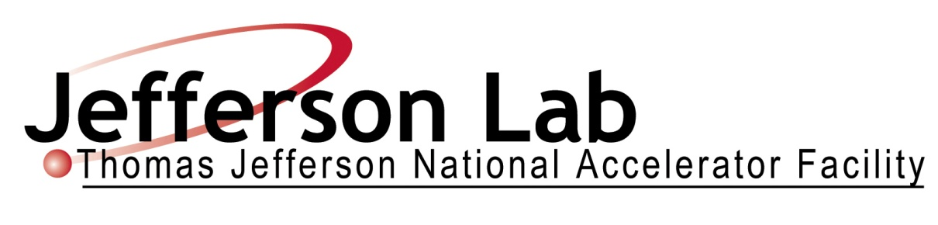

SHMS SUPERCONDUCTING DIPOLE
TECHNICAL SPECIFICATION

THOMAS JEFFERSON
NATIONAL ACCELERATOR FACILITY
December 7, 2009
Paul Brindza

Technical Specification
Specification 67115-SPEC-00020

Approved ________________________________________ Date_______________
Paul Brindza – JLab Technical Representative

Approved ________________________________________ Date_______________
Howard Fenker – 12 GEV Hall C CAM

Approved ________________________________________ Date_______________
Paul Collins – 12 GEV Safety Manager

Approved ________________________________________ Date_______________
Bruce Lenzer – JLab QA/CI Manager

Approved ________________________________________ Date_______________
Glenn Young – 12 GEV Physics APM
Summary of Revisions Date
Draft Edition for Comment Nov. 20, 2009
Initial Bid release Dec. 7, 2009

Table of Contents
1.0 STATEMENT OF WORK 9
1.1 General Overview 9
1.2 Scope of Work 9
1.3 Information Furnished by Jefferson Lab Prior to Award 10
1.4 Items Furnished by Jefferson Lab after Award 10
1.5 Responsibility 11
1.6 SHMS Dipole Requirements Summary 13
1.7 SHMS Dipole Design Documentation 18
1.8 Acceptance Testing 18
1.9 Shipping and Delivery 19
1.10 Warranty and Spare Parts 20
1.11 Applicable Documents 20
1.11.1 ASME Code for Pressure Piping 20
1.11.2 ASME Boiler and Pressure Vessel Code (see Paragraph 6.4.2) 20
1.11.3 Miscellaneous ASME Codes 21
1.11.4 NEMA and NEC 21
1.11.5 Institute of Electrical and Electronics Engineers (IEEE) 21
1.11.6 American Welding Society 21
1.11.7 American Society for Testing and Materials 21
1.11.8 Compressed Gas Association 22
1.11.9 American Conference of Governmental Industrial Hygienists 22
1.11.10 Physical Properties 22
2.0 MAGNETIC PERFORMANCE REQUIREMENTS 23
3.0 MECHANICAL PERFORMANCE REQUIREMENTS 25
4.0 LIST OF DIPOLE REFERENCE DESIGN DRAWINGS 27
5.0 SC MAGNET YOKE ASSEMBLIES 28
5.1 Yoke Interface Requirements 28
5.2 Yoke Material (rolled plate, forgings) 28
5.2.1 Steel Chemistry 28
5.2.2 Annealing of Rolled Plate or Forgings 28
5.2.3 Surface Defects Prior to Machining 29
5.2.4 Internal Defects & Sonic Tests for Voids and Inclusions 29
5.2.6 Work Hardening 29
5.3 Yoke Steel Magnetic Specifications 29
5.4 Machining & Assembly Tolerances 30
5.5 Welding 30
5.6 Inspection 30
5.7 Marking 30
6.0 SC MAGNET COILS/CRYOSTATS 31
6.1 Introduction 31
6.2 Coil Requirements 32
6.2.1 Coil Operation 32
6.2.2 Quench Requirements 32
6.2.3 Turn to Turn Tests 32
6.2.4 Coil to Ground 33
6.2.5 Overall Hipot Tests 33
6.2.6 Inductance Test (Coil “Ringing”) 33
6.3 Cryogenic Requirements 34
6.3.1 Cool down Schedule 34
6.3.2 Thermal Deflections 34
6.3.3 Heat Leak 34
6.3.4 Design Life 35
6.3.5 Thermal Cycles 35
6.3.6 Charging Cycles 35
6.3.7 Cryogen Reservoir Requirement 35
6.3.8 Loss of Power Lead Flow 35
6.4 Structural Requirements 36
6.4.1 Basic Structural Analysis Approach 36
6.4.2 Structural Analysis and ASME Requirements 36
6.4.3 Material Properties 39
6.4.4 Loads and Load Combinations 38
6.4.5 Factors of Safety and Analysis Limits 39
6.4.6 Normal Operation 40
6.4.7 Fault Conditions 41
6.4.8 Shipping and Handling Loads 42
6.4.9 Vacuum Vessel Requirements 42
6.4.10 Eddy Current Effects 42
6.4.11 Helium Vessel Leak Test Requirement 43
6.4.12 Liquid Nitrogen Leak Test Requirement 43
7.0 POWER SUPPLY INTERFACE 44
8.0 REQUIRED INSTRUMENTATION 46
8.1 Temperature Sensors (Subcontractor) 46
8.2 Operational Temperature Measurement and Display (Jefferson Lab) 46
8.3 Transition Temperature Measurement and Display (Jefferson Lab) 49
8.4 Pressure Transducers/Transmitters (Jefferson Lab) 49
8.5 Flow Instrumentation (Jefferson Lab) 49
8.6 Strain Gauges (Subcontractor) 49
8.7 Voltage Sensors (Subcontractor) 48
8.8 Quench Protection Monitor (Jefferson Lab) 48
8.9 Liquid Level Sensor (Jefferson Lab) 48
8.10 Vacuum Instruments 49
8.11 Radiation Dose 49
8.12 PLC Based Control Functions (Jefferson Lab) 50
9.0 JEFFERSON LAB INTERFACES 52
9.1 Cryogenic Interface 52
9.2 Warm Yoke Steel Interface 53
9.3 Controls and Electronics Interface 53
9.4 Wiring Schedule 53
9.5 Power Supply and Controls Electronics Racks 53
10.0 DIPOLE ACCEPTANCE TESTING 55
10.1 Location 55
10.2 Initial Warm Coil Testing 55
10.3 Standard Condition of Final Acceptance Testing 55
10.4 ISMS Requirements for Acceptance Testing 55
10.5 Exceptions to Standard Conditions 56
10.5.1 Controls 59
10.6 Scope of Acceptance Test 59
10.6.1 Acceptance Test Scope for Mechanical Performance 59
10.6.2 Acceptance Test Scope for Magnetic Performance 59
10.6.3 Instrumentation Acceptance Tests 58
10.6.4 Additional Tests Performed During Acceptance Testing 58
11.0 DESIGN REVIEWS 59
11.1 Program Review and Preliminary Design Reviews (Milestone D-2) 59
11.2 Interim Design Review (Milestone D-3) 59
11.3 Final Design Review (Milestone D-4) 59
11.4 Magnet Safety and Acceptance Test Plan Review (Milestones D&AT-6&8) 59
12.0 QUALITY ASSURANCE PROGRAM REQUIREMENTS 60
12.1 Organization 60
12.2 Scope of Quality Assurance Activity 60
12.3 Manufacturing Control 61
12.4 Document Control 61
12.5 Other Documentation 62
13.0 DIPOLE SCHEDULE 63
13.1 Design and Documentation Milestones 63
13.2 ASME BPV Code Milestones 64
13.3 Fabrication Milestones 64
13.4 Delivery and Acceptance Test Milestones 69
13.5 Required Documentation 68
13.6 Approval of Documentation and Milestones 68
13.7 Monthly Progress Reports 68
13.8 Schedule Modification and Changes 68
14.0 SPECIFICATION REQUIREMENTS AND ASSOCIATED DRAWINGS 70
Figure 1. SHMS Plan View 73
Figure 2. Close-up Plan View of SHMS and HMS at Minimum Angle between. 74
Figure 3. Cross-sectional Sketch of the Dipole Coil/Cryostat Assembly 75
Figure 4. Sketch of Reference Design Dipole 77
Figure 5. Sketch of Reference Design DIpole 78
Figure 6. Sketch of Reference Design Dipole Coil x section. 79
Supporting Documents 79

- STATEMENT OF WORK

  - General Overview

The Thomas Jefferson National Accelerator Facility (Jefferson Lab) requires a small Horizontally Bending Dipole (HB), three superconducting Quadrupole magnets (Q1, Q2, and Q3) and one superconducting Dipole magnet for the Super High Momentum Spectrometer (SHMS) to be installed within its Continuous Electron Beam Accelerator Facility (CEBAF). This Statement of Work covers the requirements for the Dipole magnet. The HB dipole and the Q1, Q2 and Q3 Quadrupole will be procured under separate Requests for Proposals. A plan view drawing of the SHMS showing the Horizontal Bend (HB) magnet, all three Quadrupoles and the Dipole installed on the support structure is shown in Figure 1 SHMS Plan View. Figures 3 through 6 depict sketches of the Dipole magnet system.

  - Scope of Work

This specification covers the design, manufacture, assembly, testing, delivery, and acceptance testing of the superconducting cosine theta Dipole magnet . The Technical Requirement includes magnetic requirements, configuration, tolerance, and interface specifications for the steel yoke/poles and assembly; plus configuration/performance aspects of the coil/cryostat unit. The offeror shall submit an offer for the Dipole magnet as per this specification and the Jefferson Lab supplied Reference Designs or the offeror shall submit on offer for the Dipole magnet as per this specification and an offeror-proposed alternative design.

This subcontract will feature substantial Government Furnished Material (GFM) and Government Furnished Equipment (GFE). Jefferson Lab will furnish at no cost to the subcontractor the tested composite superconductor, warm yoke steel, cryogenic control reservoir (CCR), DC power system, and a Jefferson Lab standard design PLC based SC magnet control system for the Dipole magnet system consistent with Section 1.4.

    - The subcontractor shall, unless otherwise noted, furnish all labor, materials, equipment and facilities to design, fabricate, deliver and test the Dipole magnet in accordance with this specification.

    - Each magnet shall include the following: superconducting coils, winding fixtures and tooling, helium vessel, cryostat, warm-to-cold support system, integration of the Jefferson Lab-supplied cryogenic control reservoir (CCR), liquid nitrogen cooled heat intercept shields, internal instrumentation (voltage taps, helium temperature thermometers, LN₂ temperature thermometers) and any other items required for a complete operating Dipole magnet not covered by this specification. GFE/GFM are the responsibility of JLAB until accepted by the sub contractor.

    - The subcontractor shall perform the Acceptance Tests at Jefferson Lab in accordance with this specification. The Acceptance Tests Plans shall be prepared by the subcontractor within the guidelines of the Jefferson Lab Integrated Safety Management System (ISMS) as defined in Section 10.4.

    - The subcontractor shall supply all documentation required in this specification.

    - The subcontractor shall host the three design reviews (Section11.1-11.3) for the Dipole magnet designs at the subcontractor’s facility. Other design reviews may be held as required either at the subcontractor facility or at a mutually agreeable location..

    - The subcontractor shall prepare and present the Dipole magnet Design Safety and Acceptance Test Plan at the Dipole magnet Safety Review to be held at Jefferson Lab prior to installation and operation of the Dipole magnet (Section 11.4).

  - Information Furnished by Jefferson Lab Prior to Award

A Reference Designs (RD) for the Dipole magnet is provided. The Jefferson Lab RDs represent approaches which Jefferson Lab considers feasible for meeting the requirements of this specification when fully developed by the subcontractor. The offeror is free to propose alternative designs for the Dipole magnet or to develop the Reference Design for the Dipole magnet. The Jefferson Lab RD consist of 3D CAD models, drawings, TOSCA analysis, FEA analysis, test reports, R&D reports, engineering reports, publications, documentation of Jefferson Lab provided items and other documents.

  - Items Furnished by Jefferson Lab after Award

    - Composite Superconductor consisting of a copper substrate soldered to a Rutherford cable in sufficient quantity to produce the Dipole Superconducting (SC) magnet plus a reasonable amount for waste, set up and trial winding.

    - One Jefferson Lab standard design Cryogenic Control Reservoir (CCR) complete with valves and actuators, bayonet connections, current leads, instrumentation and relief devices. Drawings and engineering design information for the CCR will also be furnished.

    - Warm yoke steel for the Dipole magnet (Section 5).

    - A DC power system complete with 10 PPM DC source, polarity switch, quench detection, energy dump switch, and dump resistor, controls, and current transductors for the Dipole magnet.

    - A Jefferson Lab designed and built PLC based SC magnet control and instrumentation system complete with PLC, server, GUI, control software, I/O modules, signal conditioners and wiring between racks and to the subcontractor supplied connectors on the Dipole magnet.

    - Jefferson Lab will unload the as-delivered Dipole magnet and perform all on-site system assembly tasks to install the magnet including preparing ISMS work control documents for the on-site unloading and assembly.

The above items are to be furnished by Jefferson Lab at no cost to the subcontractor. The composite superconductor and the cryogenic control reservoirs will be shipped by Jefferson Lab to the subcontractor’s facility at Jefferson Lab expense. The warm yoke steel, DC system and PLC based I & C system will be delivered to Jefferson Lab for use on the Dipole magnet system Acceptance Testing. The offeror shall indicate their acceptance of the offered GFM/GFE in their proposal. The offeror may propose alternatives at the offeror’s expense to any of the above GFM/GFE items. The offeror shall state clearly and in sufficient detail in their proposal the design and specifications of the offered alternative item, the benefits to Jefferson Lab and a convincing discussion of the overall schedule and the impact, if any, of the alternative items.

  - Responsibility

1.5.1 If the Jefferson Lab furnished Reference Design is developed the magnet system, steel geometry and ampere-turns placement geometry shall be as stated in the RD drawings and the Requirements Drawings of Section 14.0. Jefferson Lab will then bear responsibility for the magnetic field quality of the Reference Designs (see Section 2.0). All other requirements shall be the responsibility of the subcontractor.

1.5.2 If the offeror proposes an alternative design for the magnet system, then the full responsibility (including all aspects of magnetic performance) for meeting the requirements of Section 2.0 and 3.0, all the Requirements Drawings (Section 14.0) and all other requirements of this specification shall rest with the subcontractor.

The offeror shall provide sufficient detail in their proposal so that Jefferson Lab may evaluate the magnetostatics of the proposed design. TOSCA analysis of the subcontractor’s alternate design shall accompany the offeror’s proposal.

1.5.3 Jefferson Lab will appoint a technical representative authorized to interact with the subcontractor. The Jefferson Lab Technical Representative for the Dipole subcontract will be a Jefferson Lab staff engineer with extensive expertise and experience in all aspects of SC magnet design and technology. Jefferson Lab reserves the right to appoint an Alternate Technical Representative to cover occasions when the Technical Representative is unavailable. Jefferson Lab reserves the right to change the individual designated as Technical Representative. Jefferson Lab reserves the right to send additional support personnel along with the Technical Representative to witness or participate in any contract event or function. The Jefferson Lab Technical Representative will review and approve all required documentation, make all Jefferson Lab required witness inspections (see Table 13.3), attend all design reviews, approve all milestones and other submittals and deliverables required by the Dipole magnet subcontract.

1.5.5 Any aspects of the Dipole system which are not covered explicitly by this specification, but which are obviously necessary to meet the requirements shall be furnished by the subcontractor. In the event of an oversight and/or apparent error in this specification, the subcontractor shall notify the Jefferson Lab Technical Representative for clarification/correction before proceeding with the aspect in question.

  - SHMS Dipole Requirements Summary

Table 1-1 provides a summary of the Dipole magnetic and physical requirements defined in this specification.
Table 1-1. Dipole Requirements Summary
Magnetic /Physical Requirement | Units | Value
Dipole Field Orientation |  | Horizontal
Bend Direction |  | Vertical (up)
Required Maximum Field | T | 4.25
Required Integral Field Strength | T-M | 12.3
EFL(nominal RD) | m | 2.90
Required NI Total | Amp-Turns | 3.918 x 10^6
Number of turns per pole (RD) |  | 608
Correction coils |  | NONE
Dipole Acceptance Test Current (RD) | A | 3465
Stored Energy Max | MJ | 16.2
Inductance (RD) | H | 2.7
Field in Coil Max (RD) | T | 5.41
Winding inner radius (cold) | m | 0.36
Warm Bore Radius | m | 0.30
Physical Length overall | m | 4.1
Dipole Cryostat weight (computed) | Tons | 20 T
Warm Yoke weight (computed) | Tons | 160 Tons
Coil Requirements | drawing | 67115-E-00014 Rev A
Cold mass centering tolerance | 1 mm | 67115-E-00000 sheet 3
SHMS Dipole Operating Conditions
SHMS Max Operating Momentum | GeV/c | 11
Integral Field Strength at 11 GeV/c | T-M | 11.2
11GeV/c Bend Angle | degrees | 18
Turns per pole / total turns | Turns | 608 / 1216
Dipole Max Operating Current | A | 3150
Dipole Max Operating NI | Amp-turns | 3.562 x 10^6
Dipole Max Operating EFL | M | 2.90
Dipole Max Operating Field | T | 3.86
Dipole Max Operating coil field | T | 4.92
Dipole Max Operating stored Energy | MJ | 13.4
Dipole Operating Temperature | K | 4.42
Dipole Operating Pressure | Atm | 1.2
Dipole Coil Helium Cooling |  | Bath/natural convection
Dipole Super Conductor
Strand material |  | NbTi-Cu
Strand copper/sc ratio | Cu : NbTi | 1.8 : 1
Strand dimensions | mm | 0.065
Rutherford cable | SSC Outer Cable | 36 strands
Rutherford cable dimensions(nom.) | mm by mm | 11.7 by 1.3
Ic at 4.2 K at 5 T | A | 12333
Ic at 4.2 K at 6 T | A | 9875
Ic at 4.2 K at 7 T | A | 7416
Temp Margin at Imax, Bmax | K | 1.6
Dipole Composite Conductor |  | Cable in channel
Solder |  | Pb (60) Sn (40)
Substrate (stabilizer) material |  | OFHC Copper
Substrate dimensions | mm by mm | 18.75 by 3.5
Substrate RRR | Ω(300 K)/Ω(4.5 K) | 200
Spool Diameter | inch | 96
Dipole Conductor Insulation
Kapton Tape | mm by mm | 12.7 wide by 0.025 thick
Kapton Application |  | Half lapped
B stage Glass epoxy wrap | mm by mm | 11 wide by 0.20 thick
B Stage wrap barber pole spacing | mm | 25
Dipole Reference Design Coil
Coil Type |  | Cosine Θ
Optimization |  | 2 sectors
Winding configuration |  | 6 layers
Sector 1 angles | degrees | 90.0 - 48.4
Sector 2 angles | degrees | 39.6 - 24.0
Inside winding radius | cm | 36
G-10 Layer insulation | mm | 0.50
Total turns per pole | turns | 608
Dipole Coil Layer | Turns Sector 1 | Turns Sector 2
Turns layer 1 | 65 | 25
Turns layer 2 | 68 | 26
Turns layer 3 | 72 | 27
Turns layer 4 | 76 | 28
Turns layer 5 | 79 | 29
Turns layer 6 | 83 | 30
Maximum Integral Harmonics
∫ B₍₁₎ | Dipole | 100 %
∫ B₍₃₎/ B₍₁₎ | Sexapole | + 2.0 %
∫ B₍₅₎/ B₍₁₎ | Decapole | - 1.0 %
∫ B₍₇₎₎/ B₍₁₎ | Tetradecapole | + 0.5 %
∫ B₍₉₎/ B₍₁₎ | Octaadecapole | -0.5 %
∑ ∫ B_{(n>9)}/ B₍₁₎ | All Others | |0.1 %|
Heat Leak Budget
Helium Budget | W | 40
Nitrogen Budget | W | 100
Current lead Cooling | L/Hr/KA/lead | 1.8
Current Lead Heat Load @ 0A/lead | W | 3
Current Lead Heat Load @ 5000A/lead | W | 6
Reservoir minimum holding time | Hr | 1
Reservoir LHE Volume | L
Reservoir LN2 Volume | L
Cooldown
Duration Limit Max. (300K to 4.5K) | days | 10
250K to 80K flow rate (3 atm) | grams/sec | 10
4.5K flow rate (3 atm) | grams/sec | 5
Pressures
Helium Relief setting | psig | 60
Helium Rupture Disk Setting | psig | 75
Nitrogen Relief setting | psig | 60
Nitrogen Rupture Disk Setting | psig | 75
DC Power Supply
DC supply Voltage | V | +/- 6
DC Supply Maximum Current | A | 4000
Charging time (0 to max current) | hrs | 0.5
Quench detection threshold (Min) | mV | 10
Discharge Voltage Max (Dump) | V | 300
Discharge Resistance | Ω | 0.075
Discharge time constant Dipole | sec | 36
Hi Pot Test Voltage | V | 1000
Leak Checking
Helium circuit | atm-cc/sec | 1x10⁻⁹
Nitrogen circuit | atm-cc/sec | 1x10⁻⁹
Insulating vacuum space | atm-cc/sec | 1x10⁻⁹
Inner Bore (Flange to Flange) | atm-cc/sec | 1x10⁻⁹

  - SHMS Dipole Design Documentation

The subcontractor shall provide Jefferson Lab with an electronic copy in MS Word and one signed original hard copy of all documents according to the Milestone Schedule. Jefferson Lab requires that the SC magnet designs be performed on a 3D CAD system. The final design submitted (Milestone D-4) shall include 3D CAD model files in STEP format or IDEAS MS12 3D CAD Model and CAD files of all subcontractor drawings in either IGES or DXF format. The subcontractor shall be responsible for providing 3D CAD model files and 2D CAD drawing files that are compatible with or can easily be converted to Jefferson Lab’s 3D and 2D CAD without significant error, distortion or loss of information.

The subcontractor shall provide Jefferson Lab with input files used in all design software analysis, i.e. TOSCA magnetic model files, and Finite Element Analysis model files that are compatible with Jefferson Lab’s Siemens, UGS, SDRC I-DEAS FEA software (Milestone D-4).

  - Acceptance Testing

Low current testing shall be at the subcontractor’s facility (see 10.2). This testing shall demonstrate the magnetic multipole performance of the complete Dipole magnet cold masses at low excitation. The low current test is to be performed at a current for which air cooling and conduction are sufficient for a stable safe operating temperature. Low temperature superconducting full field and magnetic acceptance testing are not required at the subcontractor’s facility; these will be performed at Jefferson Lab after delivery and installation.

Final acceptance of the Dipole magnet shall be at Jefferson Lab’s Hall C or another location at Jefferson Lab where the magnets must meet all the performance requirements in this document.

In the event that the Dipole magnet cannot successfully meet the requirements of this specification, the subcontractor shall be responsible for all costs associated with modification or repair or rework of the magnet including shipping costs necessary to permit the Dipole magnet to meet the requirements of the final acceptance tests.

  - Shipping and Delivery

Delivery shall be made to Thomas Jefferson National Accelerator Facility, End Station C, 12000 Jefferson Avenue, Newport News, Virginia 23606. The subcontractor shall be responsible for all delivery arrangements from the subcontractor’s magnet fabrication facility to Jefferson Lab Hall C including shipping fixtures, special custom fabricated lifting devices, lifting points on the Dipole magnet, crating, packing, weather proofing, sea proofing and protection, customs clearance, customs duties if any, paid in full and local transportation costs into Jefferson Lab Hall C. Jefferson Lab will apply for duty free entry.

The subcontractor shall develop, construct, document and load test the necessary custom fabricated lifting and rigging hardware (lifting harness, strong backs, cradles, rigging hardware, etc.) for Jefferson Lab to unload in Hall C and install the Dipole on the SHMS support structure. The maximum crane capacity in Jefferson Lab Hall C is 20 tons. The lifting and rigging hardware shall be compatible with cranes and lifting devices appropriate for installing the magnets in Jefferson Lab’s Hall C. This custom hardware shall become the property of Jefferson Lab after contract close out and is to be delivered with the magnet assemblies. The subcontractor shall address this issue in the subcontractor’s design. This requirement does not include slings, straps, shackles, chains or other general purpose lifting hardware including commercial strong backs. The subcontractor is advised to inquire into the availability of standard lifting hardware at Jefferson Lab Hall C prior to designing the Dipole lifting and rigging system.

The subcontractor shall provide a durable metal plate on the side of the Dipole magnet in a visible location with the magnet total weight in pounds and kilograms. This information can be inscribed on the metal plate required by Section 6.4.2.

The subcontractor’s representative shall be present for the delivery, unloading and uncrating of the magnets. Jefferson Lab will provide unloading and uncrating services for the magnets at no cost to the subcontractor. The subcontractor shall provide Jefferson Lab with a safe lifting plan for the magnets not less than 6 months prior to delivery which must include a complete description including drawings and calculations if necessary of any special lifting devices that must be custom fabricated by the subcontractor to safely lift the magnets.

  - Warranty and Spare Parts

1.10.1 The Dipole magnet shall be warranted by the subcontractor for one year from the date of each final acceptance (Milestone D&AT 12).

1.10.2 Minor spare parts and warranty spares – The subcontractor shall provide an ample quantity of minor spare parts, if any, required to ensure smooth operation of the Dipole magnet System through the full one year warranty period. These spares shall include but are not limited to spare o-rings, vacuum seals, fuses, connectors and miscellaneous hardware. The subcontractor shall provide this spare hardware, a complete list and sources for these spares. The subcontractor shall add to this inventory of spares all items requiring replacement or repair during commissioning and acceptance.

1.10.3 Spare parts and sources for 20 year lifetime – The subcontractor shall prepare a list of spare parts (if any), sources and cost including recommended quantities and service intervals for the Dipole magnet System to sustain a minimum 20 year operating lifetime after the warranty period.

  - Applicable Documents

The following documents are part of this specification. If any apparent conflict between the requirements of the reference documents and the specification is found, it shall be brought to the attention of the Jefferson Lab Technical Representative for resolution.

    - ASME Code for Pressure Piping
- B31.3 Process Piping

    - ASME Boiler and Pressure Vessel Code (see Paragraph 6.4.2)
- Section II: Materials, Parts A, B, C, and D
- Section V: Nondestructive Examination
- Section VIII: Rules for Construction of Pressure Vessels (Divs. I and II)
- Section IX: Welding and Brazing Qualifications

1.11.3 Miscellaneous ASME Codes
- Y14.5 Dimensioning and Tolerancing
- B16.9 Factory Made Wrought Steel Butt Welding Fittings
- B36.19 Stainless Steel Pipe
- B46.1 Surface Texture
Note: All fittings incorporated in this delivery shall be marked “WP”. “CR” fittings (SP-43) and “TR” fittings shall not be incorporated in this delivery.

1.11.4 NEMA and NEC
- NEMA Standards for Electrical Control 1C1-1954, latest revision, 155 East 44th St., N.Y., N.Y., which shall constitute the minimum acceptable standards.
- National Electric Code, NFPA-70-2008

1.11.5 Institute of Electrical and Electronics Engineers (IEEE)
- All electrical equipment shall conform to the latest standards of the Institute of Electrical and Electronics Engineers (IEEE).

1.11.6 American Welding Society
- AWS A 2.4 Standard Symbols for Welding, Brazing and Nondestructive Testing
- AWS A5.9 Corrosion-Resisting Chromium and Chromium-Nickel Steel Bare and Composite Metal Cored and Standard Welding Electrode and Welding Rods
- AWS A5-10 Specification for Aluminum and Aluminum Alloy Bare Welding rods and Electrodes
- AWS C5.2 Recommended Practices for Plasma Arc Cutting
- AWS D10.4 Recommended Practice for Welding Chromium Nickel Stainless Steel Piping and Tubing
- AWS D10.7 Recommended Practices for Gas Shielded Arc Welding Aluminum and Aluminum Alloy Pipe

1.11.7 American Society for Testing and Materials
- E493 Standard Test Method for Leaks using Mass Spectrometer Leak Detector in the Inside-out Testing Mode
- E498 Testing for Leaks Using the Mass Spectrometer Leak Detector in the Tracer Probe Mode
- E499 Testing for Leaks Using the Mass Spectrometer Leak Detector in the Detector Probe Mode
- A380 Standard Practices for Cleaning and De-scaling Stainless Steel Parts

1.11.8 Compressed Gas Association
- Insulated Tank Truck Specification CGA (for cold liquefied gases)

1.11.9 American Conference of Governmental Industrial Hygienists
- Pamphlet ISBN: 1882417585 “Threshold Limit Values for Chemical Substances and Physical Agents and Biological Exposures Indices (2005)

1.11.10 Physical Properties
- Thermophysical Properties of Helium-4 from 2 to 1500°K with Pressures to 1000 Atmospheres, NBS TN 631
- Thermodynamic Properties of Nitrogen from 64 to 300°K between 0.1 and 200 Atmospheres, NBS N 129
- Handbook on Materials for Superconducting Machinery, MCIC-HB-04, Battelle Columbus Laboratories
- Material Properties Database Software from JAHM Software Inc. http://www.jahm.com, e-mail:info@jahm.com
- Bubble Chamber Group, Selected Cryogenic Data Notebook, Brookhaven National Laboratory, November 11, 1966

1.11.11 SUSPECT/COUNTERFEIT ITEM PREVENTION PROCESS

- DOE Order 414.1C, section 4, DOE-WIDE SUSPECT/COUNTERFEITITEM PREVENTION PROCESS

2.0 MAGNETIC PERFORMANCE REQUIREMENTS

The following requirements are provided for offerors proposing according to the magnetic specifications. The Dipole magnet shall meet or exceed the following magnetic requirements at maximum excitation:

Table 2-1. Dipole Magnetic Requirements at Maximum Excitation
Requirements | Dipole
Kilo Amp Turns minimum  (total for all coils) | 3918
Field (Tesla) minimum | 4.24
Magnetic Effective Length (m) | 2.90
Magnet Overall Length (m) | 4.18
Warm-clear Aperture Radius (m) minimum | 0.30
Magnetic Effective Length (m) | 2.85

The offeror shall address these requirements in the proposal.

The magnetic performance requirements for maximum allowed magnetic harmonics are presented in Tables 2-2 below. The following shall apply over a field dynamic range of 10:1. The Dipole magnet shall meet the following integrated Multipole Field requirements expressed as a percentage (%) of the integrated normal dipole field strength at a radius of 0.25 m:

Table 2-2. Dipole Magnetic Requirements for Maximum Allowed Magnetic Harmonics
Dipole⁺ | Max. Allowed ## | 3D TOSCA of RD** | Multipole
∫ B₍₃₎/ B₍₁₎ | =2.0% | +2.0 % | Sexapole*
∫ B₍₅₎/ B₍₁₎ | -1.0% | -0.52% | Decapole*
∫ B₍₇₎/ B₍₁₎ | +0.5% | +0.03% | Tetradecapole*
∫ B₍₉₎/ B₁₎ | -0.5% | -0.29% | Octadecapole*
∑ ∫ B_{(n>9)}/ B₍₁₎ | |0.1%| | --- | All Others#

(See Notes from Table 2-1 above)

There shall not be any skew multipoles nor shall there be any non-allowed harmonics. The offeror shall address these requirements in the proposal and detail how they shall be met.

- MECHANICAL PERFORMANCE REQUIREMENTS

The SHMS must be capable of operating at a scattering angle relative to the electron beam of 5.5 degrees and an angle between the SHMS and HMS of 17.5 degrees. This requirement limits the width (See Figure 2 Close-up Plan View of SHMS and HMS at Minimum Angles) of the magnets. The Dipole magnet cryostat is limited in width and the Jefferson Lab Reference Design allows for this requirement in the Dipole design. Requirements Drawing 67115-E-00001 contains the overall Dipole magnet maximum size. The subcontractor shall fabricate the Dipole magnet cryostat to the maximum size as shown on drawing 67115-E-00001. Should a vendor choose an alternative design other than the Jefferson Lab Reference Design, that alternative design shall be constrained by the same drawing 67115-E-00001. The offeror shall address this requirement in the proposal and detail how it shall be met. The offeror has the responsibility to demonstrate in their proposal that a Proposed Alternate Design meets the requirements of this specification including the maximum size constraints of drawing 67115-E-00001.

Jefferson Lab has the responsibility of installing and aligning the Dipole magnet. Jefferson Lab will perform a preliminary alignment of the magnets using mechanical magnetic center line fiducials on the exterior surface of the magnets.
In order to meet the surveying requirements, the center lines of the magnetic elements of the magnet must be transferred to fiducials on the outside of the cryostat. These fiducials will then be used by Jefferson Lab to align the magnets. The subcontractor shall measure the mechanical magnetic center lines (horizontal and vertical) and transfer those centerlines to fiducials on the outside of the cryostats.

The coil mechanical center lines (cold mass symmetry planes) shall be transferred to the external fiducials to an accuracy of ± 0.25mm. The results of this transfer of mechanical center line to external fiducials shall be reported as part of Fabrication Milestone F-8.

The offeror shall address these requirements in the proposal and detail how they shall be met.
- LIST OF DIPOLE MAGNET REFERENCE DESIGN DRAWINGS

The DIPOLE magnet system consist of the following items as shown in the drawings. The drawings supplied with this specification are in Metric Units. All CAD drawing files can be supplied upon request from the subcontractor in one of the following formats, DXF or IGES. 3D CAD files can be supplied in STEP format. Jefferson Lab cannot supply copies of proprietary software.

Table 4-1. SHMS Dipole Reference Design Drawing List
Drawing Number | Drawing Description | Sheet Applicability
67115-E-00000 | SHMS Dipole Magnet Assembly | 5 sheets
67115-E-00001 | Dipole Assembly | 4 sheets
67115-E-00002 | Cryostat Assembly | 8 sheets
67115-E-00003 | Helium Vessel Assembly | 4 sheets
67115-E-00004 | N2 Chamber Assembly (and sensor locations) | 5 sheets
67115-E-00006 | Dipole Yoke Assembly | 4 sheets
67115-E-00007 | Dipole Cold Mass (and sensor locations) | 2 sheets
67115-E-00008 | Segmented Force Ring Assembly | 1 sheet
67115-E-00011 | Key Assembly | 1 sheet
67115-E-00012 | Support System Assembly | 2 sheets
67115-E-00014-A | Coil Assembly | 7 sheets
67115-B-00016-A | Magnet Conductor Stabilizer | 1 sheet
67115-B-00017-A | Magnet Conductor Assembly | 1 sheet
67115-E-00018 | Dipole Cryobox connector details | 2 sheets
67115-E-00019 | Magnet Support Mount | 3 sheets
67125-E-00013-02 | Transport Flange Assembly | 1 sheet
67125-E-00110-C | Temperature Electrical Connections | 1 sheet
67125-E-00111 | Potential Taps Electrical Connections | Sheet 5 only
67125-E-00112 | Strain Gauge Wiring | 1 sheet
67125-E-00113 | DC Circuit Diagram | Sheet 4 only
67125-E-00114-C | Cryo Flow Diagram | 1 sheet
67145-E-01000-D | SHMS Cryobox Assembly | 5 sheets
67145-D-00206 | SHMS Cryobox Assy LN2 reservoir shield | 1 sheet
67145-E-00210-A | SHMS Cryobox Assy LN2 reservoir piping 3 | 1 sheet
67145-E-00211-A | SHMS Cryobox Assy LN2 reservoir piping 4 | 1 sheet
67145-E-00307 | SHMS Cryobox Assy LN2 bellows | 1 sheet
67145-E-00313-B | SHMS Cryobox Assy LHE reservoir piping 6 | 1 sheet
67145-E-00405 | SHMS Cryobox Assy bottom plate weldment | 1 sheet
67304-E-00001 | Hall C Standard Graphical Symbols | 1 sheet

5.0 SC MAGNET YOKE ASSEMBLIES

This section provides the interface requirements for the Jefferson Lab-provided steel yoke assemblies for the Dipole magnet.

5.1 Yoke Interface Requirements

The subcontractor shall maintain the yoke cryostat interface as described on drawing 67115-E-00001 for the Dipole magnet. These drawing describe the yoke location shim pads that are to be mounted to the Dipole cryostat that centers and positions the warm yoke (furnished at Jefferson Lab by Jefferson Lab) relative to the cryostat center.

5.2 Yoke Material (rolled plate, forgings)

The specifications in this section cover the fabrication of the Jefferson Lab provided magnet yoke/pole pieces manufactured from rolled plate or forgings. The rolled plate and forgings will meet the requirements of this section.

5.2.1 Steel Chemistry

Impurity | Wt.%
Carbon | 0.04 – 0.08
Manganese | 0.25 – 0.45
Phosphorus | ≤ 0.04
Silicon | ≤ 0.4
Aluminum | ≤ 0.03
Nitrogen | ≤ 0.012
Oxygen | ≤ 0.035
Sulfur | ≤ 0.025
Copper | ≤ 0.15
Nickel | ≤ 0.15
Chromium | ≤ 0.09
Molybdenum | ≤ 0.07

5.2.2 Annealing of Rolled Plate or Forgings

All yoke pieces shall be fully annealed following rough cutting to shape. Rough machining is to be done before annealing, and final machining after annealing. In order to assure optimum magnetic performance, Jefferson Lab will use the following annealing cycle for a material similar to AISI-1006:

- Heat piece to 1650 °F at a rate of 100 °F per hour.
- Hold piece at 1650 °F ±50 °F for one hour per inch of thickness.
- Furnace-cool piece to 600 °F at a rate not to exceed 50 °F/hour, then air cool.

5.2.3 Surface Defects Prior to Machining

The combined area of all surface defects shall not exceed 2% of that plate surface area. Plates will be conditioned by the manufacturer for the removal of surface imperfections in accordance with ASTM Specification A-6 except that welding is not permitted.

5.2.4 Internal Defects & Sonic Tests for Voids and Inclusions

The ultrasonic inspection shall reveal no voids (or equivalent defects) with a characteristic diameter greater than 0.3 inches throughout the pole volume; no evidence of defects within 0.9 inches of the finished pole surface.

5.2.6 Work Hardening

In order to prevent deterioration of magnetic performance, the machining and drilling schedules to be followed after the yoke material has been annealed shall be such as to avoid work hardening the pole material to a depth greater than 0.02 in. beneath the finished yoke surfaces and 0.05 in. beneath all other finished surfaces.

5.3 Yoke Steel Magnetic Specifications

The offeror may propose an alternative design for the Dipole magnet according to the magnetic specifications in the tables in section 2.0 of this specification. The following magnetic performance for yoke materials table is provided as guidance. It should be noted here that the JLAB Reference Design for the Dipole magnet was performed using the “Iron” B-H curve in TOSCA which closely resembles 1006 magnet steel. The curve below is similar to 1006 steel and to the TOSCA “IRON” curve. The offeror may use the B-H curve below, the TOSCA IRON B-H curve or a curve from other sources equivalent to 1006 magnet steel.

Table 5-1. Magnetic Performance (each specimen as machined)
Magnetizing Force (H)  Amperes-Turns/Meter | Magnetic Flux Density  TESLA
80 | ≥ 0.20
240 | ≥ 0.85
500 | ≥ 1.25
2000 | ≥ 1.6
10000 | ≥ 1.82
25000 | ≥ 2.00

Coercive Force: Not to exceed 100 Ampere-Turns/Meter following saturation.

5.4 Machining & Assembly Tolerances

All machining tolerances, profiles, surface finishes and assembly tolerances are indicated on the Jefferson Lab Reference Design Drawings.

5.5 Welding

There will be no welds on the interior surfaces of the yoke steel assembly. Welds are permitted on the outside perimeter of the yoke assembly only as indicated in the RD drawings.

5.6 Inspection

All finished yoke assemblies will be inspected and shall demonstrate compliance with the dimensional tolerances given in the manufacturing drawings.

5.7 Marking

Each yoke steel assembly will be marked on one side and on one end with its part number or part name.

6.0 SC MAGNET COILS/CRYOSTATS

6.1 Introduction

The Jefferson Lab-provided Reference Design (RD) represents an approach which Jefferson Lab considers feasible for meeting the requirements of this specification, when fully developed by the subcontractor. The Jefferson Lab Reference Design for the Dipole magnet uses a composite superconductor consisting of a copper substrate soldered to a NbTi superconducting Rutherford Cable that is identical to SSC outer cable as described in open literature. A quantity of composite superconductor sufficient to fabricate the Dipole magnet will be provided by Jefferson Lab at no cost to the subcontractor. Items to be furnished include short sample tested Rutherford cable, copper substrate, wave soldering, large radius reels, inspection and shipping to the subcontractor’s facility. The test data for the Jefferson Lab provided cable is included in supporting documents as is the performance of the cable in the magnet.

The offeror shall declare their intent to follow the Jefferson Lab Reference Designs in their proposal. The offeror shall declare and clearly state any departures, changes or improvements to the Jefferson Lab Reference Designs in their proposal. The offeror may propose alternate magnet designs that meet the Dipole magnet performance requirements of Sections 2.0 and 3.0 and/or an alternate superconductor to be provided by the subcontractor at the subcontractor’s expense. The offeror shall describe their alternate design Dipole magnet in the proposal in sufficient detail that Jefferson Lab can evaluate the offer. It is the offeror’s sole responsibility to provide sufficient and convincing detail and data to support any alternate magnet designs. The offeror shall provide a stability analysis for a proposed alternate superconductor as a part of the offeror’s proposal and any schedule impact to the overall magnet delivery schedule. The offeror shall address this issue in their proposal.

Table 2-1 summarizes the basic coil/cryostat requirements for the Dipole. Tables 2-2 summarize the basic requirements of the magnetic performance of the RD coils and superconducting cable. Figure 3 depicts a cross-sectional sketch of the Reference Design coil/cryostat assembly. The drawings listed in Section 14.0 are Dipole magnet Technical Specification Requirements and all requirements on those drawings shall be met by a subcontractor proposing to follow the Jefferson Lab Reference Design. The offeror is free to present an alternative design or to develop the reference design. In either case, full responsibility for meeting the requirements of this specification will rest with the subcontractor. Offerors who select the Jefferson Lab Reference Design shall meet the dimensional requirements of this specification and drawing 67115-E-00001. Offerors who select an alternate design shall meet the magnetic requirements of this proposal and the dimensional constraint of this proposal and drawing 67115-E-00001. All other requirements of this proposal shall apply equally to the Jefferson Lab Reference Design or an alternate design. Reference Design Drawings are listed in Section 4.0 and Requirements Drawings are listed in Section 14.0.

6.2 Coil Requirements

The complete Dipole system shall meet the following requirements:

6.2.1 Coil Operation

Operate with maximum ampere-turns in each coil as stated in Table 2-1. The Dipole magnet shall be capable of operating at full design current with either polarity.

6.2.2 Quench Requirements

The Dipole magnet coils shall be capable of withstanding a quench at full operating current. This shall be validated by analysis and, if feasible, by an induced quench test as part of the Acceptance Test. Jefferson Lab will provide a complete DC system for the SC magnet that contains a quench detection system, an energy dump and a fast discharge switch. The subcontractor shall determine the quench detection threshold and maximum allowable delay time for magnet and furnish this information to Jefferson Lab as part of the Final Design Review and the Quench Analysis milestone reports. The Jefferson Lab furnished quench detection system has a variable and adjustable quench detection capability.

6.2.3 Turn to Turn Tests

The coils during winding shall be continuously monitored for the presence of turn to turn shorts. The subcontractor shall have to identify shorts while winding and be able to “back up” and repair any detected shorts.

6.2.4 Coil to Ground

The coil winding process shall be continuously monitored for leakage to ground in order to identify ground faults as they occur. The subcontractor shall have a system to identify such ground faults and to “backup” and repair.

6.2.5 Overall Hipot Tests

The nominal fast discharge voltage for the Dipole magnet is set at 200 volts by the design of the DC . The completed coils shall be hipot tested at 1000V in dry air or nitrogen. The subcontractor shall submit a schedule of these tests as a part of the QC plan (Milestone D-5) and the Jefferson Lab Technical Representative shall witness all hipot tests. The subcontractor shall give the Jefferson Lab Technical Representative a minimum of fourteen calendar days’ notice of the time and place of these tests. Written acceptance of successful test results are required from Jefferson Lab. Jefferson Lab will respond within ten calendar days after receipt of the test results documents. The subcontractor shall demonstrate to the Jefferson Lab Technical Representative at the time of testing the ability of his equipment to detect deviations from these specifications.

The subcontractor shall perform a DC hipot test of each coil at 1000V for one minute. DC leakage current shall be recorded at the beginning of each test, at 30 and at 60 seconds. Breakdown shall be cause for rejection of the unit under test. All magnet coils within the Dipole magnet shall display leakage currents of similar magnitudes.

6.2.6 Inductance Test (Coil “Ringing”)

Each coil shall be subjected to a “Ringing” test. A photographic record of oscilloscope traces or digital data log shall be maintained. The coil pancakes shall show no variation in this test. There shall be no evidence of variation between the two coils of the Dipole. The subcontractor shall demonstrate to the Jefferson Lab Technical Representative that the “ringing” test is sufficiently accurate to detect a shorted single turn (Milestone F-7).

Standard lightning impulse tests (IEEE Std. 4-1978) shall be employed for the “ringing” tests. Apply two full waves (500 V peak) as follows to each coil:
“A” terminal tested with “B” terminal grounded.
“B” terminal tested with “A” terminal grounded.

The wave shape (sawtooth) shall have a rise time of 1.2 microseconds and a fall time of 50 microseconds. There shall be no deviation in wave shape between test oscillograms.

6.3 Cryogenic Requirements

6.3.1 Cool down Schedule

The subcontractor shall provide a Dipole magnet cool down analysis that demonstrates that the magnet can be safely cooled from room temperature to 4.5 K within ten days. The Jefferson Lab furnished magnet control system and variable temperature source provides a nominal 10 grams per second of Helium gas at any temperature from 250 K to approximately 80 K. The controls of the Jefferson Lab supplied magnet cool down system provides a continuously variable helium coolant temperature that is ~ 50 K less than the magnet temperatures. The cool down of the Dipole magnet shall proceed with a maximum temperature difference of 50 K in the magnet. The time period for the magnet to be cooled from 300 K to 4.5 K shall be less than ten calendar days.

6.3.2 Thermal Deflections

Thermal deflections shall be accommodated by the magnet assembly support and the thermal shield supports and documented in the Dipole magnet structural and stress analysis report by the subcontractor.

6.3.3 Heat Leak

Under normal operation, the heat leak budget for the cryostat system shall not exceed 40W for helium and 100 W for nitrogen. This shall be verified by test. The helium consumption for the Jefferson Lab furnished “no burnout” current leads has been measured to be 1.8 l/Hr/kA/lead and approximately 6 watts heat leak to 4.5 K per lead at 5000 amps. The no current heat leak is approximately 3 watts per current lead. These values for current lead heat load and helium consumption will be used to offset the total heat leak measurement of the magnets during Acceptance Testing. The 40 watt requirement is after removal of the contribution of the current leads.

6.3.4 Design Life

The coil and cryostat system shall be capable of operating for a period of 20 years.

6.3.5 Thermal Cycles

The coils, cryostat and force collar system shall be designed to satisfy all the design requirements for at least 200 thermal cycles. A thermal cycle is defined as Cool down from 300 K to operating temperatures and subsequent warm up. This requirement should be considered as a cyclic load fatigue life requirement.

6.3.6 Charging Cycles

The magnet coils, cryoat and force collar hall be designed to satisfy all the design requirements for at least 20,000 charging cycles of the magnet. The charging time of the magnet to maximum operating current shall not exceed one hour. The maximum power supply voltages are ±10 V for the Dipole . A charging cycle is defined as raising the current from 0 to the maximum current and subsequent reduction back to zero amps. This requirement should be considered a cyclic load fatigue life requirement.

6.3.7 Cryogen Reservoir Requirement

The Jefferson Lab supplied Cryogen Reservoir will be sized to permit a minimum of one hour operation without refill of either helium or nitrogen under normal operating conditions, 40W to helium and 100W heat load to nitrogen. The Jefferson Lab Dipole magnet control system has the capability to sense the loss of cryogenic flow to the Dipole magnet and initiating a magnet current discharge. The magnet control system senses the liquid helium level and will initiate a magnet discharge if the helium level falls below the minimum level ~ 10 %.

6.3.8 Loss of Power Lead Flow

The magnet system shall be capable of discharging without damage in the event a loss of power lead coolant flow is detected. The Cryogenic Control Reservoir supplied by Jefferson Lab will have burnout resistant current leads that are designed to permit a safe discharge of the Dipole magnet from maximum current if a loss of power lead coolant is detected. The Jefferson Lab supplied magnet control system will be capable of sensing a loss of lead flow and initiating a safe discharge automatically.

6.4 Structural Requirements

6.4.1 Basic Structural Analysis Approach

As typical of most structures, conceptual design and analysis of superconducting magnets can be accomplished with simplified solutions. However, as the finalized engineering phase is approached, increasingly heavy dependence upon computerized analysis is needed. A finite element (FE) code such as NASTRAN, IDEAS, ANSYS or any well known FE codes will be required as a primary structural analysis tool.

6.4.2 Structural Analysis and ASME Requirements

The following considerations shall govern the structural analysis of the Dipole magnet system.

The ASME Pressure Vessel Code (BPV) Code shall be the basis for design, materials certification, weld qualification, materials to component traceability, fabrication, documentation, inspection and testing of the Dipole SC Magnet’s vacuum vessel, nitrogen vessel and helium vessel. These vessels are required to conform to the requirements stated within the ASME BPV code including all ASME required design, documentation, inspections, material certification and traceability, weld and welder qualifications, weld inspections, certifications, overall inspections and testing. The subcontractor shall provide all documents required by this section and those listed in the Milestone Table for ASME Requirements (Section 13.2). These documents shall be marked with a Jefferson Lab Pressure System Identification Number (to be supplied by the Jefferson Lab Technical Representative).

The subcontractor shall furnish and attach a durable metal vessel information plate (not a “U” Stamp) to the side of the Dipole magnet in a visible location. The plate shall be permanently inscribed with the following information for the vacuum vessel, nitrogen vessel and helium vessel:
- Maximum allowable working pressure (MAWP) in pounds per square inch at specified temperature (there may be more than one)
- Minimum design metal temperature at specified MAWP
- Type of construction
- Year built
- Jefferson Lab Pressure System Identification Number (to be supplied by the Jefferson Lab Technical Representative)

The structural analysis of the magnet vessel shall be conducted in accordance with ASME BPV code.

6.4.2.1 Cold Mass

The Reference Design cold mass structure is composed of the following items; aluminum force collar segments, stainless steel keys, stainless steel bolts and dowel pins and the coil. The force collar shall be adequately preloaded at room temperature and through cooldown to operating temperature to prevent the coil from unloading from the keys or from the collar and to prevent any coil motion during excitation of the magnet.

Material certifications and inspection reports shall be provided by the subcontractor.

Structural analysis shall be based on linear elastic behavior of materials at temperature through all operating conditions.

6.4.2.2 Tension Links

The Reference Design tension links are composed of high strength materials: Titanium Ti-6Al-4V for the bottom part and the pins, and Nitronic 50 stainless steel for the top part. The angles of the tension links and the preloads shall be optimized so that the links are always in tension from room temperature to the magnet operating temperature and magnetic forces while keeping the stresses below the maximum allowable stresses. It is also required that the center of the Dipole magnet shall not need to be re-centered after the initial adjustment in the first successful cool down.

Material Certifications, welding procedure specifications, welder performance qualifications, weld examination reports and inspection reports shall be provided by the subcontractor.

6.4.3 Material Properties

Structural materials shall have acceptable properties over the entire range of temperatures that they will be exposed to. If necessary, tests shall be conducted to verify the acceptability of materials. Material properties should be based upon NIST (NBS) data for low temperature application and ASME for room temperature. Material not covered by the above standards shall be approved by the Jefferson Lab Technical Representative

6.4.4 Loads and Load Combinations

Tables 6-1 and 6-2 present basic loads, plus combinations.

Table 6-1. Individual Load Conditions
Category | Load Case | Load Condition
Electromagnetic | 1 | Normal Operation
 | 2 | Fault Condition
Thermal | 3 | Residual Cool down
 | 4 | Magnet Quench
 | 5 | Cool down/Warmup  Gradients
 | 6 | Liquid Nitrogen Supply Only
Other | 7 | Internal Pressure  (Normal Operation)
 | 8 | Internal Pressure  (Quench)
 | 9 | Gravity Dead Load
 | 10 | Acceleration in rigging and spectrometer motion
 | 11 | Magnetic de-centering force
Fault/Failure | 12 | Sudden Loss of Vacuum
 | 13 | Fire
 | 14 | Rupture of Cryogen Vessel(s) or Piping

Table 6-2. Load Combinations
Category | Load Case | Load Combinations
Normal Operation | 1 | 1+3+7+9+10+11
 | 2 | 2+3+8+9+11
 | 3 | 2+6+9

6.4.5 Factors of Safety and Analysis Limits

Design stresses for normal conditions shall use ASME BPV Code Section VIII, Division I or Division II rules. Offeror shall specify which criterion will be used. For buckling analysis, a factor of safety of 4.0 shall be applied if end conditions, etc., are not precisely defined. Otherwise a buckling factor of safety of 2.0 shall be used, unless the ASME BPV Code Section VIII requires more restrictive criteria. Design stresses for abnormal conditions not covered by ASME BPV Code Section VIII rules shall not exceed the lesser of 0.9 S_{Y} or 0.5 S_{U}.

6.4.5.1 Cold Mass

The principal stress limits for the cold mass shall be the lesser of 0.9 S_{Y} (yield strength) or 0.5S_{U} (ultimate stress), at temperature for the force collar and stainless steel components. The shear stress shall be less than 0.4S_{Y} at temperature. The maximum principal stress for the coil package shall be less the 150MPa.

6.4.5.2 Tension and Shipping Links

At the normal operating temperature the tension links supporting the cold mass and its associated pins shall be limited to Von Mises stresses that are the lesser of 2/3S_{Y} or 1/3S_{U} and the shear stress shall be less than 0.4S_{Y}. The worst case scenario analysis (cases above) the allowable von Mises stress of the tension links shall be the lesser of Sy or 0.5 Su. Detailed plastic analysis shall be utilized to show that the yielding zones of the bracket weldment are acceptable and safe.

Shipping links shall be designed to not exceed the lesser of S_{Y} or 0.5S_{U} at temperature. The shear stress shall be less than 0.4 S_{Y}. Detailed plastic analysis shall be applied to the shipping fixtures to show that the yielding zones of the bracket weldment are acceptable and safe.

6.4.6 Normal Operation

Each system shall be designed to operate without interruption under all combinations of the following normal operating loads:

Magnetic Loads – Structural Design shall satisfy the magnetic load conditions caused by normal operating current including an allowance for finite cold mass warm iron mis-alignment of 3 mm..

Gravitational Loads – Weight of all system components shall be considered for dead weight loads. The weight of thermal shields and the weight of fluids contained in piping and vessels shall be included.

Thermal Stresses – Cool down and warm up within the specified period will produce stresses due to thermal gradients. Cool down/warm up induced brittle fracture must be avoided. The operating temperature will produce stresses and distortions due to differential thermal contraction of dissimilar materials. The design shall account for these effects.

Thermal Deflections – Thermal effects also cause displacements of the magnet, shields, piping, and supports. All these deflections shall be accounted for in the design.

Vacuum/Pressure Loads – Internal pressure/vacuum in all vessels and lines shall be accounted for in the design.

Radiation Environment – All materials used in the Dipole magnet shall be designed and selected to meet the required criteria after a dose of 1x10⁺⁸ rad of gamma radiation.

6.4.7 Fault Conditions

The Dipole magnet system shall be designed to withstand any combination of the following fault loads in addition to the normal operating loads with no structural failures. The Dipole helium vessel shall withstand a 100 psig over pressure.

Pressure Loads – The worst case fault pressure is associated with a magnet quench. Rapid release of helium vapor is restricted by the flow impedance of the helium outlet piping, and results in an increased pressure within the magnet coils.

Magnetic Loads – Magnetic forces resulting from all credible current imbalances, mis-alignments and quenches.

Thermal Stress – The coil is warm while there is continuous liquid nitrogen supply to cool down the cold-to-warm support system. This produces large reaction forces in the support system.

Other Loads – The subcontractor shall identify all credible upset conditions and design to accommodate such conditions.

End Station C Environment – The End Station C atmospheric environment will have a maximum dew point of 57 ºF and a temperature range of 60 ºF to 85 ºF. The Dipole cryostat design shall be compatible with this environment. Specifically, the cryostat system shall be designed to prevent condensation or frost on the exterior of the vacuum vessel and interconnection region during normal operation and standard transient conditions.

6.4.8 Shipping and Handling Loads

The Dipole magnet system shall be designed to withstand shipping and handling loads equal to the magnets dead weight plus an acceleration of 3 g in any direction with suitable removable shipping restraints. The subcontractor has complete responsibility for any in transit damage.

The Dipole magnet cold to warm support system with shipping restraints removed is designed to withstand loads of 0.25 g in any direction, the cold mass dead weight, coil de-centering forces due to yoke-coil mis-alignments and the reaction forces due to the structural shrinkage at the 4.5 Kelvin operating temperature. The Dipole Cold Mass shipping restraint requirements are shown on drawing 67115-E-00001 Sheet 4 of 4 and drawing 67125-E-00013-02.

6.4.9 Vacuum Vessel Requirements

The Dipole vacuum vessel shall withstand an internal pressure of 1.5 atm or 22 psia or 7 pounds above atmospheric. The vacuum vessel shall be free of leaks as demonstrated by a helium mass spectrometer with a minimum sensitivity of 1x10⁻⁹ atm-cc/sec.

For the Dipole magnet, the warm bore vacuum flanges shall conform to drawing 67115-E-00002 Sheet 8 of 8 (see Table 14-1, Item 11) and the auxiliary vacuum flanges shall conform to drawing 67115-E-00001 Sheet 2 of 4 (see Table 14-1, Item 12).

6.4.10 Eddy Current Effects

The Dipole cryostat system shall be designed to withstand eddy current effects resulting from current changes in the magnet including a maximum rated discharge during a quench. The Jefferson Lab Reference Design shrink fit Aluminum force collar is segmented to reduce eddy current heating of the Dipole magnet during a discharge. The final design of the Dipole magnet force collar shall be such that a fast discharge will NOT quench the magnet. If the offeror proposes an alternate design the offeror shall demonstrate that the alternate design has provisions to limit eddy current heating of the Dipole magnet cold masses down to levels at least as low as the Jefferson Lab RD.

6.4.11 Helium Vessel Leak Test Requirement

The complete Dipole magnet helium vessel and related plumbing shall be helium mass spectrometer leak tested with a minimum sensitivity of 1x10⁻⁹ atm.-cc/sec. There shall be no leaks detectable at a minimum sensitivity of 1x10⁻⁹ atm.-cc/sec. Leak tightness shall be demonstrated by recording the helium mass spectrometer leak detector output on a chart recorder for a minimum of one hour. Suitable techniques such as “bagging” may be used as interim tests. The final leak check shall be performed in the magnet cryostat. The final leak check shall include a calibration of the magnet and leak detector system sensitivity by attaching a standard leak at a suitable port on the magnet under test at a distant location from the port where the leak detector is connected and measuring directly the leak rate due to the standard leak with all auxiliary pumps attached and open in an identical configuration as that used during leak testing. The Jefferson Lab Technical Representative shall witness these tests and the subcontractor shall give the Jefferson Lab Technical Representative a minimum of fourteen calendar days’ notice of the time and place of the tests. Written acceptance of successful test results are required from Jefferson Lab. Jefferson Lab will respond within ten calendar days after receipt of the test result documents. The subcontractor shall be prepared to demonstrate to the Jefferson Lab Technical Representative at the time of testing the ability of their equipment to detect deviations from the requirements of this Section.

6.4.12 Liquid Nitrogen Leak Test Requirement

The complete Dipole magnet liquid nitrogen system shall be mass spectrometer leak tight to a minimum sensitivity of 1x10⁻⁹ ATM.-cc/sec in a similar manner to the helium system leak rate test described in Section 6.4.11. There shall be no leaks in the magnet nitrogen system detectable at a minimum sensitivity of 1x10⁻⁹ ATM.-cc/sec.

7.0 POWER SUPPLY INTERFACE

A DC power system including the DC source, local control panel and display, programmable automatic controls, AC phase metering, interlocks, water cooling, automatic remote polarity switch, fast dump switch, energy dump resistor, quench detection, and precision transductor (DCCT) current measurement and monitoring for the Dipole magnet system will be supplied by Jefferson Lab at no cost to the subcontractor. The Jefferson Lab supplied DC system will be commercially procured and delivered directly to Jefferson Lab on a schedule that supports inspection and test of the DC system, installation in Hall C and acceptance testing of the Dipole magnet system. The DC power supply specifications are provided below in Table 7-1 and the DC system schematic including the energy dump is shown in Table 14-1, Item 2 and Drawing 67125-E-00113 Sheet 4 of 4 for the Dipole magnet. Jefferson Lab will provide the subcontractor with the actual DC system manual as soon as it is available and before the Acceptance Test Plan is due (Milestone D&AT-7).

Table 7-1 Dipole magnet DC System Specifications
DC Power Supply Description | Specification
Output power | Dipole +/- 6 VDC, 4000 Amps
Ramp down voltage | 2 quadrant operation
Output range | 0 to 100 % output current
Regulation Topology | Linear regulation with series transistor bank
Output ripple | 10 mV
Current setting | 18 bit DAC
Current Readback | 16 bit DAC
Stability Class | <3 ppm (30 min.), <10 ppm (8 hours)
Temperature Coefficient | 1 ppm/ degree C
Remote Control Interfaces | RS-232, RS-422, RS-485
AC input | 480 V +/- 10%, 3 phase &ground, 60 Hz
AC input power | 70 KW
Cooling water | 200 liter/min. (approximate)
Dimensions (3 relay racks) | 1.84 m high x 1.05 m deep x 1.8 m wide
Weight | 5300 lbs (approximate)
Quench discharge circuit | Fast DC breaker/resistive load 300 Volts
Discharge resistance | 0.075 Ohms
Magnet Inductance | 2.71 Henries
Discharge time constant | 36 seconds
Magnet Energy | 16.3 Mega Joules
Peak Discharge Power (I^2R) | 1.2 Mega Watts
Average Discharge Power(E-E(t))/t) | 0.37 Mega Watts
Polarity switch (motorized) | I(max) 4000 Amps  1.84 m High x 0.8 m deep x 0.61 m wide

8.0 REQUIRED INSTRUMENTATION

Jefferson Lab will provide a complete PLC based SC magnet control system for the Dipole magnet as described in the supporting documents at no cost to the subcontractor. This Jefferson Lab supplied system will contain a dual redundant PLC, software, GUI, I/O modules, local signal conditioners and racks, wiring between the PLC I/O and the Jefferson Lab supplied local signal conditioners, wiring between the local signal conditioners and the Dipole magnet.

The subcontractor shall supply all internal instrumentation within the Dipole magnet as described below. The internal instrumentation shall be wired according to the requirements shown on the instrumentation drawings listed in Table 14-1.

Jefferson Lab will provide the Cryogenic Control Reservoir complete including all instrumentation mounted within and on the CCRs.

8.1 Temperature Sensors (Subcontractor)

    - Above 60 K, 100 ohm platinum resistors shall be used. They shall have a temperature coefficient, alpha, of 0.00385 ohms/ohms/C and an accuracy as defined in Specification DIN 43760 (Class B) or IPTS-90. Dual sensors are required for each sensing location. Refer to Table 14-1, Items 4 and 5 for the temperature locations for the PT100 sensors. The Liquid Nitrogen Shield shall have PT100 sensors installed and wired according to the requirements of Table 14-1, Item 5.

    - Below 60 K carbon glass thermometer sensors shall be used. The sensors shall provide a temperature measurement range of 4 K to 400 K. Reproducibility shall be better than 0.03 K. Calibration documentation for the carbon sensors shall be provided to Jefferson Lab. Dual sensors are required for each sensing location. The sensors shall be capable of being powered by a 10 microampere current source. Refer to Table 14-1, Item 4 for the temperature locations for the carbon glass sensors.

  - Operational Temperature Measurement and Display (Jefferson Lab)

    - Sensor excitation, measurement, storage and display of helium cold mass temperatures in Kelvin will be provided.

    - Sensor excitation, measurement, storage and display of shield temperatures in Kelvin will be provided.

8.3 Transition Temperature Measurement and Display (Jefferson Lab)

Sensor excitation, measurement, storage and display of cool down temperatures in Kelvin will be provided. Cool down progress and temperature profiles will be used to establish cryogenic modes and will be interlocked to prevent excessive temperature gradients.

  - Pressure Transducers/Transmitters (Jefferson Lab)

8.4.1 Pressure transducers/transmitters will be “absolute PSIA pressure type” with a static pressure rating of at least 1.5 times the maximum relief pressure of the piping. The transducer/transmitter will withstand pressures up to the relief pressure of the piping or vessel pressure without shifting its calibration or accuracy. All transducers/transmitters will be equipped with span and zero adjustments, process isolation valving, and calibration/bleed ports. An equalization valve will be provided for all differential transducers/transmitters.

    - The accuracy of the instruments will be 1.0% of calibrated span. Repeatability will be 0.1% or better.

    - There will be a pressure transducer on the helium vessel and the nitrogen shield. The transducers will be mounted external to the magnet (i.e. warm) and connected through appropriate plumbing.

  - Flow Instrumentation (Jefferson Lab)

Lead Flow Instrumentation will be MKS type series 1700 or equivalent. The measurement will have an accuracy of at least 5% of the calibrated range. Jefferson Lab will provide visual flow indication with Rotameters.

  - Strain Gauges (Subcontractor)

All cold to warm support rods shall be provided with a direct reading strain gauge calibrated in kpsi as shown in the drawings. The strain gauge equipped support rods shall have dual sensors. The strain sensors shall be located and wired according to the requirements in Table 14-1, Item 6.

  - Voltage Sensors (Subcontractor)

8.7.1 The subcontractor shall provide voltage taps in each coil at the following locations at a minimum. Dual sensors are required for each sensing location. The voltage taps shall be located and wired according to the requirements of Table 14-1, Item 3.

Voltage Sensor Table
Plus Current lead – Warm end
Plus Current lead – Middle Splice
Plus Current lead – Bottom Splice
Plus lead on each coil
Minus lead on each coil
Minus Current lead –Bottom Splice
Minus Current lead –Middle Splice
Minus Current lead – Warm end

8.7.2 The voltage taps shall be protected by a minimum series 200 K Ohm resistor to prevent voltage tap failure in the event of a fault to ground. Dual sensors are required for each sensing location.

  - Quench Protection Monitor (Jefferson Lab)

Jefferson Lab will provide a quench protection monitor (QPM) system that is capable of detecting quenches during all phases of Dipole magnet operation including ramping at the maximum rated rate. The QPM will be capable of initiating the energy discharge circuit which will safely remove the stored energy of the Dipole magnet at any value of the operating current up to the maximum and either polarity. The QPM detection threshold can be adjusted down to 10 millivolts and the Dipole fast discharge voltage is 200 volts.

  - Liquid Level Sensor (Jefferson Lab)

Jefferson Lab will furnish liquid level sensors for the helium and nitrogen reservoirs. These sensors will be removable for servicing.

  - Vacuum Instruments

    - Jefferson Lab will provide a combination thermocouple gauge-ion gauge pair and readout electronics. Each vacuum gauge controller will be interlocked to the magnet control system and shall discharge the magnet safely if a loss of vacuum is detected.

    - Residual Gas Analyzer Connection (Subcontractor)

The subcontractor shall provide a valve and flange to permit connection of a Jefferson Lab supplied RGA. A submission shall be made and included with the subcontractor’s design (Milestone D-4)

    - Helium Mass Spectrometer Leak Detector Connection (Subcontractor)

The subcontractor shall provide a valve and flange for connection of a helium mass spectrometer leak detector to the cryostat. The location of this port shall be determined to permit leak testing of the cryostat system during operation. A submission shall be made and included with the subcontractor’s design for Jefferson Lab approval (Milestone D-4).

  - Radiation Dose

    - Control and Monitoring Electronics

Control and monitoring electronics shall be designed to withstand an absorbed gamma dose of 1x10⁵ rads. See Figure 1 for the location of control and monitoring racks.

    - Transducers, Valve Actuator and Electronics Mounted on the Magnet.

Transducers, valve actuators and electronics mounted on the Dipole magnet shall be designed to absorb a gamma dose of 1x10⁸ rads. Electronic devices mounted within the magnet shall be able to withstand an absorbed gamma dose of 1x10⁸ rads. Spare electronic devices may be provided in the event that suitable electronic devices that meet the radiation requirement are unavailable or uneconomical. The offeror shall state which devices are offered as spares and the recommended replacement interval. See Figures 1 and 2 for location of the Dipole.

  - PLC Based Control Functions (Jefferson Lab)

All sensor (temperature, pressure, stress, voltage, etc.) output signals will be available for remote monitoring and logging through the Jefferson Lab provided PLC based control system and GUI. It is the subcontractor’s responsibility to provide internal sensors as described and required by this specification wired to and including vacuum feed thrus.

    - Cool down control of variable temperature helium supply and flow.

    - Helium fill and proportional level control.

    - Nitrogen fill and proportional level control.

    - Power lead flow automatic adjustment for current and interlocked to power supply. A power lead over temperature sensor safety system is required.

    - Power supply control functions (provided by Jefferson Lab)

      - Remote current setting
      - Proportional ramp up and down
      - Soft start and step of ramp
      - Interlock to power lead flow
      - Interlocked to helium liquid level
      - Interlocked to power supply water flow
      - Interlocked to dump resistor over temperature
      - External safety interlock input.

    - Quench Detection (provided by Jefferson Lab)

      - Automatic detection of quenches
      - Automatic discharge
      - Display to indicate location of quench (i.e. which coil)
      - Dump resistor temperature interlock.

    - Operational Mode Switching (Jefferson Lab Control Functions)

The magnet system shall be capable of the following operational modes and remotely switchable between modes.

      - Cool down mode – variable N₂ and He temperature.

      - Standby at LHe temperature – current off.

      - Operational at LHe temperature – current variable.

      - Long term standby at LN₂ temperature – LHe supply off.

- JEFFERSON LAB INTERFACES

  - Cryogenic Interface

    - Jefferson Lab will provide to the subcontractor at no cost a tested Jefferson Lab Standard cryogenic control reservoir (CCR) complete with all valves, reservoirs, bayonets, current leads and instrumentation and as described in the drawing (Table 14-1, Item 13). The CCR and the DIPOLE magnet shall conform to the cryogenic flow sheet Drawing 67125-E-00114 –C (Table 14-1, Item 1).

    - The subcontractor shall be responsible for design, fabrication, installation, connection, testing, wiring or otherwise assembling the Jefferson Lab provided CCRs to the subcontractor supplied Dipole magnet according to the requirements of this specification. The subcontractor shall be completely responsible for the design, fabrication, assembly and test of the interface between the Jefferson Lab supplied CCRs and the subcontractor supplied magnet and cryostat.

    - Cool down Flow

Helium gas from a variable temperature source at 10 gm/sec max flow rate and 3 ATM. of pressure will be provided by Jefferson Lab. The Jefferson Lab supplied cool down control system will modulate the supply temperature as needed to safely meet the cool down time required. The subcontractor is responsible for providing a flow path internal to the Dipole magnet and an interface to the corresponding CCR to supply the cool down gas flow to the most distant point in the magnet cold mass from the CCR to guarantee an efficient cool down from room temperature to near 80 K.

9.1.4 Operational Flow

Helium will be provided by Jefferson Lab at 4.2 K and 2.5 ATM. to fill the reservoir by JT expansion. The Jefferson Lab Supplied I&C system will provide a proportional liquid level type control to maintain the helium reservoir.

Nitrogen at 80 K and 3 ATM. will be provided by Jefferson Lab. The Jefferson Lab Supplied I&C system will provide a proportional liquid level control to maintain the nitrogen reservoir.

    - Power Lead Flow

The Jefferson Lab Supplied I&C system will provide power lead flow control that is interlocked to the power supply and automatically adjusts the lead flow up prior to raising the current and down after lowering the current.

    - Connections

Jefferson Lab will provide “U-Tube” cryogen connections and connections to warm return gas leaders.

  - Warm Yoke Steel Interface

The warm yoke steel interface is described in Section 5.1.

  - Controls and Electronics Interface

Jefferson Lab will provide a PLC based I&C system and computer interface modules to read out the subcontractor’s instrumentation and control signals. All voltages and currents shall be addressed in the proposal. The submission shall be updated at the design reviews and otherwise as needed with the final submission and approval at the 100% design reviews (Milestone D-4).

  - Wiring Schedule

The subcontractor shall provide detailed wiring schedules and list of signals and vacuum feed thru pinouts for all internal sensors at the time of the final engineering design reviews (Milestone D-4).

  - Power Supply and Controls Electronics Racks

Jefferson Lab will supply a complete new commercially procured SC Magnet DC System to include the DC Source, polarity switch, quench detection, energy dump switch energy dump resistor capable of powering the connected Dipole magnet. The nominal capacity will be 6/11 V, 5000 A. Jefferson Lab will mount power supply, controls and electronics on the spectrometer support carriage and provide the DC bus wiring between the SC magnets and the DC system.

- Dipole ACCEPTANCE TESTING

  - Location

Initial warm testing is required at the subcontractor’s facility. Cold, full field and magnetic readiness acceptance testing are not required at the subcontractor’s facility. If the contract is awarded according to performance specifications (see Section 2.0) then the final magnetic performance acceptance testing shall be conducted at Jefferson Lab using Jefferson Lab furnished equipment and staff.

  - Initial Warm Coil Testing

The scope and test plan for warm coil testing shall be established at Milestone F-9. Prior to installation into a cryostat, the subcontractor shall conduct (one that will not damage the coils) “warm coil” testing. The magnet shall be energized with a suitable low current (≈ 50 amps) and the subcontractor shall determine that the correct Dipole field does exist and that no errors of manufacture, wiring or assembly have occurred. These tests may be performed by the use of a simple rotating “null coil” or Halbach coil (references can be provided). The null coil should be designed to either include or cancel out the Dipole field and will thus be capable of measuring isolated error fields. The offeror may propose other test methods. The test method shall be capable of measuring the error field at a level of 1.5% or less of the Dipole field. This test shall be repeated after the coils are installed within the cryostat. Warm testing reports shall be submitted for Jefferson Lab approval (Milestone F-9). The offeror shall address the warn coil testing and how this testing will be performed in their proposal.

  - Standard Condition of Final Acceptance Testing

The standard condition shall include the complete Dipole assembly, that is, the complete coil, cold yoke and cryostat, magnet support stand, DC system, controls and controls wiring, instrumentation, cryogenic connections and warm gas and cold gas connections.

  - ISMS Requirements for Acceptance Testing

Jefferson Lab requires all on site activities including SC magnet assembly, installation and acceptance testing to be performed under the guidelines established by and in strict accordance with the Jefferson Lab Integrated Safety Management System (ISMS). The subcontractor shall prepare a comprehensive Magnet Acceptance Test Plan for the Dipole magnet in accordance with Jefferson Lab ISMS practices that demonstrates all the performance requirements of this specification (Milestones D&AT-7 & 8). The subcontractor shall prepare and present a comprehensive defense of the Dipole magnet design safety and the Acceptance Test Plans at a SC Magnet Safety Review (Milestones D&AT-5, 6, 7&8) to be held at Jefferson Lab prior to start of acceptance testing of the Dipole magnet (Milestone D&AT-9). The ISMS process shall be used in preparation of the Acceptance Test Plan (Milestone D&AT-7) and the application of ISMS to magnet testing shall be demonstrated during the SC Magnet Safety Reviews (Milestones D&AT-6&8). The ISMS process is as follows:

- Work Plan and description
- Work Hazard Analysis
- Hazard mitigation plan
- Performance of work within Plan
- Lessons learned/continuous improvement feedback

The Jefferson Lab ISMS program is straightforward and consistent with DOE regulations and it is well documented with forms, examples and descriptions at www.jlab.org/ehs/ISM/. A copy of ES&H Manual Chapter 3310 Standard Operating Procedures and Operational Safety Procedures (see especially the section covering Work Control Documents on Page 4) and ES&H Manual Chapter 3320 Temporary Work Permits are included as Supporting Documents to this specification. The subcontractor shall be responsible for incorporating ISMS principals and ES&H Manual Chapters 3310 and 3320 in the Acceptance Test Plans and all work at Jefferson Lab shall be carried out within the ISMS Principals inherent within the Acceptance Test Plan and any other work control documents that may be required within the work scope of this specification.

Jefferson Lab will be responsible for SC Magnet assembly at Jefferson Lab and installation of the Dipole magnet and Jefferson Lab supplied Magnet System (DC power system, Controls and wiring). ISMS Work Planning documents required for these Jefferson Lab tasks are the responsibility of Jefferson Lab.

  - Exceptions to Standard Conditions

The offeror may propose exceptions to the standard conditions for Jefferson Lab Technical Representative approval. Ten working days advanced notice must be given.

It is the subcontractor’s sole responsibility to perform each acceptance test and this responsibility shall not be altered or lessened by any exception granted under this section.

    - Controls

The acceptance tests shall be run from the local control panels. There is no requirement for the acceptance tests to be run from a remote location.

  - Scope of Acceptance Test

    - Acceptance Test Scope for Mechanical Performance

The scope and test plan for final acceptance testing shall be established at Milestone D&AT-7. The acceptance test shall demonstrate compliance with all of the requirements of this specification. The acceptance tests shall include but are not limited to final leak testing, final hipot testing, purification of cryogenic chambers, passages and plumbing, cool down, heat load verification, instrumentation verification, current ramp to full field, ramp down, ramp up followed by a “dump” at full field, ramp up and discharge with an induced quench at full field, ramp up and hold at full field for one hour and ramp down.

The mechanical centerline location of the magnetic elements shall be determined as per Section 3.0. Milestone D&AT-7 shall be submitted for Jefferson Lab approval. The acceptance tests shall confirm that all required instrumentation functions as specified.

    - Acceptance Test Scope for Magnetic Performance

If the contract is awarded under magnetic performance specification (Section 2.0), each acceptance test shall also confirm that the SC magnets meet the magnetic requirements of Section 2.0 (i.e., field gradient strength as required, multipole content as required).

The offeror shall address this in their proposal.

    - Instrumentation Acceptance Tests

The acceptance tests shall confirm that all required internal and external magnet instrumentation functions as specified.

    - Additional Tests Performed During Acceptance Testing

The subcontractor may perform other tests outside of the scope of the acceptance test plan at Jefferson Lab during the acceptance test period. The scope, nature and timing of such additional tests shall be mutually agreed to by the subcontractor and Jefferson Lab prior to the start of each acceptance test. Additional equipment required for tests outside of the acceptance scope shall be provided by the subcontractor. If applicable, the offeror shall address this in their proposal.

- DESIGN REVIEWS

The subcontractor shall host and conduct design and program reviews for the Jefferson Lab Technical Representative and any additional personnel Jefferson Lab wishes to have in attendance. These reviews shall be held at the major milestones described in Section 11.0 or Section 13.0, as applicable. The actual dates and times of these meetings shall be mutually agreed to by the subcontractor and Jefferson Lab. The following reviews are required:

  - Program Review and Preliminary Design Reviews (Milestone D-2)

This review shall take place within 45 days of the contract award and will concentrate primarily on the specification, project organization, schedule and the preliminary engineering design. Required documentation shall be submitted to Jefferson Lab prior to this review.

  - Interim Design Review (Milestone D-3)

This review shall cover the 60% design package of the applicable magnet design. It shall take place coincident in time with the design submission.

  - Final Design Review (Milestone D-4)

A final design review shall be conducted to review the 100% design at the time of submission of the 100% package.

  - Magnet Safety and Acceptance Test Plan Review (Milestones D&AT-6&8)

A Magnet Safety and Acceptance Test Plan shall be prepared and presented by the subcontractor at a review to be held at Jefferson Lab prior to the start of Acceptance Testing (Milestone D&AT-9). The subcontractor shall have primary responsibility for presenting and defending the magnet design safety and Acceptance Test Plan at this review or reviews and Jefferson Lab will present in support of the subcontractor. The Review Committees will be composed of subject matter experts who are not directly involved in this magnet project and may include non Jefferson Lab personnel. This review or reviews will review all relevant magnet design and safety calculations and design data and the Dipole Magnet Acceptance Test Plans. Successful conclusion of this review or reviews and resolution of issues resulting from this review or reviews are required before magnet acceptance testing may begin (Milestones D&AT-6 & 8).

- QUALITY ASSURANCE PROGRAM REQUIREMENTS

The subcontractor shall be certified under an internationally recognized quality assurance program (for example ISO9001, NQA1 or others). The offeror shall provide a copy of their QA certification with their offer. This certification shall have an effective date prior to the date of this specification. The offeror shall present a list of similar scope SC magnet projects with their offer that were completed while the offeror was certified under the internationally recognized QA program (ISO9001, NQA1 or other as above). This list of completed SC magnet projects shall include the contract name and a brief description, the customer and a customer technical contact, the contract value and the dates of start and completion. The dates of reference contract start shall be after the date of QA Certification and reference contract completion dates shall be prior to the date of this Technical Specification. Jefferson Lab reserves the right to audit the offerors performance under their QA certification and reject offers that do not comply with this requirement.

The subcontractor shall have written procedures under the QA program of certification that cover at least all of the below items. This QA process and procedure shall be described in a written manual or plan (Milestone D-5) and shall be subject to review and approval by the Jefferson Lab Technical Representative. The subcontractor’s Quality Assurance program and Quality Control procedures, processes, material control, document control, design process, worker qualifications, process certifications, travelers, inspections, examinations and tests shall be in conformance to the QA program of certification. The written and signed copy of the Specific Quality Assurance plan for the Dipole magnet project shall be submitted to the Jefferson Lab Technical Representative in accordance with Section 13.0 (Milestone D-5).

  - Organization

The subcontractor’s organization, to be represented on an organizational chart, shall demonstrate that personnel responsible for quality assurance shall have sufficient authority and independence to identify quality problems, verify conformance of supplied items to specified requirements, control nonconformance and obtain satisfactory resolution of conflicts involving quality.

  - Scope of Quality Assurance Activity

The offeror shall demonstrate that a Quality Assurance Program that the offeror/ subcontractor is currently certified under will be in effect in all phases of the SC Magnet project. This shall include design, procurement, manufacturing, inspection, installation and test. There shall be hold points in the subcontractor’s manufacturing plan for required Jefferson Lab witness inspections and a minimum of 10 working days notice is required for all Jefferson Lab witness inspections. Jefferson Lab reserves the right to visit the subcontractor’s facility at any time during the effective period of the SC Magnet project for the purposes of making inspections of the work and project and related activities. The Jefferson Lab Technical Representative will provide the subcontractor with reasonable advanced notice of any site visits or inspections that are not already planned and required by this specification (for example Milestone witness inspections) and such visits or inspections will be during normal business hours unless other arrangements that are mutually agreeable are made.

  - Manufacturing Control

The offeror shall prepare a manufacturing plan for the Dipole magnet system that will include materials certifications, control of materials, process qualification, examination, inspection and test, worker qualification and certification, hold points for required witness inspections and subcontractor inspections, ASME inspections, examinations and tests, and contract milestones. The use of a manufacturing process traveler is a proven method of manufacturing process and quality control and the use of such a traveler is strongly recommended by Jefferson Lab. The subcontractor’s manufacturing plan must be consistent with the subcontractor’s QA program of certification and with Jefferson Lab Quality Assurance Procedures (see supporting documents). This plan shall demonstrate the offeror’s ability to meet the SC Magnet Milestone Schedule (see Section 13) required by Jefferson Lab. This manufacturing plan or traveler shall require Jefferson Lab approval prior to start of construction (Milestone D-6). This plan shall address the specific materials inventory control and traceability, inspections, examinations and tests as required by the ASME requirements of this specification.

  - Document Control

The subcontractor’s Quality Assurance Program shall provide for a system of distribution and control of approved engineering and procurement documents (including specifications, drawings, CAD files, procedures, purchase orders, and other critical documents) as well as changes thereto. Such a system shall provide for control of superseded or voided documents by such means as recall, clearly marking as “VOID”, or other effective means of assuring that superseded documents are not inadvertently used.

For design drawings, the subcontractor shall maintain a “drawing tree” showing all project drawings in a proper logical relationship to each other. A preliminary issue of the drawing tree for the Dipole magnet shall accompany the offeror’s proposal. The drawing tree shall be updated at each program and design review and at other reasonable times to accompany intermediate drawings submissions to Jefferson Lab.

  - Other Documentation

The subcontractor shall deliver an electronic copy in MS Word and one signed original hard copy of an operations manual and a maintenance manual for the Dipole magnet (Milestone D&AT-1).

- DIPOLE SCHEDULE

  - Design and Documentation Milestones

The following table lists the required milestones and deliverables relating to the design of the SHMS Superconducting Dipole Magnet.

Table 13-1. Design and Documentation Milestones and Deliverables
Mile-stone No. | Milestone | Months ARO | Deliverable
D-1 | Notice to Proceed | 0 | Contract Signed
D-2 | Preliminary Design Review | 1.5 | PDR Document
D-3 | Intermediate Design Review | 6 | IDR Document
D-4 | Final Design Review | 12 | FDR Document
D-5 | QA/QC Plan complete | 6 | Document
D-6 | Magnet Traveler complete  (Manufacturing Plan) | 10 | Document
D-7 | Magnetic Analysis complete | 6 | Document
D-8 | Stress Analysis complete | 12 | Document
D-9 | Quench Analysis complete | 6 | Document
D-10 | Quench Protection Analysis | 12 | Document
D-11 | Pressure Analysis complete | See Table 13-2
D-12 | DC System Analysis complete | 12 | Document
D-13 | Instrumentation design | 12 | Document
D-14 | 60% Drawing package | 6 | IDR drawings/documents
D-15 | 100% Drawing package | 12 | FDR drawings/documents
D-16 | Final Drawing package | 36 | As accepted drawings/documents

  - ASME BPV Code Milestones

The following table lists the required milestones and deliverables relating to the ASME BPV Code requirements defined in Section 6.4.2.

Table 13-2. ASME BPV Code Milestones and Deliverables
Mile-stone Number | Milestone | Months ARO | Deliverables
C-1 | Analysis of Pressure Vessels | 12 | PE signed report
C-2 | Vessel Materials Certifications | 18 | Documents
C-3 | Vessel Components Materials Traceability | 18 | Documents and drawings
C-4 | Vessel weld design & analysis | 12 | PE signed report
C-5 | Weld qualification | 12 | Report, documents
C-6 | Welder qualifications | 12 | Documents
C-7 | Weld inspection reports | 30 | Documents
C-8 | Vessel inspection traveler | 30 | Report, document
C-9 | Vessel pressure test report | 30 | Document,  Witness Inspection

  - Fabrication Milestones

The following table lists the required milestones and deliverables relating to the fabrication of the SHMS Superconducting Dipoles.

Table 13-3. Fabrication Milestones and Deliverables
Mile-stone Number | Milestone | Months ARO | Deliverables
F-1 | Receipt & acceptance of GFM Superconductor | 6 | Inspection & Acceptance Report
F-2 | Insulation and preparation of SC cable | 9 | Test Report
F-3 | Acceptance of JLab Cryo Control Reservoir | 18 | Inspection & Acceptance Report
F-4 | Winding Tooling Complete | 10 | Report
F-5 | Cold Mass Components Complete | 19 | Report
F-6 | Trial Winding Complete | 12 | Report-Witness Inspection
F-7 | Coil Winding Complete | 16 | Report-Witness inspection
F-8 | Cold Mass Assembly Complete | 20 | Report–Witness inspection
F-9 | Warm Testing Complete | 21 | Report –Witness inspection
F-10 | Cold Mass Alignment Complete | 21 | Report-Witness Inspection
F-11 | Cryostat Components Complete | 21 | Report
F-12 | Magnet Cryostat Sub-Assembly Complete | 22 | Report
F-13 | Cold mass installed in cryostat and aligned | 23 | Report-Witness Inspection
F-14 | CCR installed on cryostat | 24 | Report
F-15 | SC and Electrical connections complete and tested | 24 | Report
F-16 | Helium vessel complete and tested | 26 | Report
F-17 | Shield complete and tested | 27 | Report
F-18 | Cryostat complete and tested | 27 | Report
F-16 | Final leak, pressure, electrical, hipot mechanical tests | 28 | Report-Witness Inspection
F-17 | Magnet System Complete | 28 | Report
F-18 | Magnet shipped | 30 | Report

  - Delivery and Acceptance Test Milestones

The following table lists the required milestones and deliverables relating to the delivery and acceptance testing of the SHMS Superconducting Dipole. The milestone dates are driven by the availability of Hall C and the SHMS spectrometer installation schedule which is the Acceptance Test Site for the Dipole magnet.

Table 13-4. Delivery and Acceptance Testing Milestones and Deliverables
Mile-stone Number | Milestone | Months ARO | Deliverables
D&AT-1 | Magnet System Delivery | 31 | Acknowledgment of delivery  Operations manual and maintenance manual
D&AT-2 | Magnet Arrival Tests | 32 | Report- Leak, pressure, hipot, electrical, mechanical tests
D&AT-3 | Magnet Installed | 34 | Report
D&AT-4 | Magnet System Installed | 34 | Reports, drawings, as built,  as installed complete
D&AT-5 | Safety& Failure Effects Analysis | 30 | Document
D&AT-6 | Safety Review at JLAB | 30 | Reviewers Report from JLAB
D&AT-7 | Acceptance Test Plan | 30 | Document
D&AT-8 | Acceptance Test Readiness Review at JLAB | 30 | Acceptance Test Plan  Reviewers Report from JLAB
D&AT-9 | Acceptance Test | 35 | ATP-Complete  Punch list from JLAB
D&AT-10 | Conditional Acceptance | 36 | Magnet Operational
D&AT-11 | Resolution of “punch list” | 37 | Closeout of Punch List
D&AT-12 | Magnet Acceptance | 37 | Certificate from JLAB

  - Required Documentation

The subcontractor shall submit to the Jefferson Lab Technical Representative for approval all documentation or evidence of milestone completion listed in Section 13.0, Schedule. All milestone reports or documents shall be in electronic form (MS Word) and one signed original hard copy.

  - Approval of Documentation and Milestones

The Jefferson Lab Technical Representative shall respond within 10 working days either approval, conditional approval with changes, or disapproval.

  - Monthly Progress Reports

On a monthly basis, the subcontractor shall provide by email to the Jefferson Lab Technical Representative a brief narrative progress report and an updated project schedule that indicates activities started and progress, activities complete, activities late and corrective action required and any schedule changes.

  - Schedule Modification and Changes

    - Offerors shall include a milestone schedule with their proposal. The offeror’s overall schedule must meet the delivery and acceptance test milestones presented in Table 13-4 but may differ from the Jefferson Lab proposed schedule for other milestones. The successful offeror’s schedule will be used as the contract schedule.

    - Subcontractors may propose contract schedule changes for Jefferson Lab approval.

14.0 SPECIFICATION REQUIREMENTS AND ASSOCIATED DRAWINGS

The following table presents a list of the Dipole specification requirements and the reference drawings associated with those requirements.
Table 14-1 Specification Requirements
Item No. | Requirement | Dipole Applicability
1 | Cryogenic Flow Diagram  Hall C Standard Graphical Symbols | 67125-E-00114- C  67304-E-00001
2 | DC Schematic of magnet and DC source | 67125-E-00113 Sht 4 of 4
3 | Coil Potential tap location and wiring | 67125-E-00111 Sht 5 of 5
4 | Helium Temperature sensor wiring  Helium Temperature sensor location | 67125-E-00110- C  67115-E-0000 7  Sht 1 of 2
5 | Nitrogen Temperature sensor wiring  Nitrogen Temperature sensor location  Nitrogen Temperature sensor location | 67125-E-00110-C  67115-E-00004  sht 2 of 5  67115-E-00001  Sht 3 of 4
6 | Strain Sensor wiring  Strain Sensor location | 67125-E-00112  67115-E-00012 Sht 1 of 2
7 | Magnet support stand interface requirements | 67115-E-00002 Shts 2,3,8 of 8
8 | Magnet shipping restraint requirements  Magnet shipping restraint requirements | 67115-E-00001 Sht 4 of 4  67125-E-00013-02
9 | Magnet dimensional requirements | 67115-E-00001 Shts 2,3 of 4
10 | Coil dimensional requirements  Composite Superconductor dimensions | 67115-E-00014- A  7 sheets  67115-B-00016- A 67115-B-00017- A
11 | Warm bore vacuum flange requirements | 67115-E-00002 Sht 8 of 8
12 | Auxiliary vacuum flange requirements | 67115-E-00001 Sht 2 of 4
13 | Cryo-reservoir Assembly interface requirements | 67145-E-01000-D Sht 1&2 of 3  67145-E-00206  67145-E-00210- A  67145-E-00211- A  67145-E-00307  67145-E-00313- B  67145-E-00405
14 | Dimensional Requirements for Yoke | 67115-E-00001  Sht 3 of 4
15 | Support System Assembly | 67115-E-00012  2 Sheets

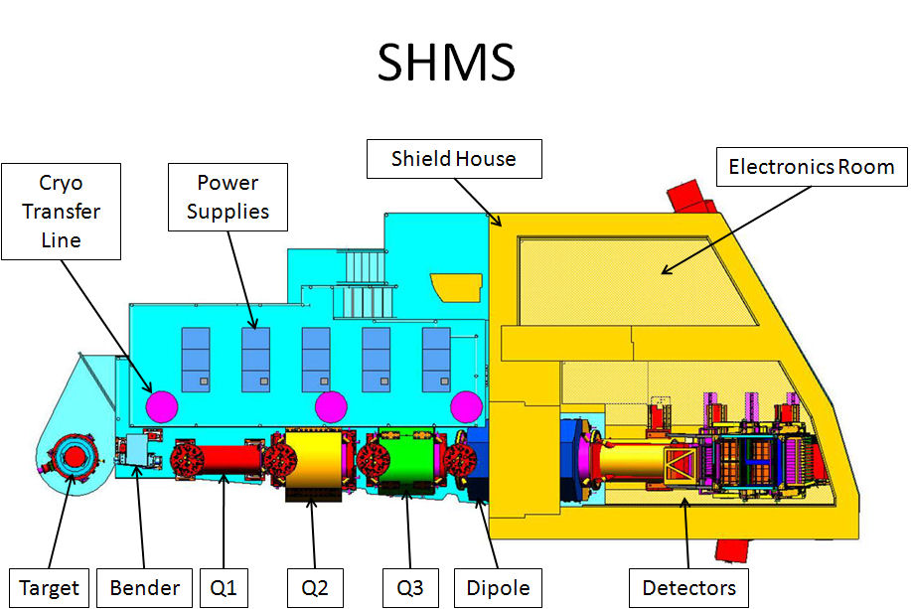

Figure 1. SHMS Plan View

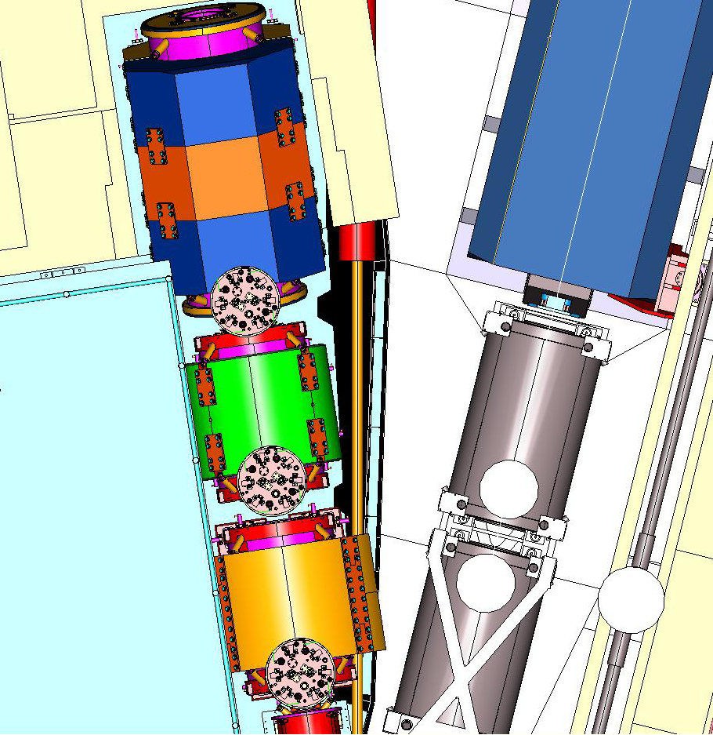

Figure 2. Close-up Plan View of SHMS and HMS at Minimum Angle between.

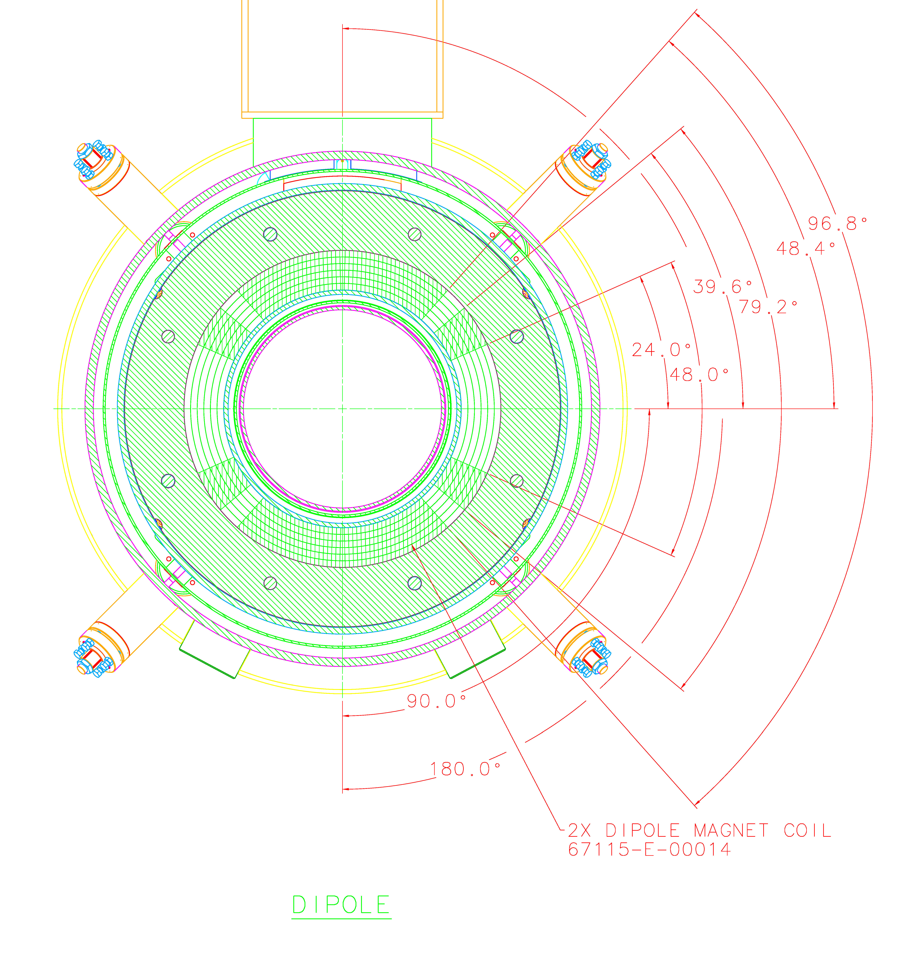

Figure 3. Cross-sectional Sketch of the Coil/Cryostat Assembly

Figure 3a. Dipole Longitudinal cross section

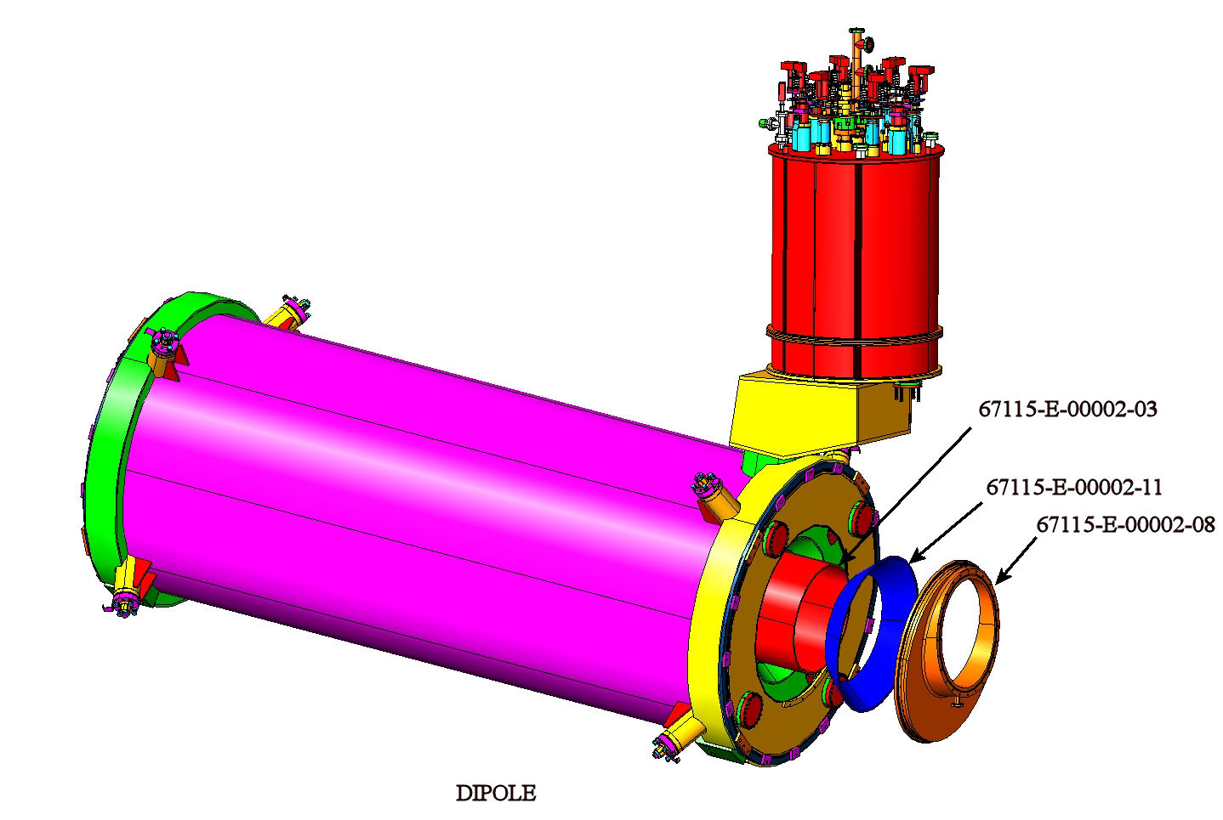

Figure 4. Sketch of Reference Design Dipole cryostat

with warm bore end details

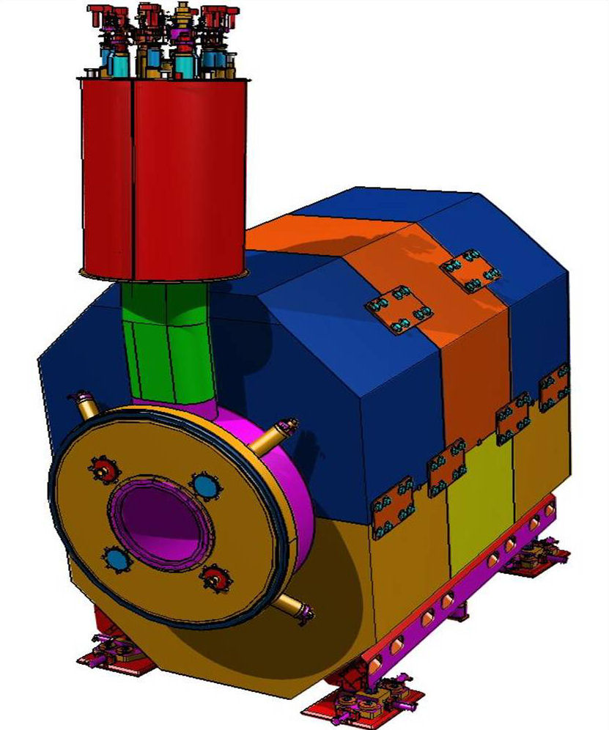

Figure 5. Sketch of Reference Design Dipole

Assembly with warm yoke

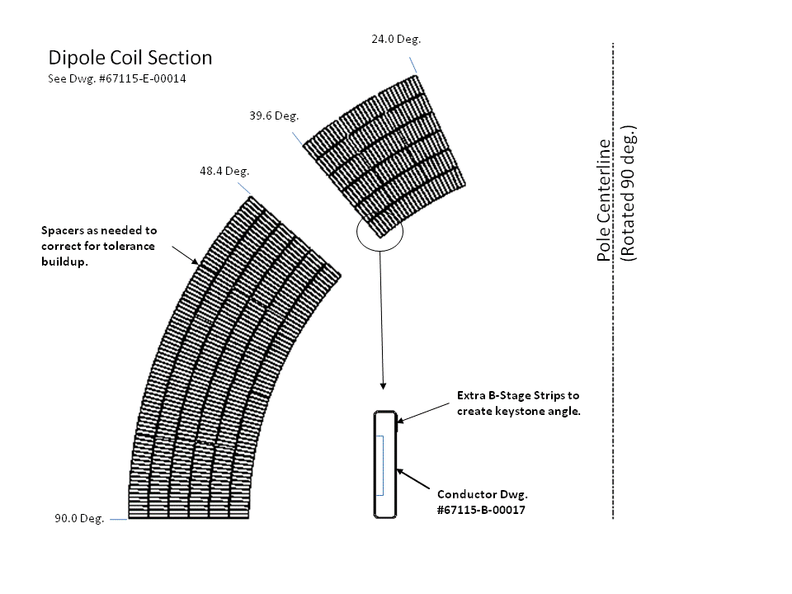

Figure 6. Sketch of Reference Design Dipole Coil Cross Section

Supporting Documents

- SHMS Dipole TOSCA Model Document
- SHMS Magnet Control System
- ES&H Manual Chapter 3310 Operational Safety Procedures Program
- ES&H Manual Chapter 3320 Temporary Work Permits
- ES&H Manual Chapter 3410 ES&H Aspects of Procurement
- SC Cable Tests, SSC Outer Cable Spec. ( Dipole conductor tests)
- Current Lead Report from AMI
- JLAB Internal Technical Reports
Cryogenic Analysis for SHMS Q2, Q3 and Dipole
Design and Analysis of the Warm to Cold Suspension Links for the SHMS Q2, Q3 and Dipole
Cryostat Design and Analysis of the SHMS Q2, Q3 and Dipole
Eddy current heat calculation for SHMS Q2, Q3 and Dipole
Relief Valve sizing Analysis of SHMS HB, Q1,Q2, Q3 and Dipole
Quench Analysis of SHMS Q2, Q3 and Dipole
Structural Analysis of the SHMS Cosine Theta Superconducting Dipole Force Collar
SHMS Dipole Force Collar FEA
Physical property measurement of the SHMS Cosine Theta Magnet coils
4K and 77KTensile and Compression Tests (Conductor Samples)
- Jefferson Lab Publications:
Magnet Technology MT-20 (2007)
Applied Superconductivity ASC 2008
Magnet Technology MT-21 (2009)
- SC Magnet Review 2006, http://www.jlab.org/~brindza/SC%20Mag%20Rev%20-2006/
- SC Magnet Review 2008, http://www.jlab.org/~brindza/SC%20Mag%20Rev%202008/
- Jefferson Lab Safety and Health Requirements
- Jefferson Lab Facilities Guide Specifications
- Dipole SC Magnet TOSCA files- Reference Design
- Dipole SC Magnet 3D CAD Model File (Step file and Ideas Archive file)
- Jefferson Lab Quality Assurance Plan
- Jefferson Lab Graded Approach Procedure

