**Scintillation Detector Testing and Refurbishing for the Large Acceptance Detector (LAD)**

By

Sonja Jayne Schimmers-Wood

A Senior Thesis Submitted to the Faculty of the Department of Physics

Old Dominion University in Partial Fulfillment of the

Requirement for the Degree of

BACHELOR OF SCIENCE

# OLD DOMINION UNIVERSITY

20 August 2015

Approved by:

________________________

Lawrence Weinstein (Advisor)

________________________

Stephen Bueltmann

________________________

Lepsha Vuskovic

#### ABSTRACT

**Scintillation Detector Testing and Refurbishing for the Large Acceptance Detector (LAD)**

Sonja Jayne Schimmers-Wood

Old Dominion University, 05/09/2015

Advisor: Dr. Lawrence Weinstein

This project is aimed at testing and refurbishing scintillators typically sized as 5 cm x 22 cm x 350 to 450 cm with 3 inch photomultiplier tubes from the CLAS TOF system at Jefferson Lab. We are refurbishing them for use as large acceptance detectors in the EMC-SRC experiment in Hall C. CAMAC, CCUSB-Win and C++, excel were used as a data acquisition system. By using the pulse height and timing from detectors in coincidence to see if the results fall into the expected range, the results will be used to determine if and what type of maintenance is to be performed on the detectors. After maintenance is complete the detectors will be retested to ensure the detectors’ readings were of the proper timing, efficiency, as well as within the expected range and time resolution.

Copyright, 2015, by Sonja Jayne Schimmers-Wood, All Rights Reserved.

# This thesis is dedicated to Cody J Wood, without you I could not have accomplished all that I have. Thank you for your unwavering support and encouragement.

## **ACKNOWLEDGMENTS**

I would like to take this opportunity to express gratitude to all of the faculty members from the ODU physics department for all of their help and support. Also a special thanks to Dr. Lawrence Weinstein, for all his guidance and patience throughout my project.

**TABLE OF CONTENTS**

Page

LIST OF FIGURES vii

LIST OF GRAPHS viii

Chapter

1. INTRODUCTION…………………………………………………………………… 1

2. BACKGROUND AND DESIGN 2

2.1 TIME OF FLIGHT SYSTEM 2

2.2 SCINTILLATION DETECTOR COMPONENTS 3

3. EXPERIMENT SETUP 7

3.1 DETECTOR SET UP 7

3.2 CAMAC AND NIM COMPONENTS 9

4. DATA ACQUISITION & ANALYSIS 12

4.1 CAMAC OPERATION 12

4.2 CCUSB-WIN DAQ 13

4.3 EXCEL SPREADSHEETS ANALYSIS 13

4.4 15

4.5 ADC & TDC HISTOGRAMS 17

4.6 TIME RESOLUTION 18

5. CONCLUSION 28

REFERENCES 29

APPENDIXES

A. C++ Program used 30

**LIST OF FIGURES**

Figure Page

1. Detectors on storage cart 3

2. Photocathode Operation and Amplification 4

3. PMT diagram 5

4. Cross sectional view of scintillator 6

5. Scintillator set up 6

6. Logic Diagram 8

7. Experiment set up 9

8. Data-way Display Panel 10

9. CAMAC 11

10. CCUSB-Win 13

11. Image of dat.file 16

12. Excel spreadsheet image 17

# **LIST OF GRAPHS**

Graph Page

1. Top Left ADC 20

2. Top Right ADC 20

3. Bottom Left ADC 21

4. Bottom Right ADC 21

5. Middle Left ADC 22

6. Middle Right ADC 22

7. Top Left TDC 23

8. Top Right TDC 23

9. Bottom Left TDC 24

10. Bottom Right TDC 24

11. Middle Left TDC 25

12. Middle Right TDC 25

13. Time Resolution Plot Zoomed Out 26

14. Time Resolution Plot Zoomed In 26

15. Gaussian 27

# 

**CHAPTER** 1

INTRODUCTION

The large-angle scintillation detectors from the CEBAF Large Acceptance Spectrometer (CLAS) are no longer needed for the CLAS detector and are being moved and rearranged to form the Large Acceptance Detector (LAD) in Hall C for the EMC-SRC experiment. First the detector was taken apart, the scintillation detectors and photomultiplier tubes disconnected from the CLAS frame, and then transferred to new frames, and shipped to Old Dominion University. Here we collected data and analyzed their time resolution which will allow us to distinguish particle flavors from one another and to measure the particles’ momenta.

**CHAPTER** 2

BACKGROUND AND DESIGN

2.1 TIME OF FLIGHT SYSTEM

The Time of Flight system allows for a more accurate measurement and discrimination between particles. We use both time and energy measurements in calculating time of flight. Time measurements are used for velocity measurements. This allows a more accurate measurement of particles energy than magnetic analysis, as slow moving particles such as the neutron can also be detected. Energy measurements may also give us the rough estimate of a particles velocity, if the particle is a proton. The TOF is calculated by using the distance traveled by the particle divided by speed of the particle.

The design of the time of flight for CLAS was based on geometry, size, magnetic field, crossing tracks, and readout capability. The components of the Time of Flight for the CLAS detector were each designed and optimized under these design constraints, along with cost. Time resolution played a very large part as to the overall design, especially in design of the width of the scintillators. The TOF’s geometry was used for placing PMTs, cables, and voltage meters. Particle trajectory measurements or crwere alsofor the CLAS, . In order to correct this, However, in Hall C, there is no magnetic field, so only time and energy will be used as measurements. The proton will be detected in the time of flight plane first, and the neutrons will be detected in subsequent planes.

2.2 SCINTILLATION DETECTORS

The detectors are composed of specialized scintillation materials, photomultiplier tubes, voltage dividers, light guides and magnetic shields. The large angle detectors are from the CLAS detector (refer to fig 1) from Jefferson Lab’s Hall B.

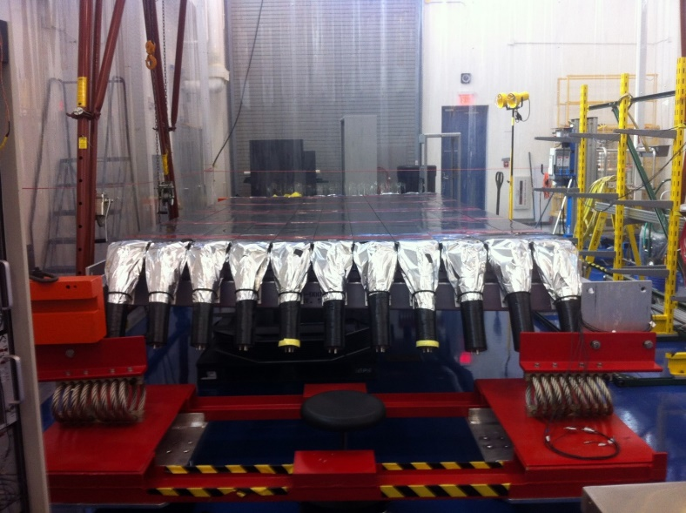

Figure 1 Scintillators on the transport and storage racks.

The scintillation material used must optimize the time resolution over the volume of the counter, absorption length, and overall cost. Bicron BC408 was used as it allows fast response time and low light attenuation, as well as the ability to be fabricated in the lengths and widths required for the CLAS. Each CLAS6 TOF counter we repurposed for the LAD consisted of a Bicron scintillator typically 5 cm x 22 cm x 350 to 450 cm with a 3 inch photomultiplier tube at each end.

The photomultiplier tubes (PMTs) were made up of three inch diameter with 12 stages, which allows amplification to around 106 . The PMTs are responsible for receiving the light emissions from the scintillator and converting it into an electrical signal and sending it to the amplifier, which is illustrated in (Fig. 2).

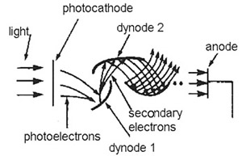

Figure 2 Photocathode operation and amplification

The voltage divider use four high voltage field effect transistors the fix the gain on the PMTs and protect them from high light levels, and will shut down the circuit in case of over current. The voltages between the first dynode and the anode can be changed proportionally with high voltages to compensate for variations between the photomultiplier tubes.

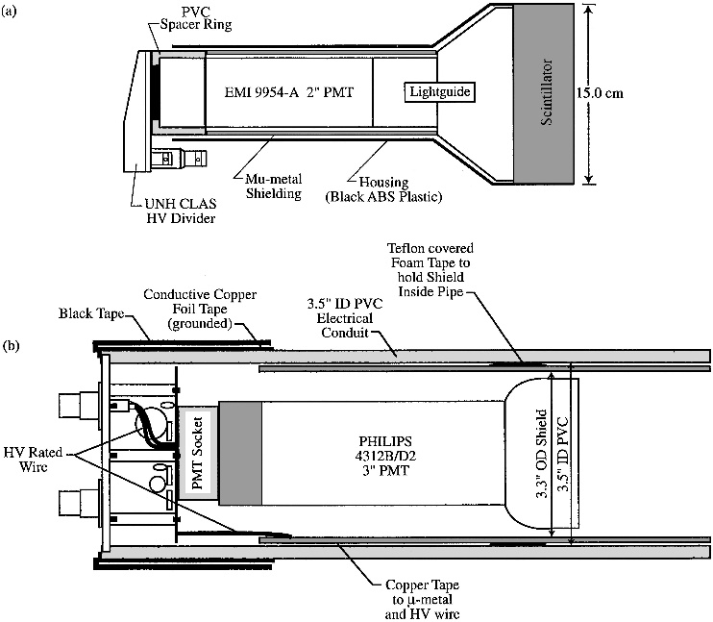

Figure 3 PMT diagram

The light guides used were triangular in shape, straight and tapered from the scintillator down to the PMTs, refer to Fig. 3. They are bent light guides to be efficient for coupling with the three inch PMTs, and for the special considerations of the geometry of the space, and magnetic fields being applied.

Magnetic shield that was used was a cylindrical shield. The shield is made of mu-metal material and extends 2.5 inches beyond the photocathode for protection.

The assembly itself consists of each scintillation counter being individually wrapped and has two photomultiplier tubes, and light guides at each end.

The scintillators are covered with two layers of aluminum around the plastic, and one strip of .0005” lead foil on the target facing side, which helps shield the scintillators from background x-rays produced by the target. There is also a layer of black Kapton. Once the scintillators are wrapped they are attached to a support structure, and then the light guides and PMTs are glued in place, presented in (Fig. 4 and 5).

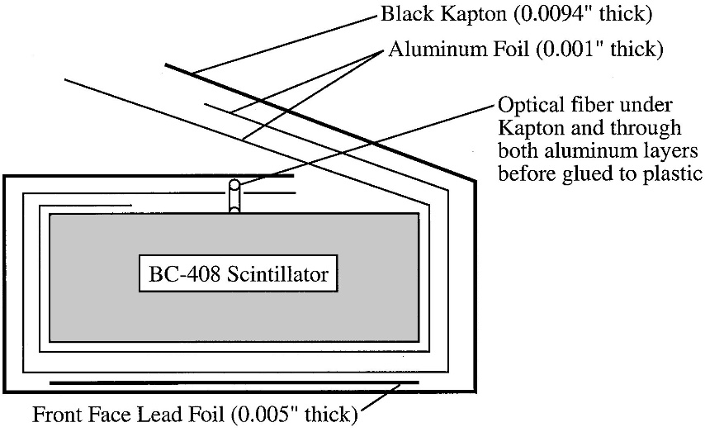

Figure 4 Materials used in the detector to protect and allow proper operation of the scintillator

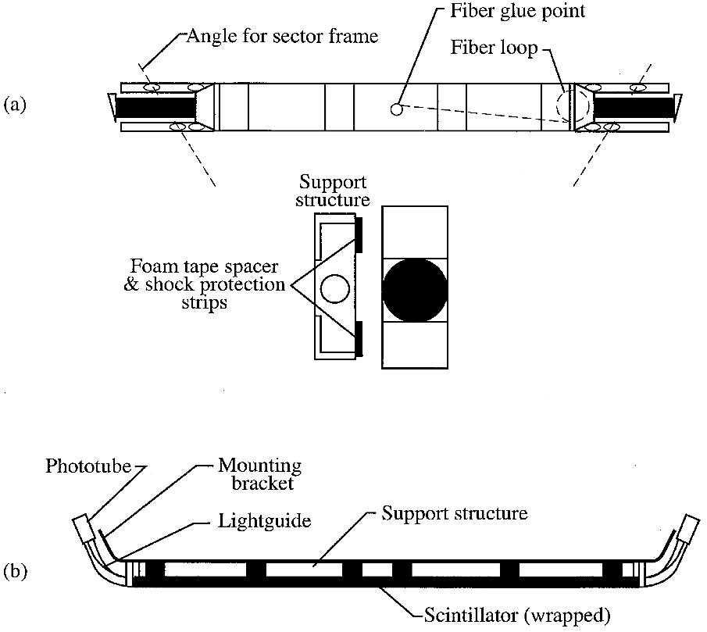

Figure 5 How the scintillators are mounted and their support structure

**CHAPTER** 3

**EXPERIMENT SETUP**

3.1 SETUP FOR TESTING OF SCINTILLATION DETECTORS

The method used was using muons from cosmic rays to calibrate and calculate time resolution of the detectors. Cosmic rays are energetic particles from space that impinging on the atmosphere. In actuality they aren’t even rays at all but an assortment of particles. Cosmic rays are mostly made up from around 90% protons, 9% helium, and the last 1% is made up from electrons, heavier elements, and gamma ray photons. As the particles collide and interact with interstellar matter, they split and scatter into smaller particles. This phenomenon is called cosmic ray spallation, and here the particles decay into smaller particles such as pions, neutrinos, and muons. The particles from the cosmic rays have energy levels as low as 107 eV to large as 1020 eV.

We placed 3 detectors in a vertical stack spaced equally. The reference pair of detectors was placed directly above (A) and directly below (B) the scintillator being tested (S) (see Fig. 7). In order for this to be successful, the photomultiplier tubes are assumed to be equal, meaning the travel time is the same for the signal. Also with using a TDC a common start must be used, in this case the cosmic ray interacting with the detectors. This set up is known as coincidence technique. The coincidences are obtained from having the detectors parallel to each other and the cosmic ray must pass through all three detectors in order to get an event to record as shown in Fig. 6.

To actually get the delay time calibrated properly, we used an oscilloscope to match the pulses. The actual event is triggered when the cosmic ray interacts with the scintillator. The cosmic ray will pass through the scintillator, and as it passes through the scintillator it excites the electrons along its path. The electrons will then release their excitation energy, giving off photons of light. The photons travel along the scintillator via total internal reflection using a light guide. Once the photons arrive at the PMTs face, they collide with the photocathode and eject electrons. The electrons accelerate at the series of dynodes which amplifies the signal into electronic signal that can be collected in the end. If the signal reaches 30 mV threshold, the discriminator will send a logic pulse to the data acquisition system. We used delay cables to prevent the ADC from taking data in until the trigger is activated, as well as the TDC begins counting. Once the trigger is implemented, the TDC and ADC send their results to the DAQ for storage and analysis. Usually around 800 nanoseconds of data is collected for each recorded pulse.

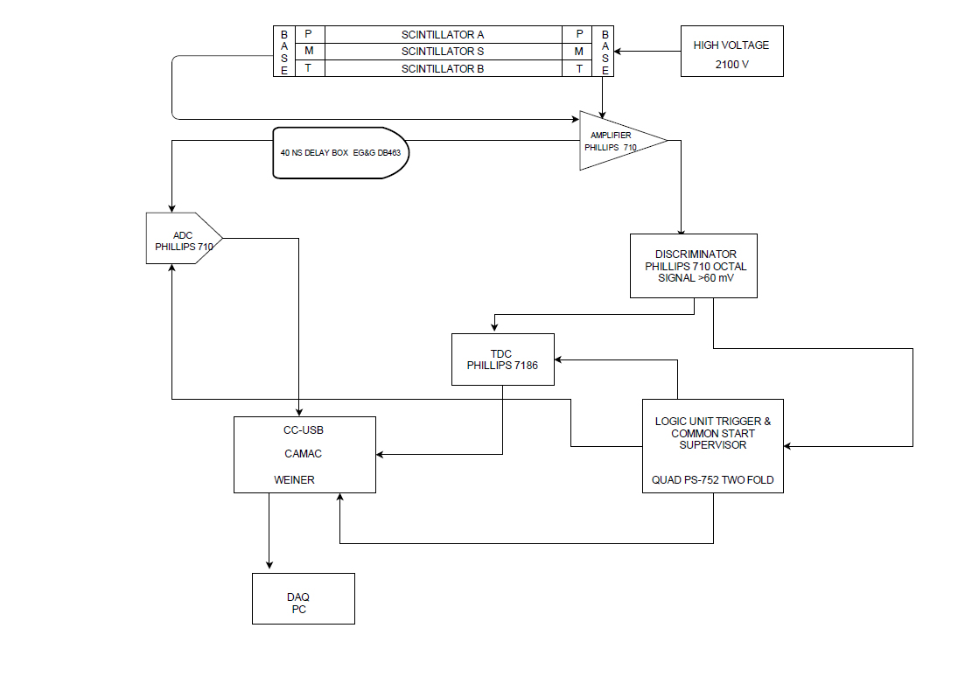

**Figure 6** Logic diagram of scintillators and PMTs to the DAQ system

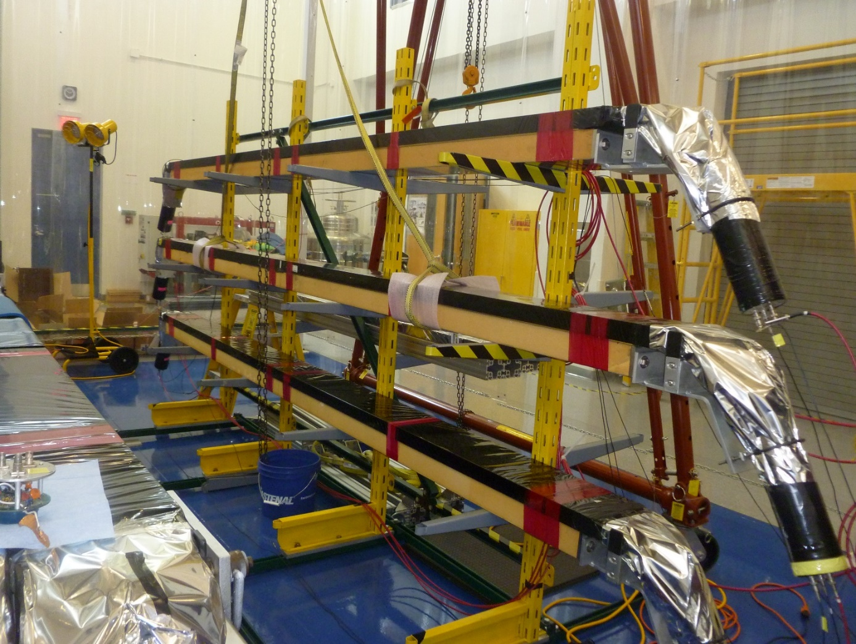

Figure 7 The scintillator set up, top scintillator A, middle scintillator S, and bottom scintillator B

.

3.2 CAMAC COMPONENTS AND NIM COMPONENTS

The following is a list of the components and their functions in the Computer Automated Measurement and Control (CAMAC) and the NIM (see Fig. 9).

CCUSB by Weiner is the crate controller, it serves as the master of all the components or slaves in the cart. Everything runs through the CAMAC, as it acts as a central control. The CAMAC crate has 26 slots, with the CCUSB crate controller in slots 25 and 26. 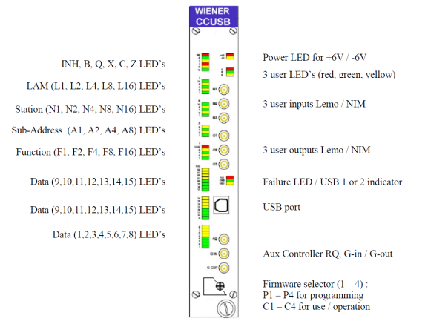

Figure 8 The data gataway display on the CC-USB

CCUSB front panel 3291 Data way Display by Kinetic Systems: The data way indicates the state of all the data way signals with LED lights during the cycle. Ensured we had proper signals from the TDC (Fig. 8).

NIM COMPONENTS

Phillips Scientific 7186 : The time to digital converter has 16 channels in which it can process signals to as well a digital processing section and plugs in the CAMAC.

Phillips Scientific 710 Discriminator: We set threshold to 30.0mV and 60.0mV, if the event reaches the threshold it converts the analog signal to a digital signal.

Quad Phillips Scientific 752 Quad Two Fold Logic Unit. These are the fan in fan out units that take the one signal to several identical channels.

Power Supply: Supplies power to the detectors at 2100 Volts

Delay Box-EG& and G DB463 was used to ensure the signal from the right bottom photomultiplier tube was delayed by 40 nanoseconds, as to make sure the signal was the last to arrive when we made the trigger. This model has 0.5 nanosecond to 63.5 nanosecond with a 0.5 nanosecond increments. We also used a large 119 nanosecond homemade delay box, to delay the digital and analog signals to the ADC and TDC. This was done to ensure the TDC signals came after the TDC start, and that the ADC signals came during the ADC gate.

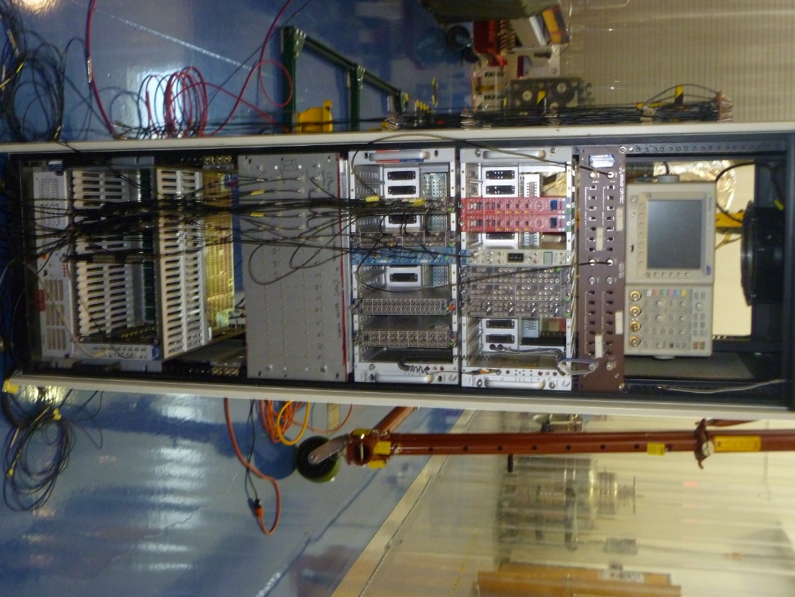

Figure The crate controller and CAMAC

**CHAPTER** 4

DATA AQUISTION AND ANALYSIS (DAQ)

4.1 CAMAC OPERATION

The modular crate system we used was Weiner FASTCAMAC compliant CAMAC. The CCUSB crate has an integrated high speed USB which allowed us to plug it into our computer. Also included is a data way display with additional LEDs for the controller. The USB port allows all necessary system information for debugging, hardware control, and monitoring.

The Register Block contains only the Action Register which can only be used outside of the CAMAC operations path. CAMAC has common functions that used with CCUSB-Win program. The common CAMAC functions are Initialize (Z), Clear (C), and Inhibit (I). These three functions are generated by the crate controller itself and are received by any units plugged into the crate. The initialize function sets the module to an initial defined state, specifically when the module is powered on. The initialize function is also accompanied by a busy (B), timing signals from strobes 1 and 2 (S1, S2), as well as the inhibit signal. The Initialize function takes priority over all other signals. The clear function clears the CAMAC’s register, and resets any ongoing operations with the CAMAC. The inhibit function disables features for the duration of the signal, allowing minimum interference.

The signals are interpreted by the module using NAF where N is the slot number the module is inserted in the crate station module, A is the sub-address of the module which are the channels of the ADC and TDC, and F is the command function which allows the crate controller to issue commands. The crate controller is located at N=25 and N=26, and those ports are reserved specifically for the crate controller.

4.2 USING CCUSB-WIN

The data acquisition program we used to collect data was the CCUSB-Win which was included with the CCUSB unit itself. Using CCUSB-Win program, we created command stacks which allowed us to execute commands. A CAMAC data stack is a sequence of simple encoded commands. We had to use a text editor to write our CAMAC command stack, as the program wasn’t interacting with the TDCs with its stack reader. The following Fig. 10 is an example of the CCUSB-Win program stack builder. From here we built stacks and developed the stack commands to issue to the CCUSB CAMAC. As we were unable to fully use the program to communicate we took the codes that were generated from the control panel and created a text file for program executing.



Figure 10 The stack builder and CC-USB Win program interface

The CAMAC stack code we used was set up by CCUSB-Win program to use the Phillip Scientific 7186 TDC in the N3 slot. The commands we used were:

F9 – Clear Inhibitor

F10-Clear the LAM

F26-Enable Inhibitor

F8-Test

F0 A0-Data In

F0 A1-Data In

F0 A2 Data In

F0 A3 Data In

F0 A4 Data In

F0 A5 Data In

F0 A6 Data In

F11, A (3)-TDC-Data Out The F11 command was used to reset the Hit register, LAM, and data memory. This only occurs on the S(2) strobe.

After building the code, we execute the code by loading it into the CCUSB-Win program. We then built and loaded the scalar stack. Then we started the DAQ by using trigger mode. In our case, the trigger started when a cosmic ray passed through all six scintillators with the detector. The cosmic ray interacts with the detector, which then triggers the execution of a stack, as the signal from photomultiplier tubes give a signal to the NIM, as discussed earlier. When the CCUSB model received the signal from the trigger, it would execute the command stack. The stacks would execute in sequential order, reading in and then clearing each individual TDC channel. After this completes it would reinitialize the TDC for the next event. The program will continue to read and write the data until a timer comes to a close. The data is written to and saved as a.dat file.

C++ PROGRAM DEVELOPMENT

We had to design a C++ program which would take the data acquired from the data acquisition program dat file (as shown in Fig. 11)and convert it to a file that Microsoft Excel could read. We had to open file, read file, and write to a .csv file. There were a few numbers which had to be skipped and ignored or the out file would be inaccurate, and we would be unable to analyze it properly. We also had to insert an end of file command at the beginning of a while loop or the program would continuously loop, and print the same data over and over.

We had to take the data we were receiving from ADC and TDC inputs and get them into separate data columns. However, every 314 events there would be reading of 65535 and 314 that would be printed to the data file. To correct this, we used a dummy parameter in the program. When the program reads in 65535, it knows to skip that and the next data line, so we could extract the right data. After reading the data the program then creates a comma separated values (csv) file for Microsoft Excel.

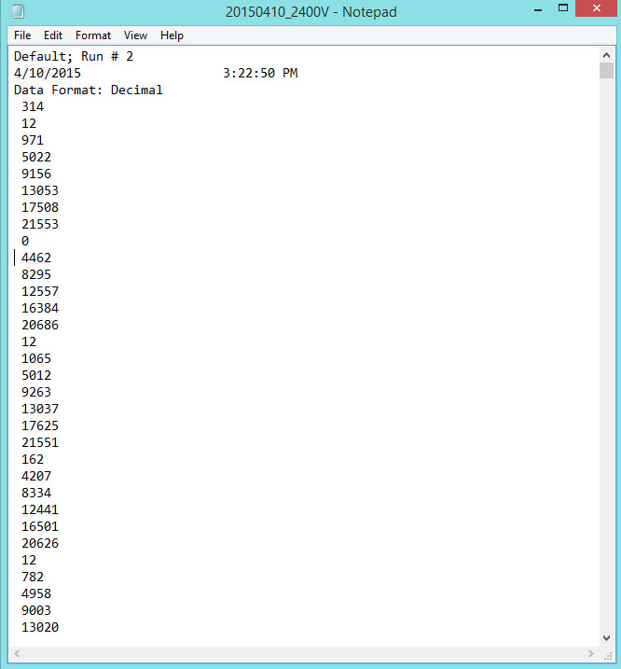

**Figure 11** An example of the data we got in a .dat file from CC-USB Win program

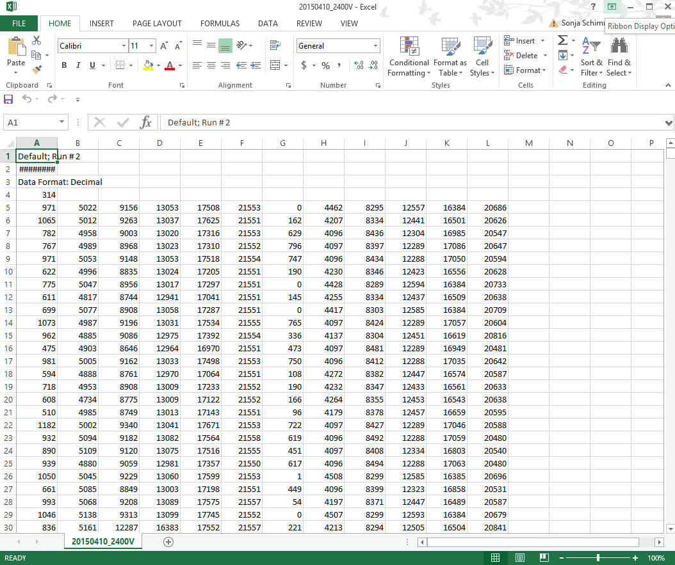

**Figure 12** The excel file after the computer program ran and analyzed it.

EXCEL SPREADSHEET ANALYSIS

I used Microsoft Excel as shown Fig.12 to analyze data and create histograms and a Time Resolution Plot. The columns on the excel spreadsheet had to be adjusted. To adjust the ADC and TDC values we used the formula: Value = (4096) * (n-1). The (n) was the TDC address number and ranged from 1 to 6 for the 6 PMT inputs. The TDC converts the time interval between START/STOP events spanning 0–100 ns into a 12-bit integer between 0–4095. The number 4096 was chosen as this allowed the whole spectrum of values from the TDC and ADC to be used, allowing us to exclude any values that didn’t fall into this range.

After the values were corrected, I binned different values until the data was properly graphed. Values that were not between the values of 0-4095 were removed as well as values that didn’t fall between ten and 90% of the curve.

**Calculating the Time Resolution**

To calculate the time resolution first I had to remove any counts that equaled 4095, 1, or 0. Then used calculations to get the time resolution values. The top scintillator is represented by the letter A, the bottom scintillator the letter B, and the scintillator being tested is represented by the letter S.

The reference systems time resolution is measured using

Tref = (TAL + TAR – TBL –TBR)/2

where T is the signal of the arrival times in the photomultiplier tubes, AL and AR are the times from the left and right signals from the top scintillator, and BL and BR are the signals for the B detector. We assume all four photomultiplier tubes time resolution are equal.

The timing for a cosmic ray particle to pass through counter S is

TS = (T SL + TSR)/2

This equation can also be used to calculate the mean.

The time a cosmic ray passes the scintillator S relative to the reference system is calculated. Cosmic is the label for cosmic ray.

TCOSMIC = (TAL + TAR +TBL +TBR)/4 – TS

Calibration

The purpose of calibration is to correlate the voltage readings we got with rough estimate of expected energy from the cosmic rays and to ensure we have uniform readouts for all the PMTs in the scintillator. To calibrate we took the voltage readings from a PMT and checked to make sure they roughly corresponded to ADC readouts. Each PMT for its corresponding scintillator is unique to itself, so each graph will be slightly different. We measured the gain, which is the output we received from the data which corresponds to the voltage for a given particle. If gain levels were too low, the voltage would have to be increased to the PMT.

The following graphs (graphs 1-14) show that the PMTs are in working order as the ADC and TDC values are overlapping each other and are comparable in readings. The graphs are comprised of the data from all 6 PMTs. A Gaussian curve is included to show that the data fit in graph 15.

Graph ADC Data from the Top (scintillator A) Left output

Graph 2 ADC Data from the Top (scintillator A) Right Output

**Graph 3** ADC Data from the Bottom (scintillator B) Left Output

Graph 4 ADC Data from the Bottom (scintillator B) Right Output

Graph 5 ADC Data from the Middle (scintillator S) Left Output

Graph 6 ADC Data from the Middle (scintillator S) Right Output

Graph 7 TDC Data from the Top (scintillator A) Left output

Graph 8 TDC Data from the Top (scintillator A) Right output

Graph 9 TDC Data from the Bottom (scintillator B) Left output

Graph 10 TDC Data from the Bottom (scintillator B) Right output

Graph 11 TDC Data from the Middle (scintillator S) Left output

Graph 12 TDC Data from the Middle (scintillator A) Right output

Graph 13 TDC Time resolution data

Graph 14 TDC Time resolution data

Graph 15 TDC Time resolution with Gaussian Fit Blue is gaussian and orange is the Time resolution data.

Figure

.

**CHAPTER** 5

**CONCLUSION**

After completing many graphs and analysis of TDC, ADC and time resolutions, the detector I analyzed needs little to no maintenance. The Gaussian fit of the graph proved that the detector was in working order, and the time resolution of the detector was in range. As the time resolution was within range it showed that there wasn’t light leakage, which causes inaccurate light readouts from the PMTs, and that the PMTs and scintillators are correctly calibrated and operating correctly.

**REFERENCES**

E.S. Smith, *et al*., The time-of-flight system for CLAS, Nuclear Instruments and Methods in Physics Research Section A: Accelerators, Spectrometers, Detectors and Associated Equipment, Volume 432, Issues 2–3, 11 August 1999, Pages 265-298, ISSN 0168-9002, <http://dx.doi.org/10.1016/S0168-9002(99)00484-2>

B.A. Mecking, *et al*., The CEBAF large acceptance spectrometer (CLAS), Nuclear Instruments and Methods in Physics Research Section A: Accelerators, Spectrometers, Detectors and Associated Equipment, Volume 503, Issue 3, 11 May 2003, Pages 513-553, ISSN 0168-9002, <http://dx.doi.org/10.1016/S0168-9002(03)01001-5>.

R.T Giles, Tests of conventional and microchannel plate photomultipliers as components of a scintillation time-of-flight system, Nuclear Instruments and Methods in Physics Research Section A: Accelerators, Spectrometers, Detectors and Associated Equipment, Volume 252, Issue 1, 15 November 1986, Pages 41-52, ISSN 0168-9002, <http://dx.doi.org/10.1016/0168-9002(86)90934-4>

W.R. Leo, Techniques for Nuclear and Particle Physics & Experiments, 2nd Edition. Springer-Verlang Berlin Heidelburg Germany, 1994. Print

Anon, Read Out. [http://Scionix.Nl/Readout.Htm#Top](http://Scionix.Nl/Readout.Htm%23Top).

**APPENDIX A C++ CODE**

// main.cpp

// file read

//

// Created by Sonja Schimmers-Wood on 3/24/15.

//

//

#include <iostream>

#include <fstream>

#include <string>

using namespace std;

int main() {

string line;

ifstream in_file("C:/Users/Mizukisakura/Downloads/physics/20150410_2400V.dat");

ofstream out_file("C:/Users/Mizukisakura/Downloads/physics/20150410_2400V.csv");

long int n_tdc1, n_tdc2, n_tdc3, n_tdc4, n_tdc5, n_tdc6, dummy;

long int n_adc1, n_adc2, n_adc3, n_adc4, n_adc5, n_adc6, dummy1, dummy2;

if (in_file.is_open()) {

for (int i=0;i<4;i++)

{

getline (in_file, line);

out_file << line << "\n";

}

while (!in_file.eof())

{

in_file >> dummy;

if (dummy == 65535) {

in_file >> dummy1;

in_file >> dummy2;

cout << dummy << ", " << dummy1 << ", " << dummy2 << endl;

}

in_file >> n_tdc1;

in_file >> n_tdc2;

in_file >> n_tdc3;

in_file >> n_tdc4;

in_file >> n_tdc5;

in_file >> n_tdc6;

in_file >> n_adc1;

in_file >> n_adc2;

in_file >> n_adc3;

in_file >> n_adc4;

in_file >> n_adc5;

in_file >> n_adc6;

out_file << n_tdc1 << "," << n_tdc2 << ","<< n_tdc3 << ", " << n_tdc4 << ",";

out_file << n_tdc5 << "," << n_tdc6 << ","<< n_adc1 << ", " << n_adc2 << ",";

out_file << n_adc3 << "," << n_adc4 << "," << n_adc5 << ", " << n_adc6 << "\n";

}

in_file.close();

out_file.close();

} else

{

cout << "failed to open file\n";

}

return 0;

}