**Scintillation Detector Testing and Repair**

by

James Porter II

A Senior Thesis Submitted to the Faculty of the Department of Physics

Old Dominion University in Partial Fulfillment of the

Requirement for the Degree of

BACHELOR OF SCIENCE

# OLD DOMINION UNIVERSITY

10 May 2014

Approved by:

________________________

(Advisor)

________________________

________________________

#### ABSTRACT

Scintillation Detector Testing and Repair

James Porter II

Old Dominion University, 25 April 2014

Advisor: Dr. Lawrence Weinstein

The doubling of the electron beam energy at Jefferson Lab to 12 GeV requires the development of new or reconfiguration of existing detectors. Scintillation detectors, previously used with the CLAS detector in Hall B are being refurbished at ODU and will be used for new experiments in Hall C. In addition to replacing components that no longer function, these detectors will be examined to ensure that they can detect cosmic ray muons as accurately as they could when first installed with the CLAS detector. A method for testing the time resolution of the scintillators was successfully developed and an acceptable resolution for a test scintillator was found.

Copyright, 2014, by James Porter II, All Rights Reserved.

# This thesis is dedicated to Lenora, whose support and confidence has been indispensable.

## **ACKNOWLEDGMENTS**

I would like to express my great appreciation and thanks to my advisor Dr. Weinstein, for giving me this opportunity and for your wonderful guidance and mentorship. The advice and knowledge that you have shared with me has been invaluable. I would also like to thank my committee members, Professor Bueltmann and Professor Vušković for serving as my committee members and guiding me when I needed it. I also want to extend my thanks to Tom Hartlove and Holly Szumila-Vance for their continuous help and support, and for sharing their knowledge and experience with me. Lastly, I would like to thank Mathieu Ehrhart for always offering a helping hand when I needed one.

**TABLE OF CONTENTS**

Page

LIST OF TABLES 7

LIST OF FIGURES 8

CHAPTER

I. Scintillation Detectors 9

II. Testing and Repairs 13

III. Time Resolution Calculations. 18

IV. Results and Future Experimentation 29

REFERENCES 31

**LIST OF TABLES**

### Table Page

1. Voltage Divider Test Values 15

2. Effective Voltages to achieve 80 Hz Hit Rate 17

**LIST OF FIGURES**

Figure Page

1. The inside of a photomultiplier tube showing a photon from the scintillator striking a photocathode and causing a cascade of electrons by bouncing between several dynodes. 10

2. An overview of the CLAS detector at Jefferson Lab. The TOF Counters are the scintillators being tested and repaired at Old Dominion University. 11

3. A light guide showing the bent design used at Jefferson Lab which served to keep the PMT out of the active detection are, as well as to guide the light from the 5 cm x 22 cm scintillation material to the 3 inch diameter round PMTs (Smith). 13

4. Output signal from a PMT with a -300 mV discriminator level. The faint pulses show multiple hits occurring in quick succession. The two traces correspond to signals from the two PMTs of the scintillator. 14

5. A PMT in a protective tube with high voltage and signal cables attached with a LED light source for testing. 17

6. Three scintillators stacked on a frame used to calculate time resolution. 19

7. Signals from the top and bottom scintillators are ANDed together, and the ANDed signals are ANDed with each other to create a trigger pulse to send to the TDC. 20

8. TDC spectra from all PMTs in a 100,000 event 4096 nanosecond run. 21

9. Average TDC spectra of top and bottom scintillators. 25

10. Time resolution of the reference frame with a Gaussian distribution fit. 27

11. Time a cosmic ray passed through the test scintillator relative to the reference frame with a Gaussian distribution fit. 28

**CHAPTER I**

Scintillation Detectors

Scintillation detectors are one of the most widely used particle detectors in modern nuclear and particle physics.

Scintillation detectors are based on the principle of scintillation, that when incident radiation excites atoms or molecules in a material, light is emitted. This radiation may come in the form of photons or other high energy particles such as muons or protons. Some of the energy from these particles is transferred to the scintillation material, exciting its atoms. As these atoms revert back to the ground state, the energy is released in the form of photons.

To more readily detect these scintillations, amplifying devices such as photomultiplier tubes, or PMTs, are used. PMTs take the small flash of light from the scintillation material and amplify it into a measureable electrical signal. When the scintillation light hits the photocathode, it ejects electrons via the photoelectric effect. These electrons are focused and accelerated by an electric field into the first dynode. More electrons are knocked out of the dynode via secondary electron emission. This process repeats for each successive dynode. By placing several dynodes in a manner that the secondary electrons will collide with the next dynode a measurable electric pulse can be created from a single photon.

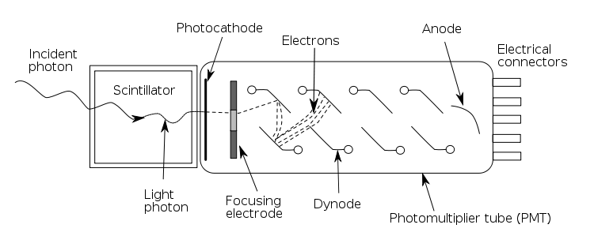

Figure The inside of a photomultiplier tube showing a photon from the scintillator striking a photocathode and causing a cascade of electrons by bouncing between several dynodes.

To ensure that each dynode gets an appropriate voltage to create the cascade inside the PMT, a voltage divider is installed. This device takes the high voltage supplied to the PMT and divides it among the dynodes in a gradient so that each dynode will create more secondary electrons upon impact [1]. To achieve this, a circuit is constructed with a series of resistors to alter the voltage to each successive dynode.

Scintillation detectors are made from a variety of materials such as crystals, plastics, glasses, liquids and gasses. Plastic scintillation material is among the most popular and is chosen because it gives quick response time, is relatively inexpensive and is rugged. Care must be taken to protect the surface of the scintillation material as the oils from one’s skin may “craze,” or create small fractures in the surface. However as the material must be covered to prevent light leaks this is a minor drawback [2].

Scintillators are popular in modern nuclear physics mainly due to their versatility. They are sturdy and do not require much upkeep once manufactured and sealed in light tight material. Scintillation detectors are capable of quick detection with little dead time, which is the time a detector must take between measuring two particles. Another positive feature is a near-linear correlation between the energy deposited by the incident particle and the light output of the scintillation which allows not only time but energy measurements of the incoming radiation [3].

The Jefferson Lab scintillators used in the CEBAF Large Acceptance Spectrometer, or CLAS, were used to detect particles resulting from the reactions between the incident electron beam and a target located in the center of CLAS.

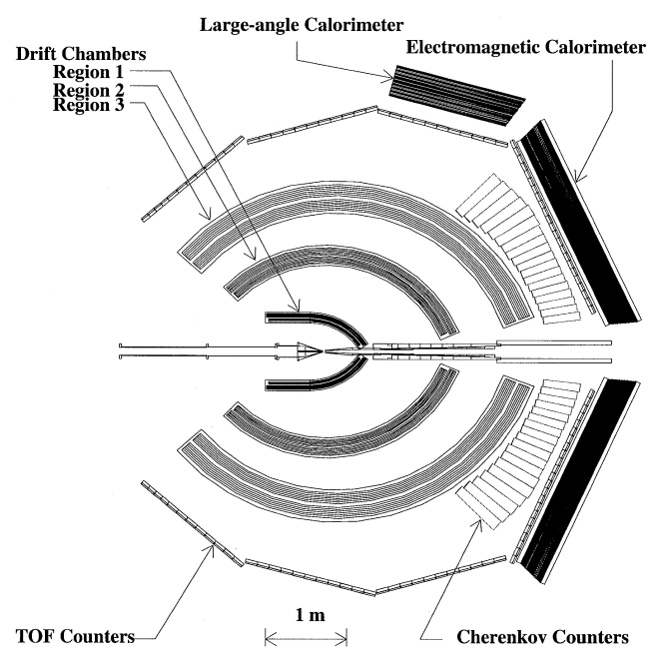

Figure An overview of the CLAS detector at Jefferson Lab. The TOF Counters are the scintillators being tested and repaired at Old Dominion University.

The scintillators were designed to provide very precise time resolution to be able to measure the velocities of different particles in a single experiment.

The scintillators use plastic material, Bicron[1] BC-408 scintillation material which was chosen using two main criteria. This material provides low light attenuation, that is, the scintillation light intensity decreases little as the light travels through the material, and it was available in lengths over 300cm which were required for the CLAS detector [4].

The scintillators were arranged in 6 sectors with 57 scintillators per sector with widths of 15 or 22 cm and lengths varying from 32 to 445 cm. Each scintillator is equipped with two PMTs at either end [4]. Of these, we received 12 scintillators, numbered 35 through 45 from panel 3, sector 3, each approximately 400 cm long and a smaller test scintillator.

In some scintillator set-ups, light guides are used to guide the light from the scintillation material to the PMT. Light guides are not a mandatory component for scintillators. However they are implemented in this set-up in order to guide the light from the rectangular scintillation material to the round PMT. Internal reflection is used to maintain that any incoming photons are reflected into the PMT and not lost.

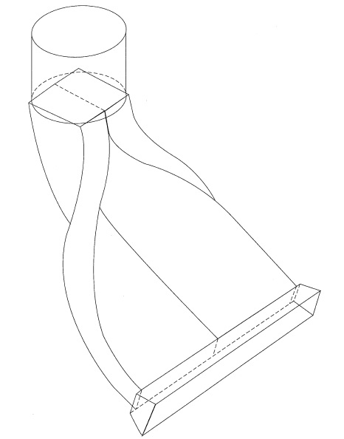

Figure A light guide showing the bent design used at Jefferson Lab which served to keep the PMT out of the active detection are, as well as to guide the light from the 5 cm x 22 cm scintillation material to the 3 inch diameter round PMTs (Smith).

**CHAPTER II**

Testing and Repairs

After their use in the CLAS detector for many years, the scintillators needed to be tested and, if necessary, repaired. To determine whether a scintillator was working properly it needed to be supplied voltage and used to detect some source of radiation. If the scintillator performed poorly, then the PMTs and voltage dividers were tested as described later.

Cosmic rays are a reliable and inexpensive source of radiation. Cosmic rays are a category of a number of different particles which are created when particles from space interact with the upper atmosphere. Most of these particles do not reach sea level. Due to their highly relativistic speeds and low interaction rates, muons can reach the Earth’s surface. Most cosmic rays at the Earth’s surface are muons. Muons can be detected with the scintillators and have a known flux so they were used as the radiation source when to test the scintillators.

The primary test of a scintillator is ensuring that it can detect individual cosmic ray muons using an oscilloscope to look at the resulting signals. A good signal from a PMT is greater than -300 mV and has a duration of 50 nanosec.

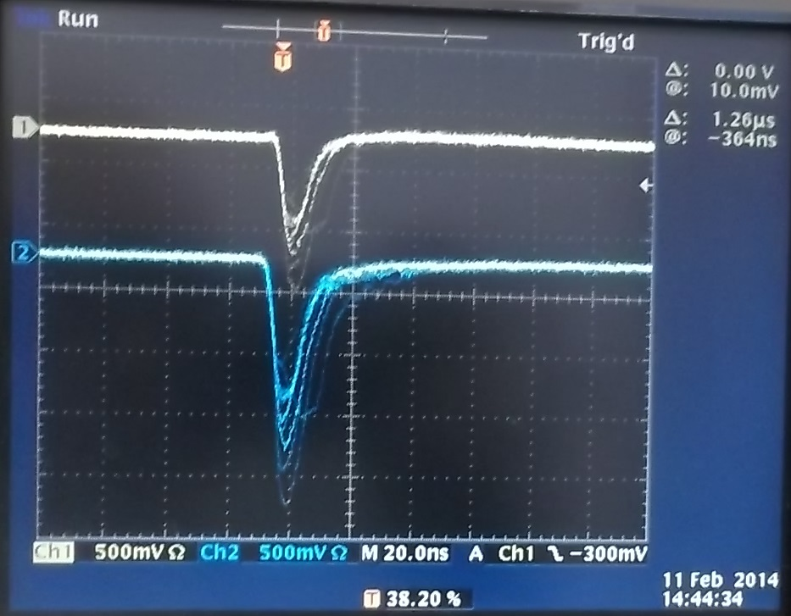

Figure : Output signal from a PMT with a -300 mV discriminator level. The faint pulses show multiple hits occurring in quick succession. The two traces correspond to signals from the two PMTs of the scintillator.

The cosmic ray’s flux is one cosmic ray through the area of the average person’s hand every second or about 102 Hz⋅cm-2. The Jefferson Lab scintillators we tested are about 400 cm in length and 20cm in width. This results in a total rate of about 80 Hz.

The effective range of voltages for the PMTs is 1500 V to 2500 V. As the PMTs age they require higher operating voltage. We measured the hit rate at 1500 V and increased the voltage in 150 V steps until a hit rate of 80 Hz was achieved. To test the hit rate, the scintillator signal was run through a discriminator.

The discriminator eliminates noise or false readings by setting a minimum voltage which a signal must achieve or it does not pass through to the output. Our discriminator value was set at -300 mV. The discriminator also converts the variable height analog output of the PMT to a fixed -800 mV logic signal.

The logic signal was then fed into a counter which would count the number of pulses over a ten second interval. If the counter achieved 800 counts over the 10 second interval, the pulse was also analyzed on the oscilloscope to make sure there was no abnormal behavior of the signal or excess noise. If the PMT required 2400 V or more to achieve 80 Hz, we removed the PMT and its voltage divider for further testing.

After removal of the PMT, we separated it from the voltage divider to determine which pieces were not functioning correctly. The voltage divider is more convenient to test than the PMT itself so the divider is tested. If the voltage divider is functioning correctly we can assume the PMT itself is bad and replace it.

To test the voltage dividers an apparatus was created to hold the voltage divider in place as well as to shield the circuitry to reduce the risk of electric shock. Different pins of the voltage divider link to the different dynodes in the PMT. A voltmeter was used to measure the voltage on these pins and check that the voltages were acceptable.

Table Ideal and measured voltages from three voltage dividers.

|  |  |  |  |  |
| --- | --- | --- | --- | --- |
| Pin Number | Documented Voltage | 36R | 37R | 38R |
| 19 | 1837 | 1859 | 1855 | 1866 |
| 2 | 1378 | 1376 | 1375 | 1365 |
| 17 | 1240 | 1235 | 1230 | 1223 |
| 3 | 1165 | 1166 | 1159 | 1137 |
| 16 | 1090 | 1095 | 1087 | 1065 |
| 5 | 1014 | 1025 | 1016 | 990 |
| 14 | 940 | 955 | 947 | 918 |
| 6 | 861 | 885 | 877 | 845 |
| 13 | 786 | 815 | 807 | 770 |
| 7 | 684 | 728 | 715 | 685 |
| 12 | 550 | 587 | 563 | 542 |
| 8 | 382 | 417 | 389 | 369 |
| 11 | 167 | 172 | 174 | 172 |

Because the voltage divider relies on resistors to provide the voltage difference between the pins, the values can vary depending on the resistor tolerances. This causes minor discrepancies (up to 5%) between the ideal voltages and the measured voltages for each voltage divider. No voltage dividers tested proved faulty, meaning that the PMTs were the source of the problem in all cases.

Since the voltage dividers all tested well the PMTs needed to be replaced. Before the new PMTs were installed they were tested to be sure that they were functioning correctly. To test these new PMTs a light tight box was constructed with a panel to connect the high voltage power supply and signal cables to the PMT without letting light into the detector. A light-emitting diode was also installed in the box and connected to a signal generator to create light pulses to be detected by the PMT. This test was to ensure that the PMT produced a signal in response to a flash of light.

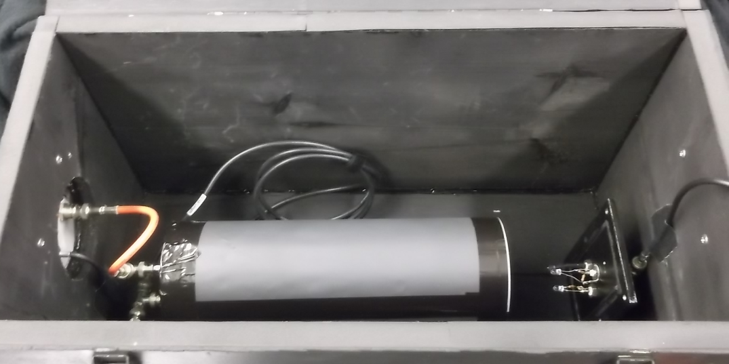

Figure A PMT in a protective tube with high voltage and signal cables attached with a LED light source for testing.

All new PMTs passed this test and could be installed on the scintillators. Once installed, they were tested to find the required high voltage to achieve an 80 Hz detection rate. These PMTs were tested similarly to the old PMTs. However 100 V steps were used instead of 150 V steps. This change was implemented because these PMTs are new and should not require as high voltages to achieve our desired hit rate.

Once installed, all new PMTs worked as expected and were ready for experimentation.

Table Required voltages to get a hit rate of 80 Hz from each PMT after all bad PMTs were replaced.

|  |  |  |
| --- | --- | --- |
| Scintillator Number | Left/Right | Voltage |
| 35 | L | 1500 |
| 35 | R | 2250 |
| 36 | L | 1550 |
| 36 | R | 1550 |
| 37 | L | 1950 |
| 37 | R | 1400 |
| 38 | L | 1500 |
| 38 | R | 1550 |
| 39 | L | 1250 |
| 39 | R | 1650 |
| 40 | L | 1650 |
| 40 | R | 1500 |
| 41 | L | 1400 |
| 41 | R | 2050 |
| 42 | L | 1350 |
| 42 | R | 2050 |
| 43 | L | 1500 |
| 43 | R | 1500 |
| 44 | L | 1400 |
| 44 | R | 1350 |
| 45 | L | 1750 |
| 45 | R | 1850 |

**Chapter III**

Time Resolution Calculations

The time resolution of a scintillator can be measured by arranging the scintillator we want to test between two other scintillators. A frame was assembled to mount three scintillators while keeping the distance between the outer and inner scintillators equal. The distance must be equal above and below the middle scintillator for the calculations to be accurate.

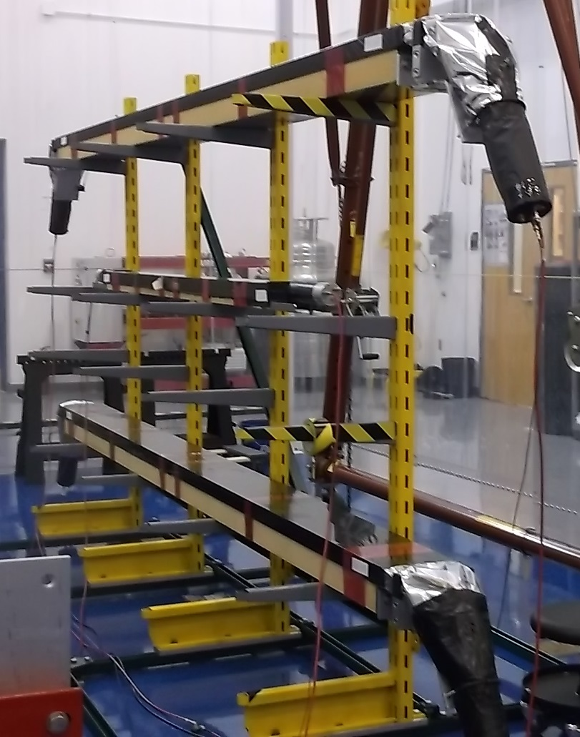

Figure Three scintillators stacked on a frame used to calculate time resolution.

To compile data the scintillators were connected to a data acquisition system. We used a FASTBUS crate with a LeCroy 1877 Time to Digital Converter, or TDC. A TDC is a data-acquisition module which records the time between a logic signal and a trigger signal. The 1877 measures time in 500 picosec bins within a 4096 nanosec window [5].

The signals from the six PMTs were sent to a discriminator with a threshold of -300 mV. In order to make sure that one cosmic ray passed through the top and bottom scintillators the logic signals from the discriminators were ANDed together. Figure 7 shows how the logic signals were ANDed to include all four PMTs from the top and bottom scintillators. If both top and bottom scintillators detect a particle within a time frame, we can assume that the middle scintillator also detected the same muon. The final ANDed signal is used as a trigger for the TDC. As we ran in common stop mode, the trigger is delayed and used to tell the TDC to stop accepting signals and begin another event window.

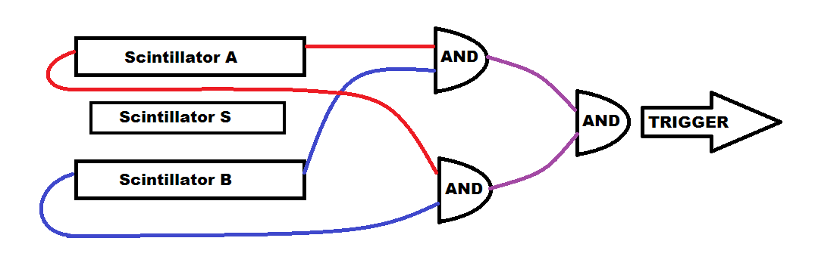

Figure Signals from the top and bottom scintillators are ANDed together, and the ANDed signals are ANDed with each other to create a trigger pulse to send to the TDC.

The number of counts each TDC bin gives is the number of muons which struck the scintillator during that half nanosecond period. Our data comes from a cycle of 100,000 4096 nanosec runs.

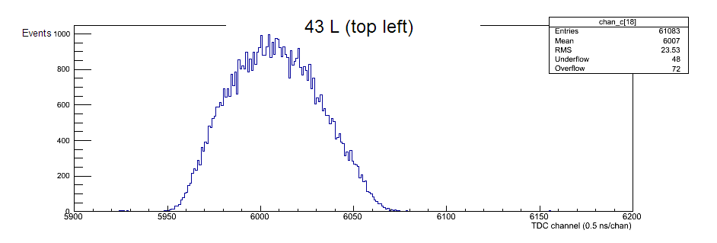

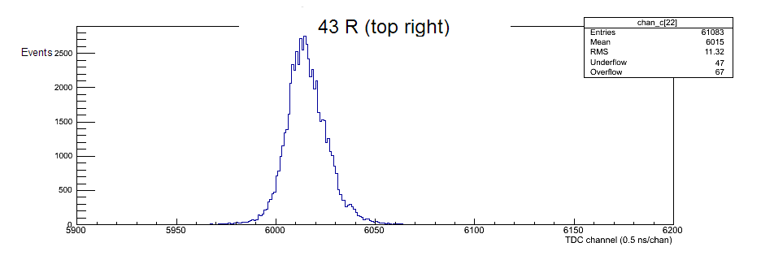

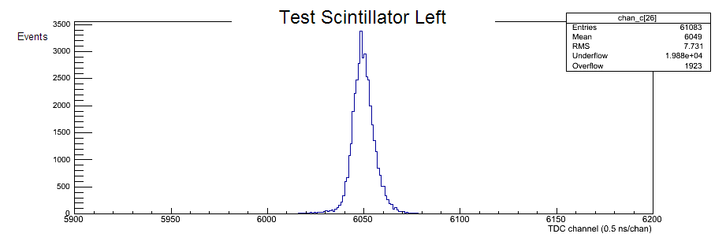

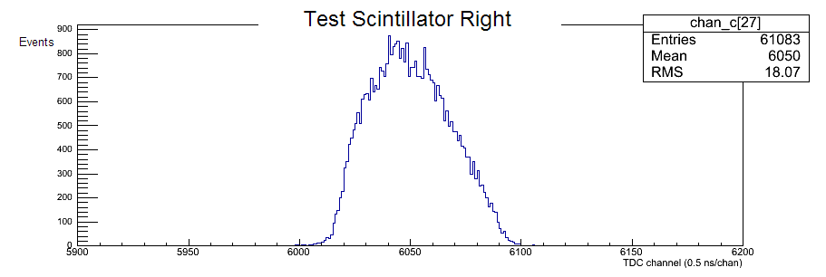

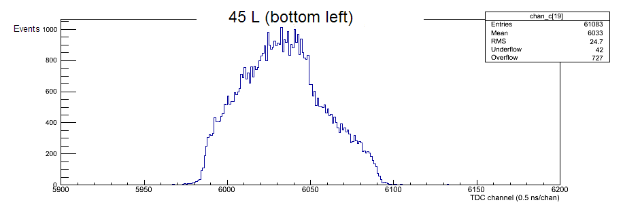

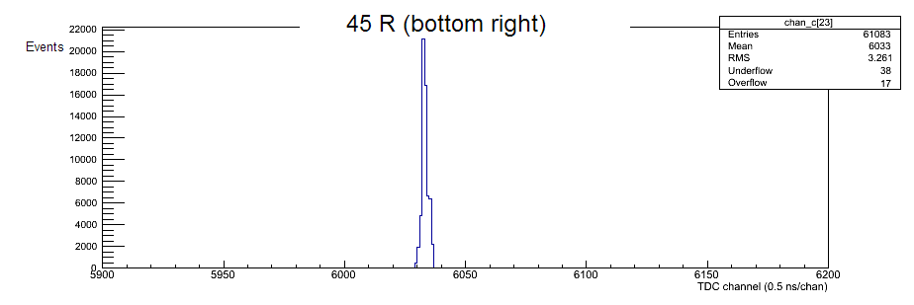

Figure TDC spectra from all PMTs in a 100,000 event 4096 nanosecond run.

The difference in spectra width results from muons hitting at different lengths along the scintillator. If all muons hit in the middle of the scintillant the time would be equal to both PMTS, however when a muon hits closer to one end it results in a shorter time to the closer PMT, and a longer time to reach the farther PMT. The speed of light in the scintillation material is roughly 20 cm⋅ns-1 so the time for the signal to reach one PMT could take up to 20 nanosec from the time of impact [6]. This is shown as the width of the TDC spectra. A narrow width means more muons impacted closer to that PMT while a wide width means more muons impacted closer to the opposite PMT. However, when one PMT has a long wait time, the PMT at the other end has a shorter wait time. If both ends are averaged with each other it should appear as though the muon hit the center of the scintillator each time.

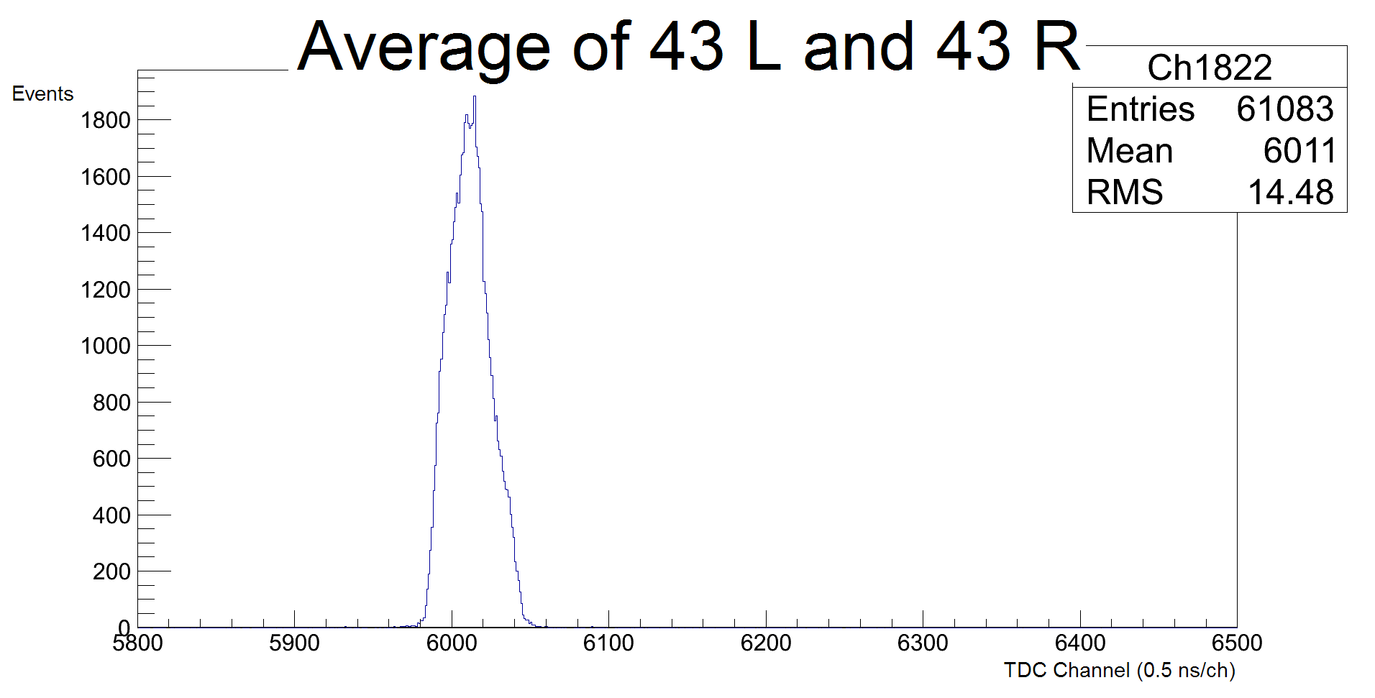

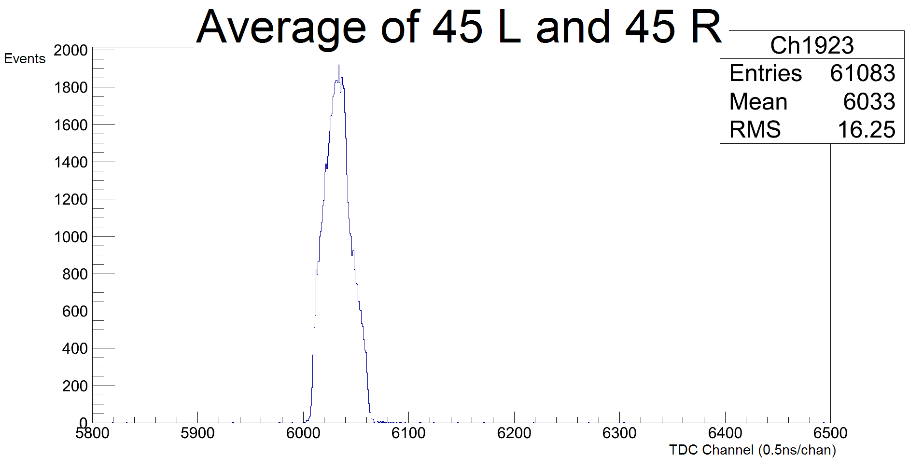

Figure Average TDC spectra of top and bottom scintillators.

Figure 9 shows the averaged TDC spectra of the top and bottom scintillators. The widths of each of these peaks are equal, roughly 60 bins or 30 nanosec, which shows that both PMTs of both scintillators detected each muon.

To find the time resolution of the middle scintillator we must first find the time resolution of the reference frame. The scintillators above and below the middle scintillator make up the reference frame while the middle scintillator is our test scintillator. To find the reference time we first average the time of the top and bottom scintillators, then subtract the bottom scintillator’s time from the top’s time. This results in the amount of time the muon spent in the reference frame, between the top and bottom scintillators.

*Tref*, the time resolution of the reference system can be defined as Equation 1:

Equation

Where:

* subscript *A* denotes the reference scintillator above the test scintillator
* subscript *B* denotes the reference scintillator below the test scintillator
* subscript *L* denotes the left PMT
* subscript *R* denotes the right PMT

Next we define a quantity, *TS*, which denotes the timing of the muon through the test scintillator. By averaging the time of the left and right PMTs on the test scintillator we can find the time the muon passed through the test scintillator

Equation

Combining equations 1 and 2 we can define *Tcosmic*, the time the cosmic ray passed through the test scintillator relative to the time the cosmic ray passed through the reference frame. By averaging all 4 PMTs of the reference scintillators we find the time the muon was in the reference frame. By subtracting *TS* we can find when the muon hit the test scintillator, relative to the time is spent between the reference scintillators.

Equation

Equations 1 and 3 can be calculated through software to obtain figures 10 and 11.

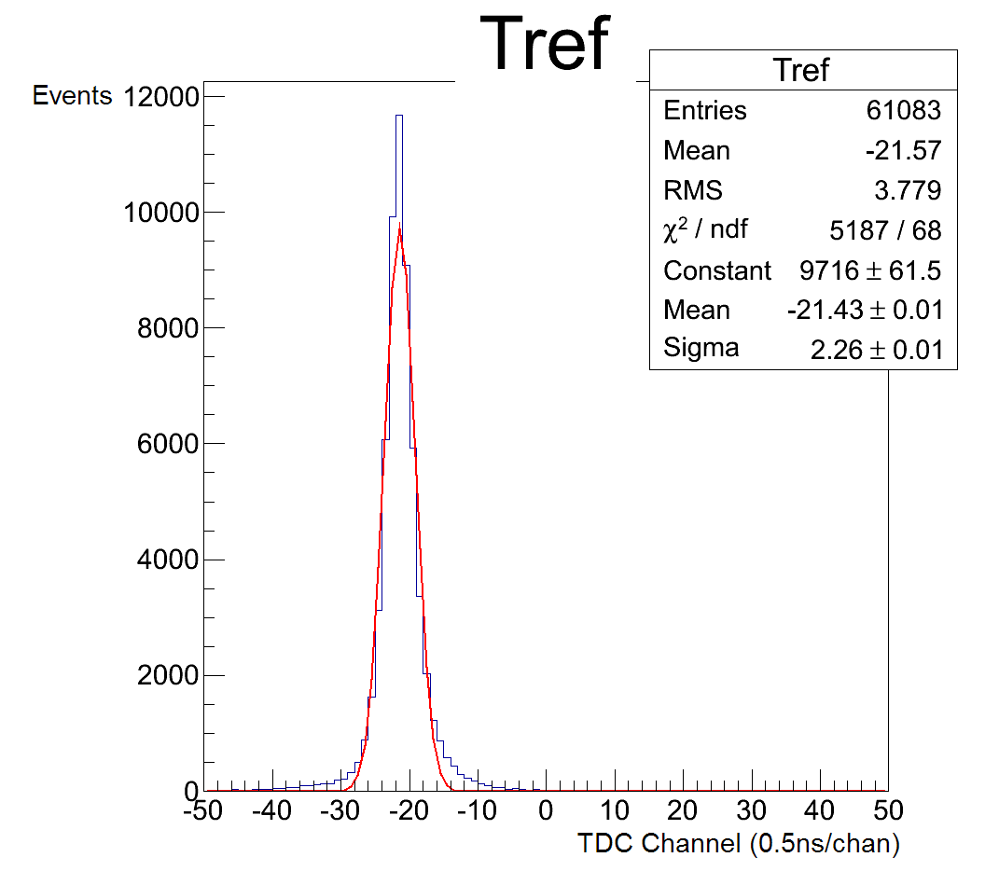

Figure Time resolution of the reference frame with a Gaussian distribution fit.

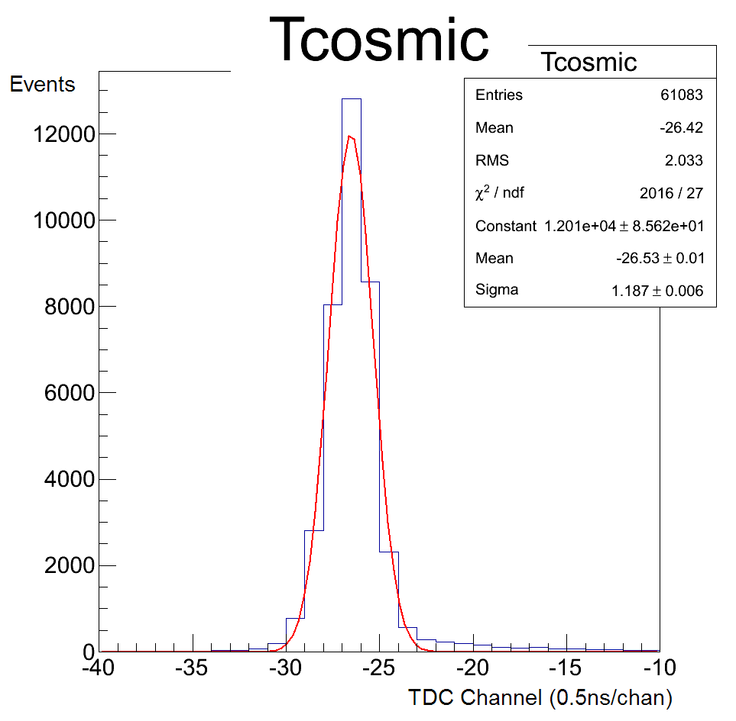

Figure Time a cosmic ray passed through the test scintillator relative to the reference frame with a Gaussian distribution fit.

To find the time resolution of the scintillators, we can use the standard deviations of *Tref* and *Tcosmic*, which are displayed as sigma on Figures 10 and 11. The standard deviation $σ_{ref}$ defines the time resolution of the reference frame scintillators, assuming they are all equal. The time resolution of the test scintillator however, is not the standard deviation of *Tcosmic*, *σcosmic*, as this includes some contribution from the resolution of the reference frame. To find a more precise measure of the test scintillator’s time resolution we must compensate for the resolution of the reference scintillators.

Equation

Equation 4 gives the time resolution of the test PMTs, *σS*, by subtracting the time resolution of the reference frame from *σcosmic*. Like the resolution of the reference scintillators, this method assumes both test PMTs have equal time resolution.

Based on the curves in Figures 10 and 11, we obtain values for *σref*  and *σcosmic* to be 2.26 nanosec and 1.19 nanosec respectively. From these we conclude that *σS* is 0.36 nanosec.

**Chapter IV**

Results and Future Experimentation

For particle detection in the CLAS detector, these scintillators were expected to achieve 120 picosec resolutions for small angles and 250 picosec at angles above 90° [4]. Our calculated value is higher than the expected values but still within the same order of magnitude.

Because our experimental value is so close to the desired value it may be possible to modify our experiment to achieve time resolution acceptable by JLab standards. There are two possible ways to increase the time resolution in the current experimental set-up, decreasing the distance between the reference scintillators, and using a more precise TDC.

Time resolution of our test scintillator, *σS*, is dependent on both *σcosmic* and *σref* which depend on the time resolution of our reference frame, which is the time the muon spends between the reference scintillators. Moving the reference scintillators closer together could result in better time resolution as there is less time the muon spends between the reference scintillators.

The LeCroy 1877 TDC operates with 500 picosec bins. Decreasing the bin time can increase the accuracy with which the time of each PMT can be read, increasing the accuracy of the time resolution. The LeCroy 1875A TDC is capable of 25 nanosec resolution which is more precise than the JLab desired standards, using this instead of the 1877 model should produce better resolution [7].

Our experiment calculated the time resolution of 3 of 12 scintillators taken from the CLAS detector. While the test scintillator achieved acceptable time resolution, our values for the reference scintillators was too high. To more accurately measure their resolution the set-up should be reconfigured to place a reference scintillator in the middle of two other scintillators. This process should be repeated until all 12 scintillators have been tested.

# **REFERENCES**

|  |  |
| --- | --- |
| [1] | Hamamatsu Photonics K. K., "How to use photomultiplier tubes and peripheral circuits," in *Photomultiplier Tubes: Basics and Applications*, 2007, pp. 83-124. |
| [2] | K. Johnson, "Particle Detectors at Accelerators: Organic scintillators," pp. 2-68, 2011. |
| [3] | W. R. Leo, Techniques for Nuclear and Particle Physics Experiments, Berlin: Springer-Verlag, 1994. |
| [4] | E. S. e. a. Smith, "The time-of-flight system for CLAS," *Nuclear Instruments and Methods in Physics Research A 432,* pp. 265-298, 1999. |
| [5] | LeCroy Corporation, *Model 1877 96-Channel FASTBUS Time-to-Digital Converter,* 1996. |
| [6] | E. S. Smith, "Scintillation Detectors," 2006. |
| [7] | LeCroy Corporation, "1875A 15-Bit, Time-to-Digital Converter," 1996. |

1. Bicron Corporation, 12345 Kinsman Road, Newbury, OH

   44065-9677, USA.